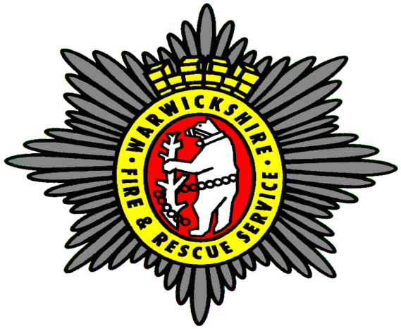
Outcomes Summary of the Draft Integrated Risk Management Plan 2017-2020 Consultation
January 9th 2017- March 10th 2017

Contents
Introduction………………………………………...Page 3
High level summary……………………………….Page 4
Overall conclusions…………………………........Page 5
Appendix 1 (as attachment) – FBU Response
Appendix 2 (as attachment) - RFU response

Introduction
Warwickshire Fire and Rescue Service (WFRS), on behalf of Warwickshire County Council as the Fire authority, consulted with the public, staff and all partner agencies over a 9 week period commencing in January 2017. The consultation was conducted on the draft Integrated Risk Management Plan (IRMP) 2017-2020 and Action Plan 2017/18, which are a statutory requirement for all Fire and Rescue Services in the United Kingdom.
The draft IRMP proposed a number of areas that WFRS could further develop to improve its service to the local communities.
The consultation used three pathways to inform communities of the proposals and invite feedback:
- On- line
Information via the Intranet, WFRS website and Ask Warwickshire
On line questionnaire; open to all
Paper based copy of the questionnaire in all main libraries

- Discussion groups
Drop in session at Shire Hall
Facilitated sessions to Council members

- Local visits to Fire stations and community venues where appropriate.
In total 78 responses were received via the online survey and several members of the Council utilised the drop in session to gain a further understanding of the proposals.

High level summary
A relatively low number of people chose to participate in the consultation on the draft IRMP and the proposals for WFRS to develop its services in the future.
There were three main ways for people to interact and provide their views on the draft IRMP, as follows:
- Online survey / paper based Survey or email direct to the IRMP address
- Drop in session at Shire Hall, Warwickshire County Council
- Informal locally delivered sessions by Station Commanders to staff
Submissions via other areas have also been included in this report including a 19 page report from the Fire Brigades Union (FBU), a 2 page report from the Retained Fire fighters Union (RFU), and email correspondence from; Members of Parliament, other Fire and Rescue Authorities; the Police and Crime Commissioner (PCC) and the Fire Officers Association (FOA).
Given the fact that Warwickshire has a population of around 550,000 the volume of responses has been low. However this is potentially because the draft IRMP sets out proposals to develop and improve the service to the local communities and doesn’t make any proposals that could be viewed as a detrimental change that would reduce the level of service provided.
Key proposals within the draft IRMP document include:
- Implement a single control facility with Northamptonshire Fire and Rescue Service
- Implement an Emergency Medical Response arrangement with West Midlands Ambulance Service(WMAS)
- Further develop our current working collaborative programme with Hereford & Worcester Fire and Rescue Service and West Mercia Police to maximise all operational, service support and future governance opportunities in keeping with forthcoming legal duties
- Produce a WFRS Asset Management Plan that sets out the future changes needed in the locations of our premises and fire engines, and incorporate within the Warwickshire County Council (WCC) Capital Expenditure Programme
- Review the provision of aerial appliances across the West Midlands Region
- Review our RDS recruitment needs and practices to maximise fire engine availability, and optimise the balance between whole time (WDS) and on-call (RDS) staffing of key fire stations
- Extend the use of Light Rescue Pumps (LRPs) within the Service
- Consider and if appropriate implement the use of new fire extinguishing technology
- Consider and if appropriate implement the use of new equipment for dealing with Road Traffic Collisions (RTCs) involving vehicles with new and more challenging construction
- Enhance our value to the community by exploring opportunities to work with partners to improve wider health and social care outcomes

It is clear from the overall responses collated from the paper based and online surveys drop in sessions and general feedback that there is little concern from the local communities around the formal implementation and adoption of the IRMP.
Online survey responses indicated that 75% of the responses received were from members of the public and 25% were members of staff. Responses from staff showed tendencies to be more concerned about the proposals than members of the public.
The FBU response indicates that there were more concerns around national agendas and budget cuts than the specific local proposals in the draft IRMP. Their concerns centered around the proposal to enter into a single fire control arrangement with Northampton FRS (which echoes the national FBU position around shared/joint fire controls) and the funding gap between the WFRS budget and the core settlement fire funding received by WCC from Government.
The RFU indicated its national position that FRSs should consider making greater use of retained firefighters, highlighting the cost effectiveness of this approach and encouraging greater organisational effort in recruitment. FOA fully supported the implementation of the draft IRMP.
Responses received from others support the proposals or have no opinion to suggest otherwise.

Overall conclusions
A very low number of participants took part in the consultation process to formally adopt the draft IRMP. This could be seen as disappointing with the wide range of communication pathways that were used to inform the public of the consultation process. This would suggest that the local communities are not concerned with the proposals. This can also be evidenced by the majority of those responses received.
The survey also offered the chance for participants to enter some free text; this has been used as a sounding board by some individuals to express opinions around issues not reflected within this IRMP, such as the potential future relocation of Southam fire station to the new Training and Development centre site being built a few miles away.
In drawing conclusions from the questions posed there is some concern around moving to a single fire control function; however the responses suggest there is a lack of understanding around the proposal and the function of a fire control. General conclusions drawn indicate a lack of understanding from the general public on the difference between a fire control and a fire station. There are no absolute responses to oppose this proposal, with less than 15% of the responses indicating concern.
In reviewing the aerial appliances within the County the response varied but generally the responses centred themselves on fire cover not aerial appliance capabilities.
Updating the fire engine fleet to Light Rescue Pumps received some support, and responses generally could see the benefit of moving to smaller and more agile appliances. However, some concerns were raised by staff around this proposal following some teething problems with the second tranche of delivered vehicles.
The proposal to move towards a wider health based agenda overall received some very positive comments.
Overall there is positive feedback for the proposals for the Service to improve its facilities, resources and services to support the communities within Warwickshire as scoped out within the IRMP.

