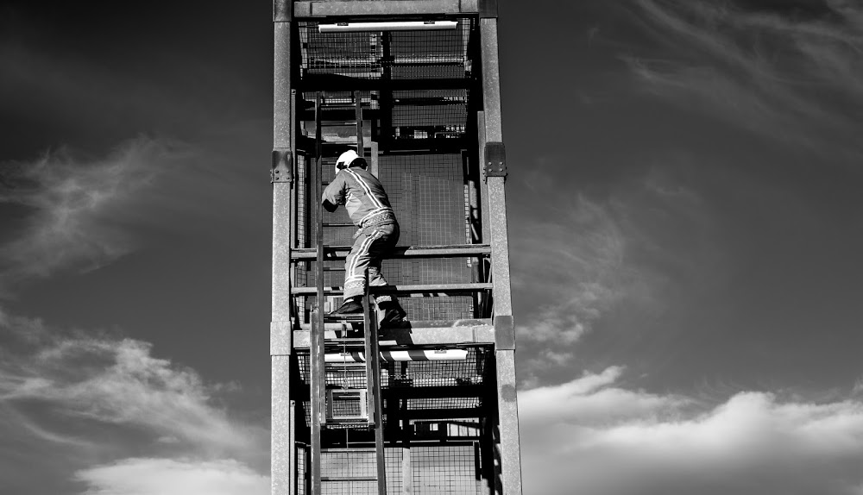
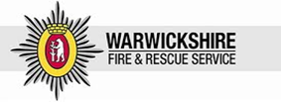
Warwickshire Fire and Rescue Service
Draft Integrated Risk Management Plan 2017 –I

20

Integrated Risk Management Plan
2017 -2020

Warwickshire Fire and Rescue Service

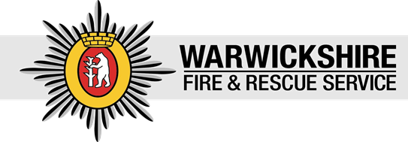

Photos by Kamil Kaim

Contents

- Introduction
- Executive Summary
- Our Purpose, Aims and Principles
- Our Outcomes Framework
- What is an Integrated Risk Management Plan?
- Our Achievements so Far
- Risk Management in Warwickshire
- The Financial Challenge
- Our Development Intentions
- Consultation
- Glossary

- Introduction
Welcome to Warwickshire Fire and Rescue Authority’s Integrated Risk Management Plan (IRMP) 2017 – 2020 and the accompanying Warwickshire Risk Profile 2016.
This plan sets out the vision for the Authority over the next three years and recognises the significant changes the Authority has already made during the period of the previous IRMP.
Whilst Warwickshire remains a safe place to live and work we cannot be complacent. As a fire and rescue service we are continually evolving, and the way we operate will look and feel different in the future as we become more innovative in the way we use new technology, deploy our resources to meet new and emerging risks and continue to revise shift and crewing arrangements.
This IRMP will identify and assess fire and rescue related risks that could affect the communities of Warwickshire, and those of a cross border, multi authority or national nature.
So far through our Service Improvement Programme and Warwickshire County Council’s One Organisational Plan, we have managed to reform the way in which we deliver a cost effective, fit for purpose service. As we look forward to the next three years we have to be realistic with Warwickshire residents about the financial challenges that lie ahead, and communicate clearly the impact these may have on the services we provide.
We welcome the challenges made to the UK fire and rescue services within the speech delivered by the then Home Secretary, Theresa May, entitled “Where next for Fire Reform?” The speech highlighted issues that included:
- The need for continuing reform in governance structure, accountability, scrutiny, transparency and workforce profile;
- The need for efficiency and collaboration between emergency services;
- Workforce changes and internal cultures;
- The lack of independent inspectorate and the limitations of fire and rescue service performance data.
Previous considerations of alliances and mergers remain very relevant given the impact of financial reductions and the effect of these on the capacity and resilience of the Service. The new statutory duty for all blue light agencies to collaborate to secure efficiency effectiveness and public safety will be a key focus in our future.
We are confident that we are well placed to embrace change and we will work with our communities and partners to ensure that we continually review and assess how we are best targeting our resources and efforts to risk in the county. Our priorities as we move through this change will be to keep the public safe by ensuring that an effective response is provided to fires and other emergencies, keep firefighters safe by ensuring that they are provided with the right equipment and training for major threats and emergencies, and doing our very best by ensuring that we deliver value for money within available resources.

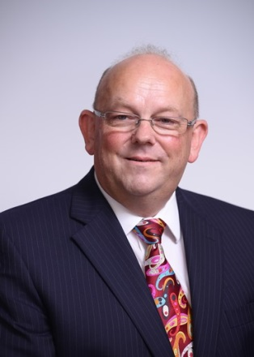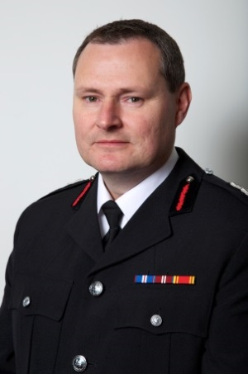
Portfolio Holder – Howard Roberts Chief Fire Officer – Andy Hickmott

2. Executive Summary
This IRMP provides a brief summary of the work undertaken in the last three years and sets out how we plan to build upon the progress made. It aims to identify emerging risks and new opportunities as well as highlight the challenges the Fire Authority will face as we move into the next three year period.

It summarises how, through effective planning, we consider all fire and rescue service-related risks within our communities and how we aim to respond to them, making the most effective and efficient use of our people, resources and equipment.

Within this document you will find:

- Our purpose aims and principles
- Our priorities
- What is an Integrated Risk Management Plan?
- Our achievements so far
- Risk management in Warwickshire
- The financial challenge
- Our development intentions
- Consultation

Warwickshire has a diverse risk profile of both rural and urban population and whilst we now attend fewer fires than we did in the past, we respond to a wide range of different emergencies which impact upon those communities. These include flooding, major industrial incidents, animal rescues, water rescues and transport incidents. Our operational preparedness is achieved though resilience planning, working with other emergency services and partners and through our work with neighbouring fire authorities.

To assess risk in Warwickshire we use a range of data and research which helps us to define our risk profile and create an accurate and up to date picture of the risks impacting our communities. These include:-

- Warwickshire Risk Profile 2016,
- Warwickshire County Council’s One Organisational Plan,
- Warwickshire Fire and Rescue Service Outturn Report 2015/16,
- National Risk Assessment,
- Community Risk Register,
- The Fire and Rescue National Framework for England,
- Operational Assessment and Fire Peer Challenge Report 2016.

- Our Purpose, Aims and Principles
Over the next three years we will need to make some changes to the way we deliver a fire and rescue service to the residents of Warwickshire, but any proposals we make will stay true to our core purpose: Protecting the community and making Warwickshire a safer place to live.
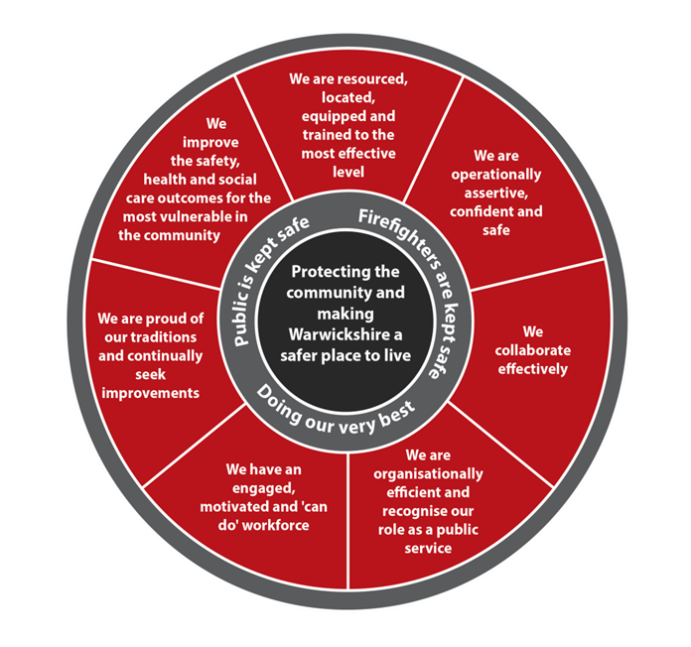

We will ensure the public is kept safe by focusing on the following outcomes:
4. Our Outcomes Framework
- We understand and proactively manage the risk in our county;
- We help our businesses and communities, particularly the most vulnerable, to be safe;
- Fire safety law is enforced in the workplace effectively;
- An effective response is provided to fires and other emergencies;
- Levels of deaths and injuries caused by fire and on the roads are minimised.

We will monitor how well we are achieving these outcomes by measuring our performance in the following areas;
- Fire engines are available to respond to 999 calls;
- We attend life risk incidents as quickly as possible;
- Safe and Well visits are delivered to our most vulnerable residents;
- Education sessions are delivered to those at risk of being involved in a road traffic collision;
- Work with our partners in the police, public health and adult social care to achieve improved community safety and wellbeing;
- Prevention and protection activity is targeted towards high risk areas.
We will ensure our firefighters are kept safe by focusing on the following outcomes:
- The skills of our workforce are developed;
- A good health and safety culture is promoted;
- The right equipment, vehicles and information to do the job are provided;
- Our staff feel supported, valued and engaged;
- We are operationally assertive, confident and safe;
- We are prepared for major threats and emergencies.

We will monitor how well we are achieving these outcomes by measuring our performance in the following areas;
- Major risk exercises and training events provide firefighters with the requisite skills and confidence;
- The crewing levels of our fire engines, and staffing of our support departments are maintained;
- Firefighters through to management level are all sufficiently competent to undertake their tasks safely and effectively;
- Sickness absences levels are at the lowest reasonable level;
- Wellness at work initiatives are delivered that improve the health and well-being of our staff;
- Training facilities enable the effective delivery of skills and knowledge training.
We will ensure we are doing our very best by focusing on the following outcomes:
- We are organisationally efficient and constantly seek improvements;
- Our customers are satisfied with the service they receive;
- Our staff are recognised as our biggest asset.
We will monitor how well we are achieving these outcomes by measuring our performance in the following areas;
- Savings targets are achieved and financial forecasts are accurate;
- The number of justified complaints remain low;
- High customer satisfaction levels are maintained.

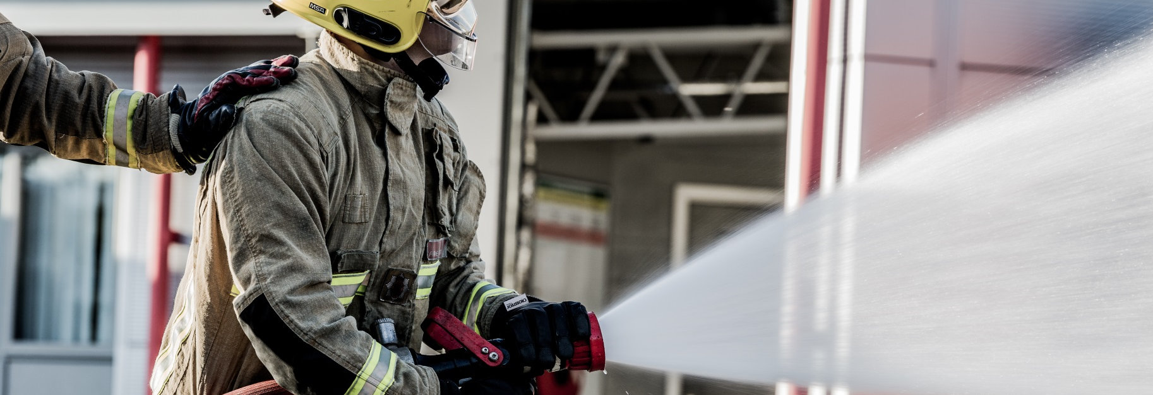

- What is an Integrated Risk Management Plan?

This IRMP demonstrates how the Warwickshire Fire and Rescue Authority assess and manages foreseeable risks within Warwickshire. It is an integral part of the business planning process as it allows us to review what has been done to make Warwickshire safer, and describes what additional actions we intend to take in the years to come.
An IRMP fulfils the requirements of the Fire and Rescue National Framework for England, which sets out the government's expectations for all fire and rescue services. The framework recognises that fire and rescue services are best placed to identify, plan, prepare for and address the risks within the communities they serve. However, the following priorities need to be considered within an IRMP;
- To identify and assess the full range of foreseeable fire and rescue-related risks their areas face, make provision for prevention and protection activities and respond to incidents appropriately;
- To work in partnership with their communities and a wide range of partners locally and nationally to deliver their service;
- To be accountable to communities for the service they provide.

The integrated risk management planning process doesn’t just review the risks in isolation though, it is about assessing and understanding the full range of risks impacting the communities of Warwickshire and ensuring that we have the plans, people, processes and equipment in place to ensure that Warwickshire remains a safe place to live and work.

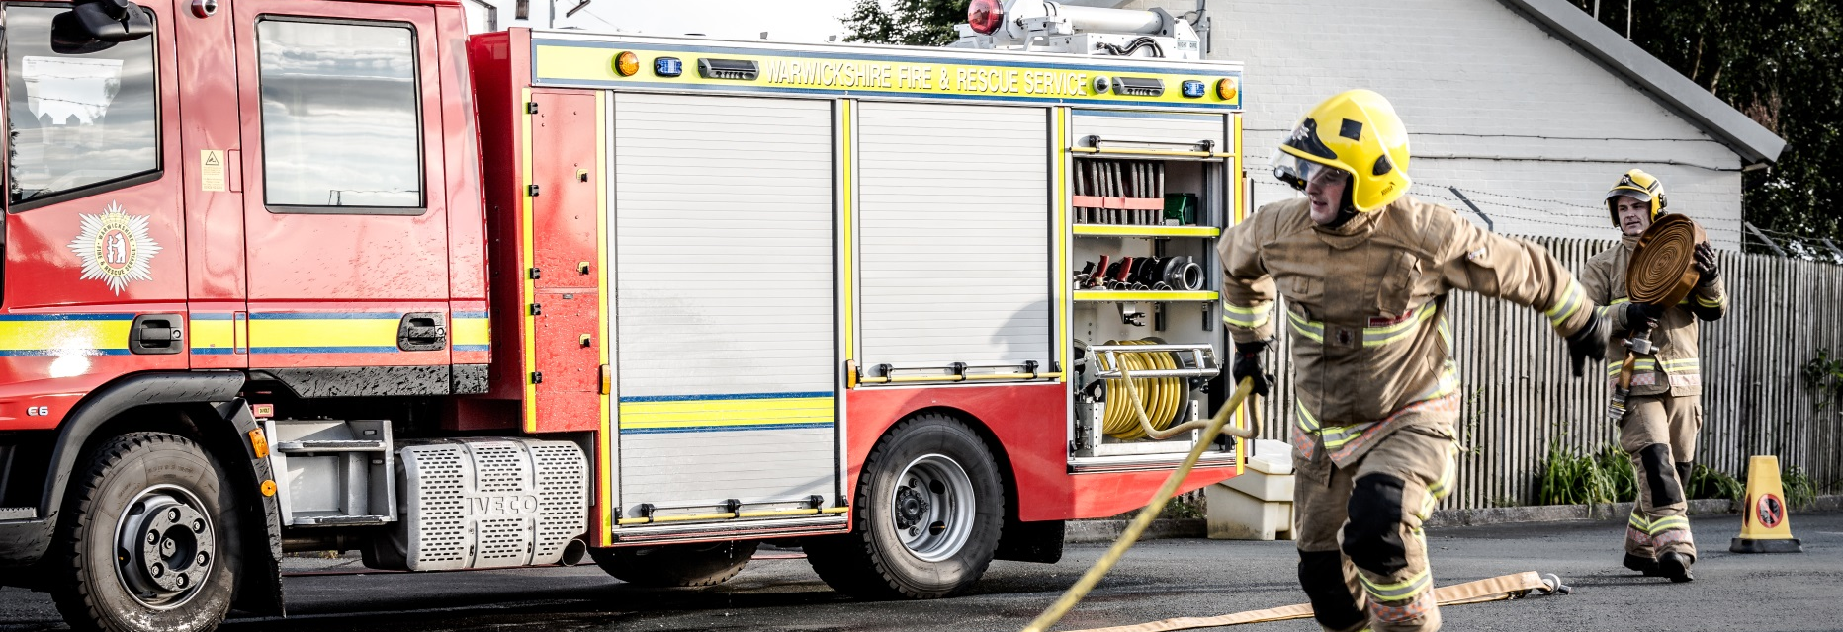
Below are some of the improvements we have made to the Service during the period of our previous IRMP. In our 2013 – 2017 IRMP:
- Our Achievements So Far
We said we would review our emergency response standards so that we can provide a better response across the whole of the county.
We did:
- The review of the response model was subject to public consultation in 2014 and a new response standard (to provide an initial response to all life risk incidents across the county in 10 minutes on 75% of occasions) was introduced in 2015.
We said that we would increase training, support and leadership for our retained duty systems firefighters (RDS).
We did:
- We introduced new roles for 23 Response Commanders, of which 8 were designated Retained Support Officers whose primary role is to support retained firefighters and station commanders.
- We provided additional training for retained firefighters including on-line training from home.
- We carried out a review of the retained duty system to help us to make further improvements.
We said that we would deploy whole-time firefighters to do jobs that make the best use of their skills and working time.

We did:
- We reviewed the number of firefighters we have and the shift patterns they work. By listening to, and working with, our firefighters, we have developed and agreed changes to the whole-time shift system that requires fewer firefighters, but maintains the number of fire engines that we have available to respond.
- The changes to the whole-time shift system provided the additional crewing for a new fire station in Gaydon. This has already improved response times to road traffic collisions on the M40.
- We introduced a Day Crewing Plus duty system at Stratford and Alcester fire stations that requires significantly fewer firefighters, but maintains the number of fire engines that we have available to respond.
We said that we would develop the role of our Fire Control teams to make the best use of their skills and working time.
We did:
- We updated our communications and command systems to ensure that our Fire Control staff have the most up to date systems from which to manage all ‘999’ calls.
- We introduced new duty systems in our control room to enable us to align with Northamptonshire Fire and Rescue Service and enable the two control rooms to support each other more closely.
We said that we would increase our water rescue capability to flooding and fast flowing water incidents so that we can respond to a wider range of incidents.
We did:
- All whole-time firefighters have been trained to the level of the Module 2 First Responder Water Rescue national qualification.
- Additional water rescue equipment was purchased to provide enhanced water rescue.

Finally, we said that we would develop our specialist rescue capability.
We did:
- We introduced new equipment, training and procedures for specialist rescues including road traffic collisions and large animal rescues
- We introduced ten Light Rescue Pumps to help us to provide a swifter response to incidents and provided more advanced cutting equipment for carrying out rescues from vehicles

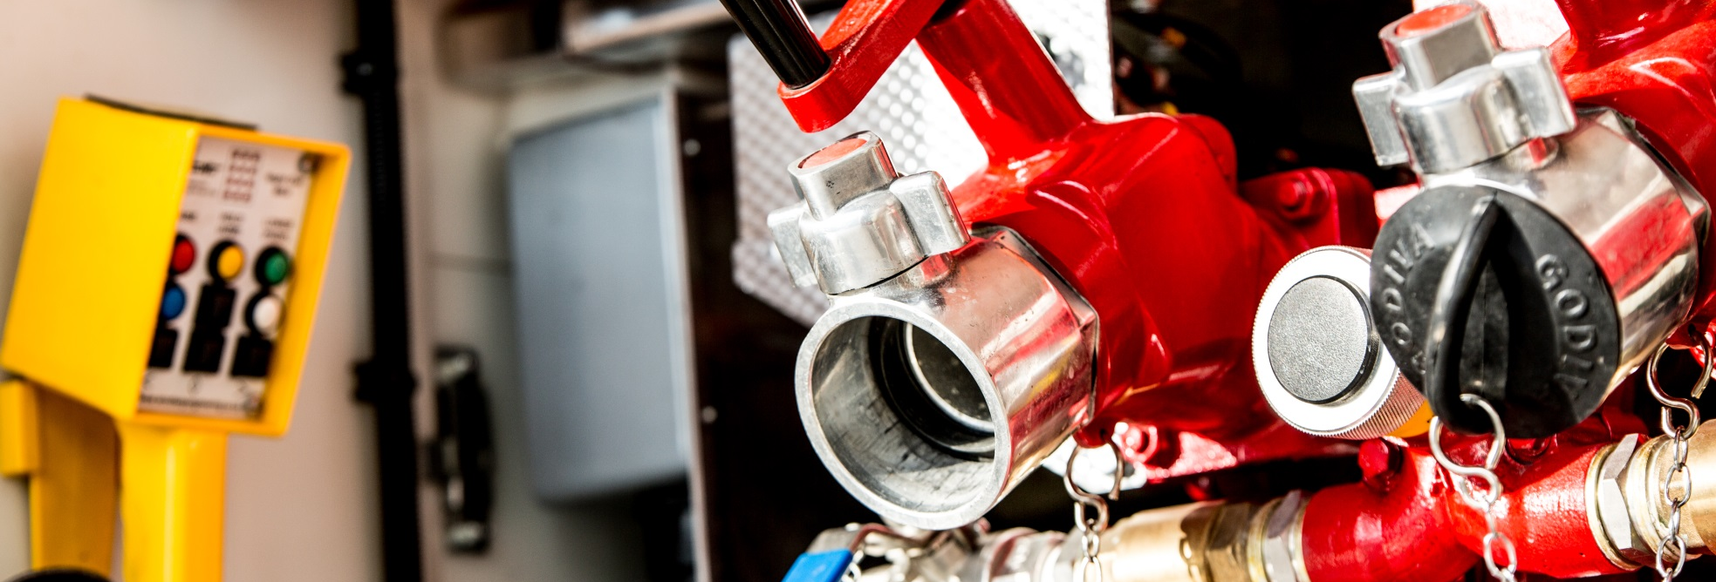
- Risk Management in Warwickshire
Risk management planning is the way that all fire and rescue services identify and manage the risks which impact upon their communities. Ensuring that we have a clear understanding of those risks underpins everything that we do.
We have a major part to play in keeping communities safe, businesses running and our heritage and environment protected. To achieve this we use a wide range of data analysis to determine the risks that impact locally upon the communities of Warwickshire against the backdrop of the Fire and Rescue National Framework.
The Warwickshire Risk Profile 2016 provides an in-depth piece of research and analysis of the incidents we have attended over previous years and the risk of emergency incidents happening in the future. The Risk Profile provides a range of actions which will drive local risk reduction plans. We also consider the Warwickshire Community Risk Register, the National Risk Assessment, the risk information we collect on all medium and high risk premises within the county, local planning applications, town and district local plans, major road developments and learning from major incidents that occur elsewhere within the United Kingdom and beyond. We also anticipate the impact that significant infrastructure projects may have on Warwickshire at the planning stage. For example, the next phase of the High Speed rail link project (HS2) will eventually cover 44 miles of Warwickshire travelling from the south east to the north of the county. The impact, in planning and operational terms, will be significant on the service given the large scale construction, hazardous processes and significant increases in traffic volumes.
From the data we review, we know that people who are vulnerable because of their social and economic circumstances are often more vulnerable from fire. Through the use of ‘Exeter’ patient registration data, ‘Mosaic’ data and incident data, we can identify the areas in our county where fires may be more likely to occur. This means that we can target our resources more effectively to reduce risk across the county and protect some of the more vulnerable members of our community.
Using this targeted approach to our prevention activity has helped us to reduce the number of incidents that we attend.
Long term trend: 10 year percentage change in incidents attended
Incident Type | Jan – Dec 2005 | Jan – Dec 2015 | Percentage Change
Primary Fires | 1408 | 611 | -57%
Road Traffic Collisions (RTCs) | 652 | 301 | -54%
Secondary Fires | 1454 | 735 | -49%
False Alarms | 3681 | 1318 | -64%
Special Services (excluding RTCs) | 848 | 259 | -69%
Total Incidents | 8043 | 3224 | -60%

However, on the back of this 10 year downward trend there has recently been a steady increase in deliberate fires and a more significant rise in the number of road traffic collisions we have attended (WFRS Risk Profile 2016). The increase in road traffic collisions locally reflects the picture nationally.

New housing and commercial and industrial developments within the county require us to consider whether the location and resourcing of our fire stations, and our protection and prevention strategies, need reviewing in response to any potential increase or change in local risk. When district/borough councils develop new Local Plans for the future we ensure that we engage with them at the consultation process. If necessary we will consider making an application for developer contributions towards any additional resources we feel we may need. Not all applications are successful, but if during the lifetime of this IRMP we have cause to consider changing the location of any of our existing fire stations in response to major new developments, we will undertake a specific piece of consultation with those communities within the area affected.

Risk versus demand
Warwickshire Fire and Rescue Authority provide a fire and rescue service aligned to risk. Risk is not the same as demand. Though the number of house fires has declined in recent years, the resources required to tackle a house fire remain the same regardless of the number of incidents an individual fire station might expect to respond to. The fire and rescue service is expected to respond immediately to all foreseeable events 100% of the time, and unlike other public services our success is measured in minutes, not days or weeks.
Fewer fires do not directly equate to a lower level of risk, and therefore does not necessarily provide the opportunity for a proportionate reduction in the number of firefighters and fire engines. If there is a terrorist incident, extreme weather event, industrial accident or any other unexpected catastrophe the public expects an immediate and professional response. The fire and rescue service needs to be equipped with the necessary resources and staff to deal with the incident effectively and ensure a swift return to normality.
Behind the firefighters, fire engines and fire stations are a range of support services that are essential to the emergency response, prevention and protection capabilities of Warwickshire Fire and Rescue Service. Though largely unseen to the public, the staff in these support services ensure that our firefighters are provided with the vehicles, equipment, training, data and policies to enable them to undertake their roles effectively and safely. These cannot be described simply as ‘back office’ as these are essential to providing and supporting the operational ‘front line’.

Warwickshire Fire and Rescue Service is a small organisation that has become smaller still given continued reductions in budget over a number of years. We have stepped up to the challenge of austerity and become more efficient in the way that we meet the demands of a modern fire and rescue service. However, we are now a very lean organisation, and in a wide range of areas now operate to the minimum level of resources necessary to provide a viable and sustainable service against the range of legal standards that apply to us. This requires us to consider very carefully the impact of further budget pressures, and to maximise the opportunities that the legal duty for blue light services to collaborate will present to us in order to enhance our efficiency, effectiveness and public safety.

Key risks;
Fires - Depending on the size of the incident, a fire can have devastating emotional, physical, environmental and economic effects.
We undertake regular analysis of where fires happen in the county and target our resources effectively to reduce the impact through home fire safety checks, arson reduction and business fire safety.
Industrial and Heritage Premises - There are a number of industrial sites in and around Warwickshire where hazardous substances may be stored. Whilst these businesses have a statutory duty to plan for emergencies, we work closely with them to ensure they have the right plans in place.
There are also a number of buildings within Warwickshire that are important to the county’s heritage and history; a notable example being Warwick Castle. These buildings pose a threat to firefighter safety due to their complex layouts and old construction methods. They are immensely valuable, often containing irreplaceable artefacts.
Our firefighters conduct regular visits to medium and high risk buildings to ensure that they are familiar with the risks. This is then reinforced with specialist training and exercises in partnership with other agencies to ensure that we have the right approach for the risks identified.
Transport Incidents - Road traffic collisions are now one of the biggest areas of work for fire and rescue services due to the fast growth of our transport networks. The impact of these types of incidents is often significant, not only to those directly involved, but also the wider community and businesses that that are impacted by the traffic disruption these types of incidents cause. We work closely with our partners to mitigate further risk and disruption to those involved and the surrounding areas.
Although thankfully very rare, we also plan for and equip ourselves to respond to rail and air incidents.
Flooding and Water Rescue - Flooding is becoming more of a frequent occurrence due to environmental change and, whilst flood defences in Warwickshire have been significantly improved, flooding continues to be a threat to our communities.
To mitigate the impact we regularly review our flood risk management plans to ensure that we have the right resources, equipment and training to deal with incidents when they occur.
We recognise the risks presented by open water, and aim to support the UK Drowning and Prevention strategy by establishing a Warwickshire Water Safety partnership.
Terrorism and other Extreme Events – The recent acts of terrorism seen in both London and Manchester provide a stark reminder that the risk and associated harm caused by such events is very real. They can present a very high risk to people and their communities. Other extreme events include; civil disturbance, major chemical incidents and explosions, extreme weather events and human pandemics.
We are part of the Warwickshire Local Resilience Forum (WLRF); a partnership comprising of the police, fire, ambulance, local authorities, Environment Agency, health, military, utility and transport companies across Warwickshire. The WLRF prepares for and plans to deal with large-scale emergencies within the county, whilst also supporting other fire and rescue services as part of a national response.
Emergency Response Locations
Alongside the planning and preventative work we do sits our emergency response service, so that when things go wrong we will always be there when the public needs us the most. The risk management process informs the location of our fire stations and fire engines, and enables us to match the provision of our resources to demand and risk.

Firefighter Safety
As set out in our Outcomes Framework, a critical aspect of our approach to risk management approach concerns the safety of our firefighters. The workplace that both we and the public expect firefighters to operate in can be difficult and dangerous. The nature of emergency activities is that they are often carried out in unfamiliar places in dynamic and deteriorating conditions in time pressured situations and with limited information. This combination of circumstances means the Service puts major and sustained emphasis on operational training, and in supporting operational crews with the best available equipment, procedures and related functions.

Current fire station and fire engine locations (April 2016)
Atherstone
Coleshill
Nuneaton
Rugby
Leamington
Stratford
Gaydon
Alcester
Kenilworth
Bedworth
Southam
Shipston
Fenny Compton
Wellesbourne
Bidford
Henley
Polesworth

- Wholetime fire engine providing 12 hour cover
(Peak demand 07:00 to 19:00)

- Wholetime fire engine providing 24 hour cover
(Flexible shift crewed)

- Wholetime fire engine providing 24 hour cover
(Self rostering)
- Wholetime fire engine providing 24 hour cover
(Day crewing plus)

- Wholetime fire engine providing 24 hour cover
(Peak demand plus)

- Retained duty system (RDS) fire engine

Operational Cover
The present operational cover requirement is based on being able to maintain ‘day to day’ emergency cover based upon the present Fire Authority’s response standards as well as:
- Our ability to respond to larger incidents (9+ fire engines);
- Our ability to respond to medium size (4-8 fire engines) and/or simultaneous incidents;
- Our ability to meet the responsibilities as lead agency for risks under the Local Resilience Forum Community Risk Register (e.g. flooding, terrorism);
- Our ability to respond to major incidents at site specific risks (e.g. Kingsbury Oil Terminal, Warwick Castle).
- Acknowledgement that neighbouring FRSs may be unable to support us operationally as they have in the past.

The Fire Authority’s present response standards are:
- To provide an initial responding fire engine to life risk incidents across the county within 10 minutes on 75% of occasions;
- To provide the second responding fire engine to life risk incidents across the county within 15 minutes on 90% of occasions.

It also provides the resilience to:
- Enable firefighters to undertake the necessary training;
- Allow staff to undertake the required premise risk inspections;
- Facilitate community safety and fire prevention activities.

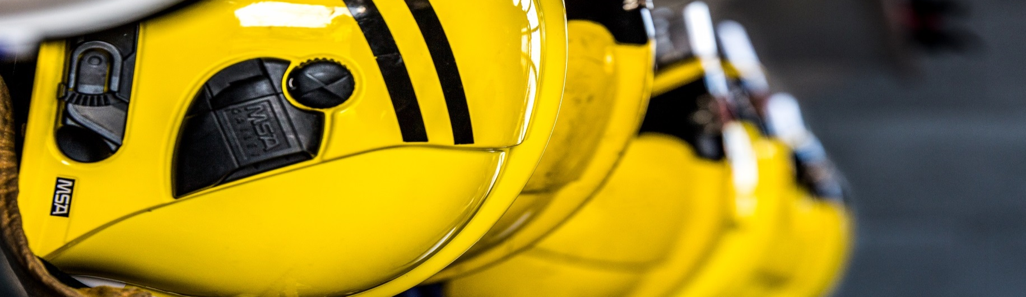
- The Financial Challenge
Local government as a whole is faced with an unprecedented set of financial challenges and Warwickshire Fire and Rescue Service is no exception to that. The Government Spending Review means that fire and rescue services nationally have been faced with a net reduction of 25% in their budgets between 2010 and 2016.
We have already made significant savings through the first three years of the One Organisational Plan savings programme, and have plans in place to achieve savings of £368K in the year 2017-2018. The One Organisational Plan sets out the potential for further savings of £2.3 million being required in 2019/20, although savings of this scale would require a fundamental change to the Service in collaboration with other blue light agencies (see actions 1.1 and 1.3 of the IRMP Action Plan 2017/18).
We will review the use of our existing resources, including financial reserves, to look at how we can use them in the most efficient way in order to create capacity to deliver the IRMP Action Plans.
We spend over two thirds of our funding on firefighters pay. The rest is spent on supporting emergencies and carrying out community fire prevention and commercial fire protection. As a fire and rescue service we strive to provide the best possible service within the budget we are allocated. This can only be achieved by being more creative in the way we use our resources, by targeting the most vulnerable in our communities and working in partnership and collaboration with external partners and other blue light services.

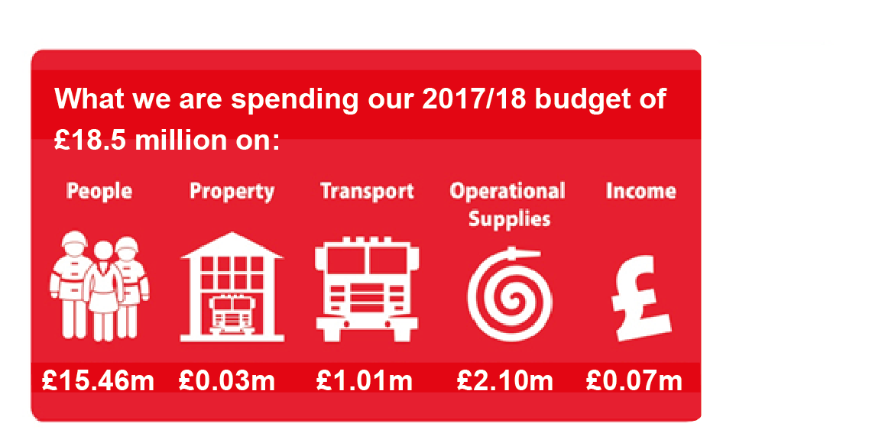

Our operational budget to run the fire and rescue service for 2017/18 is £18.5 million. The operational budget is that which is available to use once capital financing and the costs of wider corporate functions provided by Warwickshire County Council are extracted.

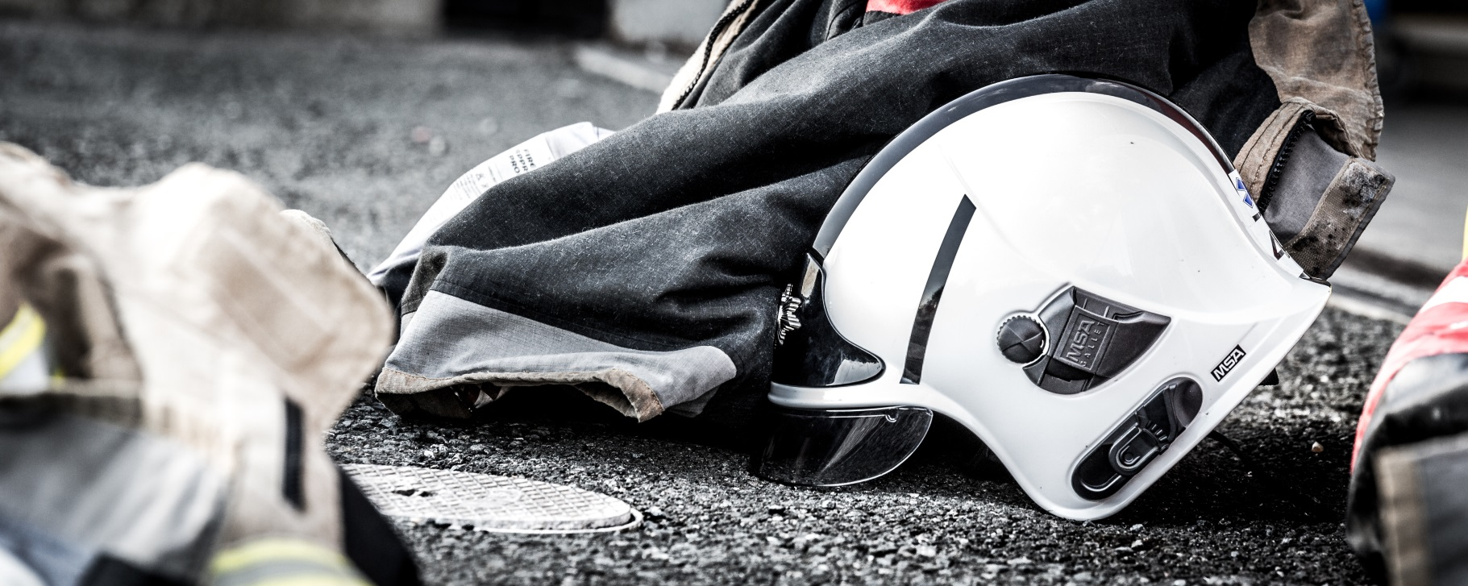

9. Our Development Intentions
What we want to do over the next 3 years and how we propose to achieve it
The financial challenge we face requires us to continually review the way that we deliver our services, so that we can continue to ensure that we provide the best possible fire and rescue service within the budget that is provided.
We have already delivered a programme to provide a joint capability for receiving 999 calls and mobilising our fire engines with Northamptonshire Fire and Rescue Service, and commenced collaborative work with Hereford and Worcester and Shropshire Fire and Rescue Services, and Warwickshire and West Mercia Police. The Home Office has given fire and rescue services strong messages about the need to collaborate with other blue light agencies; in particular the Police. This is now a legal duty. We will actively support the three pillars of Home Office fire reform:
- Efficiency and collaboration;
- Accountability and transparency;
- Reform of the workforce.
We intend to continually review the resourcing and location of our fire stations, fire engines and support structures and seek more efficient ways of delivering our emergency response service. We must increase our flexibility in how we respond to the range of incidents we now attend and maximise the utility and flexibility or our entire workforce. We must consider the impact that local area development plans will have on the demand for our services, and regularly develop our asset management plans to ensure that our response, protection and prevention arrangements are suitable and sufficient.
We realise that our staff are our greatest asset, and we need to ensure that they have the right skills and are available in the right places at the right time to crew our fire engines. We intend to continually review the way that our staff are deployed in order to provide the most efficient and effective arrangements for the delivery of our services. We recognise the particular challenge that recruiting on-call (RDS) firefighters presents to us in some areas of the county, and we will review our recruitment needs and practices to maximise fire engine availability.
Whilst reviewing the emergency response part of our Service is important, we intend to do so within a wider framework that considers the optimum organisational balance of resources. Regardless of size, every Fire and Rescue Service has to meet the same range of corporate demands. We will also consider our organisational capacity and capability against the learning outcomes of the Operational Assessment and Fire Peer Challenge we received in November 2016, and the challenging national agenda, such as the Home Office fire reform programme.
We regularly review and update the equipment that is provided to our firefighters to ensure they have the most effective tools to do their job. We will continue to consider new technologies and equipment that make our emergency response more effective, efficient and safer for firefighters.
We will never lose sight of our traditional responsibilities, but we recognise that there is an opportunity for us to provide wider social value with the resources we have available. We believe that our firefighters are ideally placed to provide emergency medical assistance through collaborative arrangements with the Ambulance Service, particularly in those areas where firefighters could get to someone in need before the arrival of an ambulance.
We know that those most at risk are impacted by wider social economic issues such as poor housing, health inequalities, education and environment. This is why, through evidence-based prevention work, we target the most vulnerable and disadvantaged members of our community. By using this approach, we have already demonstrated how we can improve the lives of people living with dementia, older people with physical impairments and troubled young people with youth offending history.
However, we know there is more that could be done. To be true to our core purpose of protecting the community and making Warwickshire a safer place to live and work we need to develop stronger links with our partners in health and social care in order to continue to deliver on the wider prevention agenda and to improve the quality of people’s lives in Warwickshire.
To achieve these intentions we propose to:

1. Identify further opportunities to develop collaborative working with other blue light services to enhance efficiency, effectiveness and public safety;
2. Continue to review the number, location and resourcing of our fire stations and fire engines;
3. Maximise the flexibility and utility of our workforce;
4. Develop the use of emerging technology;
5. Use our capacity to improve wider community health and social care outcomes.

The detail around the changes we propose to implement as a result of these areas of work will be communicated through IRMP Action Plans. This IRMP is launched with the Action Plan covering 2017/18.

The Action Plans for 2018/19 and 2019/20 will be subject to further consultation where appropriate.

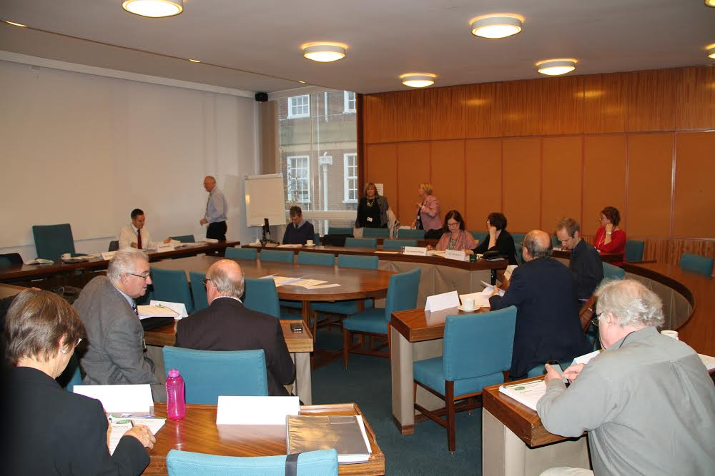
10: Consultation

10. Consultation – Have Your Say

Our approach to risk management is founded on a balanced strategy of prevention, protection and emergency response and our excellent performance tells you that this approach is very successful. However, the challenges over the next three years will require the organisation to adapt, change and work differently.
Within this IRMP, we have outlined a number of objectives on how we intend to develop the service, protect local communities and respond to emergencies. Engagement with the residents of Warwickshire and other key stakeholders is vitally important if we want to ensure that Warwickshire continues to be a safe place to live and work.
The accompanying Action Plan for 2017/18 details the changes we will make in the first year of the plan. The IRMP and Action Plan for 2017/8 have been subject to a 9 week consultation process, which concluded on March 10th 2017. The feedback received during the period of consultation has been considered, and the plan reviewed where appropriate.
You can follow us on Facebook and Twitter:
Facebook.com/warwickshirefireandrescueservice
Twitter.com/warksfirerescue
www.warwickshire.gov.uk/fireandrescue
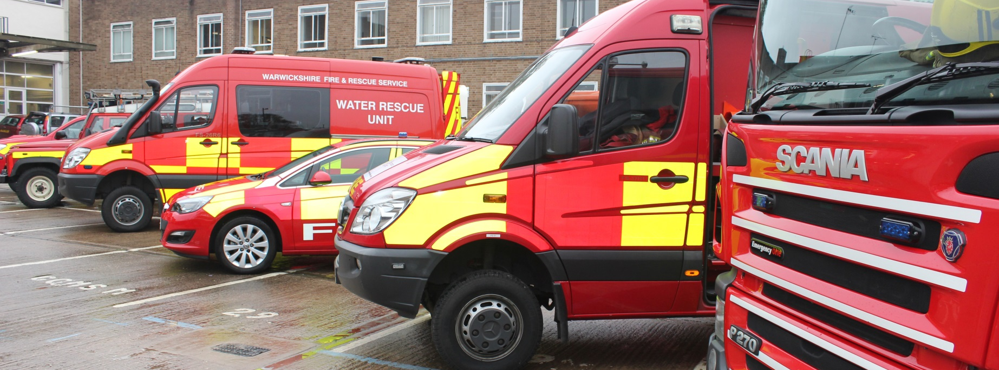
11. Glossary
Day Crewing Plus duty system – a duty system for full-time firefighters which provides the same level of fire engine availability as more traditional duty systems, but with less firefighters.
Efficiency savings – a change that results in doing more with the same amount of resource, or the same with less resource.
Emergency response model – the arrangements by which we provide an emergency response; includes location and availability of our fire stations, fire engines, firefighters and specialist equipment.
Exeter data – patient registration data that consists of the address, gender and date of birth of all over 65’s registered with General Practitioners.
False alarms – incidents where we are called to a location and discover on arrival that there is no emergency situation requiring our services.
Fire Control – the team of staff that use the latest communications technology to receive 999 calls and mobilise the nearest and most appropriate resources to the scene of the emergency. They maintain contact with the firefighters at the scene, providing additional resources and information as necessary. They liaise with other agencies and undertake a range of administrative tasks.
Hazardous substances – are defined as substances that are very toxic, toxic, harmful or irritant.
HS2 – high speed rail link that will pass through the Midlands.
Integrated risk management planning – the way that all fire and rescue services identify and manage the risks which impact upon their communities.
Light Rescue Pump (LRP) – a fire engine which looks similar to traditional fire engines and performs the same role, but is lighter and smaller.
Module 2 First Responder Water Rescue - qualification to use water rescue equipment whilst operating near, on or in moving water appropriate to the limits of wading rescue.
Mosaic – a tool for analysing the latest demographic and behavioural trends, used by the fire and rescue service to identify those citizens most likely to be at risk from fire.
Primary fires – includes home fires, business (non-domestic) fires, and vehicle fires. Involves property or vehicles, or fires where casualties or rescues have occurred. Also includes incidents where five or more fire engines are in attendance.
Retained Duty System (RDS) – the duty system that our retained firefighters work.
Retained (RDS) firefighters – firefighters who usually have primary employment elsewhere, but are available to respond to emergencies on an on-call basis from their home or work address.
One Organisational Plan - a corporate savings plan for Warwickshire County Council which incorporates Warwickshire Fire and Rescue Service.
Small Fires Unit– an off road 4 x 4 vehicle that provides the capability to extinguish small fires.
Special services – comprises an assortment of non-fire incidents, including events such as water rescue, animal rescue, chemical leaks, persons locked in/out and persons trapped in machinery etc.
Wholetime firefighters (WDS) – full-time firefighters, who are available for immediate response on fire engines.

WFRS would like to thank “Kamil Kaim” a Warwickshire resident and photographer for the use of his work throughout this document http://kamilkaimphotography.com https://www.facebook.com/KamilKaimPhotography/

