EQUALITY IMPACT ASSESSMENT/ ANALYSIS (EqIA)

Special Educational Needs & Disability (SEND) and Inclusion Strategy 2018-2023

Warwickshire County Council

Equality Impact Assessment/ Analysis (EqIA)

Group | Communities
Business Units/Service Area | Education & Learning, SEND & Inclusion
Plan/ Strategy/ Policy/ Service being assessed | SEND & Inclusion Strategy 2019-23
Is this is a new or existing policy/service?  If existing policy/service please state date of last assessment | New
EqIA Review team – List of members | Jane Carter, Ross Caws, Jonathan Wilding
Date of this assessment | 23rd October 2018

Signature of completing officer (to be signed after the EqIA has been completed)

Are any of the outcomes from this assessment likely to result in complaints from existing services users and/ or members of the public?  If yes please flag this with your Head of Service and the Customer Relations Team as soon as possible. | NO

Name and signature of Head of Service (to be signed after the EqIA has been completed)

Signature of GLT Equalities Champion (to be signed after the EqIA is completed and signed by the completing officer)

A copy of this form including relevant data and information to be forwarded to the Group Equalities Champion and the Corporate Equalities & Diversity Team

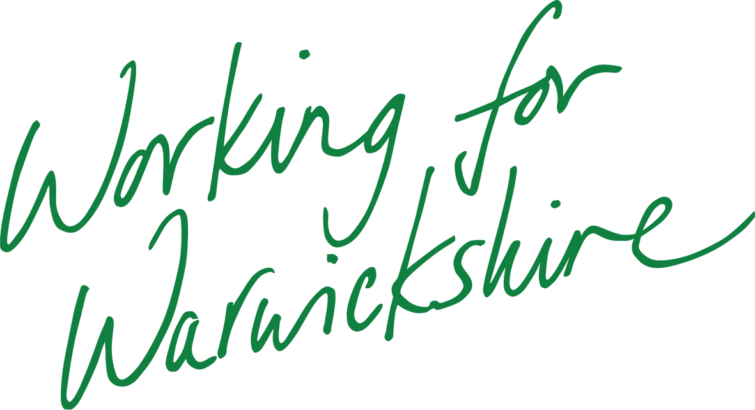


Form A1

INITIAL SCREENING FOR STRATEGIES/POLICIES/FUNCTIONS FOR EQUALITIES RELEVANCE TO ELIMINATE DISCRIMINATION, PROMOTE EQUALITY AND FOSTER GOOD RELATIONS

High relevance/priority Medium relevance/priority Low or no relevance/ priority

Note:
1. Tick coloured boxes appropriately, and depending on degree of relevance to each of the equality strands
2. Summaries of the legislation/guidance should be used to assist this screening process

Business Unit/Services: | Relevance/Risk to Equalities
State the Function/Policy /Service/Strategy being assessed: | Gender |  |  | Race |  |  | Disability |  |  | Sexual Orientation |  |  | Religion/Belief |  |  | Age |  |  | Gender Reassignment |  |  | Pregnancy/ Maternity |  |  | Marriage/  Civil Partnership (only for staff)
 | ✓ | ✓ | ✓ | ✓ | ✓ | ✓ | ✓ | ✓ | ✓ | ✓ | ✓ | ✓ | ✓ | ✓ | ✓ | ✓ | ✓ | ✓ | ✓ | ✓ | ✓ | ✓ | ✓ | ✓ | ✓ | ✓ | ✓
SEND & Inclusion Strategy
Are your proposals likely to impact on social inequalities e.g. child poverty for example or our most geographically disadvantaged communities? If yes please explain how. |  |  |  |  |  |  |  |  |  |  |  |  |  |  |  |  |  |  |  |  |  |  |  |  | NO
Are your proposals likely to impact on a carer who looks after older people or people with disabilities? If yes please explain how. |  |  |  |  |  |  |  |  |  |  |  |  |  |  |  |  |  |  |  |  |  |  |  |  | NO

Form A2 – Details of Plan/ Strategy/ Service/ Policy

Stage 1 – Scoping and Defining

(1) What are the aims and objectives of Plan/Strategy/Service/Policy? | The Strategy builds on the Vulnerable Learners’ Strategy 2015-18 and the Education Strategy 2019-2023. The aims and principles are to:  - work in a spirit of co-production and partnership with parents and their children and young people with Special Educational Needs and Disabilities (SEND), involving them in all key decisions;  - work in partnership with partner agencies and schools to deliver an effective SEND system that ensures effective early identification of need followed by robust assess- plan-do-review processes and clear pathways;  - have the highest expectations for children and young people with SEND, ensure that they are fully included in all educational settings and that their needs are met by high performing local schools;  - maintain a commitment to Warwickshire’s state-funded schools and academies, promoting and championing strong leadership and inclusive practice for children and young people with SEND across all phases, mainstream and special;  - ensure a rigorous focus on the preparation for adulthood outcomes and life after school;  - ensure that resources are fairly and consistently allocated according to needs.
(2) How does it fit with Warwickshire County Council’s wider objectives? | The strategy fits with the wider WCC One Organisation Plan targeting the most vulnerable and ensuring “Resources and services are targeted effectively whether delivered by the local authority, commissioned or in partnership”.
(3) What are the expected outcomes? | Our aspiration is  - For young people with SEND to lead a normal life and to be part of their community;  - For every child to attend a good local school;  - For children to be able to attend a mainstream school unless there is an overwhelming reason why this cannot happen. Whilst we are an inclusive authority, this does not mean we undervalue our specialist provision, which we recognise as an essential and valued component of our county’s education system; we will continue to work in partnership with our specialist education providers to ensure they provide excellent services for those pupils who are unable to attend mainstream schools.  - For every child and young person to have their health, social care and education needs met within their local community.  - For the views and wishes of children and young people with SEND and their parents to be heard. We will work with them to ensure that they have confidence in the ability of local providers to meet their children’s needs.  - That every early years setting, state-funded school, further education college and training provider will make good provision (as determined by Ofsted) for children and young people with SEND, ensuring that they make good progress in their education and development and that they transition smoothly into the next stage of their education and are helped to secure independent living and opportunities for employment as far as possible.
(4)Which of the groups with protected characteristics is this intended to benefit? (see form A1 for list of protected groups) | Children and Young People with SEND and their families
Stage 2 - Information Gathering

(1) What type and range of evidence or information have you used to help you make a judgement about the plan/ strategy/ service/ policy? | The strategy is informed by  - an External SEND Demand Management Strategic Review;  - work over four years with the SEND & Inclusion Board and Workstreams, consisting of key strategic partners across education (including schools, EY and FE settings), health, social care, the Parent Carers Forum;  - annual SEND workshops with a wide range of different partners including parents, Elected Members, settings and schools, both in Warwickshire and the Non Maintained Special School sector.  - work with young people, working alongside the Co-Production Officer
(2) Have you consulted on the plan/ strategy/ service/policy and if so with whom? | Six Planned consultation events in November and December 2018  Web consultation from 6/11/2018 to 17/12/18
(3) Which of the groups with protected characteristics have you consulted with? | The families of Children and YP with SEND.  Plans to consult with relevant voluntary sector organisations e.g. NDCS, RNIB, MENCAP, Scope, NAS, ILEAP, Take a Break etc.
Stage 3 – Analysis of impact

(1) From your data and consultations is there any adverse or negative impact identified for any particular group which could amount to discrimination?  If yes, identify the groups and how they are affected. | RACE  Neutral | DISABILITY  Positive | GENDER  Positive e.g. earlier identification of SEND and improved workforce development leading to heightened awareness of girls with ASC
 | MARRIAGE/CIVIL PARTNERSHIP  N/A | AGE  Positive: greater emphasis on Preparation for Adulthood and presumption of employability | GENDER REASSIGNMENT  Neutral
 | RELIGION/BELIEF  N/A | PREGNANCY MATERNITY  N/A | SEXUAL ORIENTATION  Neutral
(2) If there is an adverse impact, can this be justified? | N/A
(3)What actions are going to be taken to reduce or eliminate negative or adverse impact? (this should form part of your action plan under Stage 4.) | N/A
(4) How does the plan/strategy/service/policy contribute to promotion of equality? If not what can be done? | Promoting Inclusion. Wherever possible children and young people with SEND will be educated alongside their peers. We expect all providers to use best endeavours to ensure high quality educational provision so that parents can be confident that this is in place for all learners at SEN Support and for those with EHC Plans.  Delivering outcomes for school age learners with high needs. Identification and assessment of need will be effective and joined up across agencies at SEN support, early help and through the statutory Education, Health and Care (EHC) Plan process  Workforce Development. Building confidence in the system through strategic development of the workforce in schools and settings.  Improving health and social care for learners with SEND, working with our partners to see the holistic needs of the child and improving our local offer of services.  Preparation for Adulthood. We will promote with partners opportunities to develop resilience and learn to be as independent as possible and fulfil their potential as they transition to adulthood. This will inform our joint commissioning activities. We believe that the overwhelming majority of young people with special educational needs and disabilities (SEND) are capable of sustainable paid employment, with the right preparation and support. With our partners, we want to embed this ‘presumption of employability’, by ensuring there are significantly increased opportunities for our learners with SEND as they enter adulthood  Transport. Ensuring that the local authority meets its statutory obligations, works within allocated resources and seeks to remove transport issues as a barrier to success and independence.
(5) How does the plan/strategy/service/policy promote good relations between groups? If not what can be done? | Wherever possible we are committed to children and young people being taught with their peers in their local community school or as close to home as possible. Children and young people rate their social relationships as the most important aspect of their education. Being educated locally with their peers promotes social inclusion, increasing the opportunities for local friendship groups and maximising the longer term benefits for social integration and emotional wellbeing.
(6) Are there any obvious barriers to accessing the service? If yes how can they be overcome? | The inconsistent inclusive practice that was identified back in 2015 in the Vulnerable Learners Strategy has persisted and, in some schools, continues to be an issue. The Delivery Plan accompanying the Strategy outlines specific activities to address this inconsistency.
(7) What are the likely positive and negative consequences for health and wellbeing as a result of this plan/strategy/service/policy? | We believe that all children should be educated as close to their home as possible, which not only reduces the time they spend travelling, but also enables them to be an integral part of their local community, where they are able to feel welcomed, included and valued as equal members of society.  Although bullying is an unfortunate feature of any type of community life there is evidence that young people who attend a segregated special school experience far more bullying by children from other mainstream schools and from peers and outsiders in their neighbourhood.
(8) What actions are going to be taken to reduce or eliminate negative or adverse impact on population health? (This should form part of your action plan under Stage 4.) | N/A
(9) Will the plan/strategy/service/policy increase the number of people needing to access health services? If so, what steps can be put in place to mitigate this? | More joined up, effective and timely identification will impact on health services, for example, referrals to RISE, however, this is consistent with the SEND Code of Practice. Earlier proactive intervention, however, is about mitigating reactive high cost provision.
(10) Will the plan/strategy/service/policy reduce health inequalities? If so, how, what is the evidence? | Yes. For example:  More Young People with SEND in work; employment is a positive indicator in relation to health outcomes, in particular, positive mental health.  Earlier, more joined up identification and referral to appropriate services should lead to more timely interventions.

Stage 4 – Action Planning, Review & Monitoring

If No Further Action is required then go to – Review & Monitoring  (1)Action Planning – Specify any changes or improvements which can be made to the service or policy to mitigate or eradicate negative or adverse impact on specific groups, including resource implications. | No further action
(2) Review and Monitoring  State how and when you will monitor policy and Action Plan
  Review and Monitoring | Lead Officer | Date for completion | Progress Measures
  Oversee and review the SEND & Inclusion Strategy impact | SEND & Inclusion Board Chair | Half-Termly | % of school age learners in mainstream school with EHC plan;  % permanent exclusions from school for pupils with SEN Support & EHC Plans; number of supported internships.

Please annotate your policy with the following statement:

‘An Equality Impact Assessment/ Analysis on this policy was undertaken on (date of assessment) and will be reviewed on (date three years from the date it was assessed).

Previously called the “SEND Reform Board” and the “SEND Programme Board”

