Warwickshire Careers Strategy
2019/20-2024/25

Consultation Draft

Warwickshire Careers Strategy (2019/20-2024/25)

1 INTRODUCTION
Warwickshire County Council recognises the importance of careers advice and employability skills, and has invested over a number of years in our Skills for Employment programme to support schools, colleges and employers to work more closely together. Following the publication of the National Careers Strategy in 2017, we have identified the opportunity to develop a more localised Careers Strategy for Warwickshire, which is focussed on the key opportunities and challenges that exist within the county and which builds on the strong foundations that we have laid with our partners over the past few years.
This is an all-age strategy, focussing on supporting both our adult population who may want or need to change careers during their working life, and our young people as they prepare for the world of work. We also recognise that this world of work is changing rapidly as technology progresses at an exponential rate. Indeed, it is estimated that 65% of children entering education now will enter into jobs that currently do not exist. Given this rate of change, our draft Careers Strategy is also deliberately forward looking and promoting those key transferable skills and competencies that are increasingly being recognised as being foundational for future employment.
Finally, Warwickshire County Council is also committed to ensuring that we support our whole population to be safe, healthy, and independent and to be able to fulfil their potential. Through this Careers Strategy, we would like to place a particular focus on supporting our more vulnerable residents (such as those with Special Educational Needs & Disabilities) to move into employment.
We welcome all feedback and comments to help us make sure we get this strategy right for the residents, businesses and key organisations and stakeholders of Warwickshire. A short online survey where you can comment and give your views are available at:
www.warwickshire.gov.uk/ask
The online survey is open for completion from 19th June to 26th July 2019. Alternatively, a printed version can be posted to you for return by pre-paid post or handing in at your local library. To request a printed version please e-mail skillsforemployment@warwickshire.gov.uk or call 01926-418027.
If you have any queries about the consultation, or have difficulty accessing the online survey please email: skillsforemployment@warwickshire.gov.uk or call: 01926 418027.
2 BACKGROUND

Effective careers and employability advice and support are critical components of a successful local labour market. They can help to:
- enable the development of the skills within the local population demanded by local businesses;
- enable individuals to identify and pursue Careers that stimulate their interest and match their particular talents;
- facilitate social mobility by raising aspirations and showcasing career pathways; and
- support individuals who want (or need to) change occupations as the economy grows and changes.
Careers and employability advice and support also provide clear social and economic benefits. Numerous studies have shown that high quality careers support, along with effective interactions between young people and employers can: improve educational attainment; increase the likelihood of successful employment outcomes (and reduce negative destinations for people leaving education); and increase lifetime earnings. This is particularly important for our most vulnerable learners – such as those with special educational needs and disabilities, looked after children and those with wider social, emotional and mental health needs – where the evidence shows that employment rates within these groups after education is much lower than the average.
Furthermore, businesses routinely talk of skills shortages, the difficulties they face in finding and employing people with the right skills sets, and the negative impact that this has on the growth of their business. A recent business survey by the Council and the Coventry & Warwickshire Chamber of Commerce identified that nearly two-thirds of companies in the area were facing some form of skills shortage within their workforce. The Council is committed to ensuring Warwickshire communities and residents are supported to be safe, healthy and independent (particularly our most vulnerable residents). It is also committed to ensuring the Warwickshire economy is vibrant and supported by the right jobs, training, skills and infrastructure. This Warwickshire Careers Strategy therefore sets out our ambitions to work with our partners to develop and deliver a coherent, effective and locally relevant careers and employability advice and support.

3 THE CURRENT POSITION

- The Warwickshire Economy:
Warwickshire has a strong and growing economy. Indeed, since the recession of 2008/9, the County has experienced some of the strongest economic growth (as measured by Gross Value Added) of all local authority areas in England, including the fastest growth in productivity of all areas.
This growth in the economy has led to a very strong labour market, with our employment rate (the proportion of working age residents in employment) rising strongly to the highest levels seen this century, and unemployment to its lowest levels – see Figure 1 below.
The number of vacancies posted online for employment opportunities within the county have also been growing, and the ratio of vacancies to working age population is significantly above - and almost double - the national and regional averages (Figure 2).
A tight labour market with limited excess capacity, coupled with strong demand for labour, inevitably leads to problems with recruitment and skills shortages. Recent surveys of local businesses have found that 70% of companies were facing recruitment difficulties due to not being able to find people with the right skills that they required, and that 62% of businesses believed that their firm was suffering from a skills shortage.
Improving the flow of new entrants into the labour market with the skills and behaviours being demanded by our local businesses is therefore critical to helping address these difficulties being faced in the local economy. We also need to encourage businesses to consider recruitment from a wider pool of labour, including those with health and learning disabilities. Finally, helping employees and adults to explore alternative careers and undertake training to take up employment opportunities in demand will also help address this imbalance between supply of labour and demand from businesses.

Table 1: Employment & Unemployment Rates in Warwickshire (2004-2018)

Source: Annual Population Survey

Table 2: Job postings per 1,000 population
Source: Labour Insight & ONS
- Technology & future economic growth
Local Industrial Strategies are being developed at both the regional/WMCA level, and also at the Coventry & Warwickshire Local Enterprise Partnership area. A key focus of these is around longer-term, future growth opportunities and the new technologies and industries of the future in which the UK could become a world leader. Coventry & Warwickshire are extremely well placed with respect to the development of low carbon vehicles; connected and autonomous vehicles and future transportation systems; digital technology (including gaming, augmented reality and virtual reality); and smart & connected factories/automation.
These are all industries that have huge economic opportunities, but which will also be highly disruptive, and have a significant impact on the future labour market. Moreover, the technologies are developing at an exponential rate, making it increasingly unclear what future occupations and careers might look like. Indeed, a study by the World Bank estimated that two-thirds of children entering primary education today will go into jobs that do not yet exist.
Automation of activities and occupations is also starting to take effect, with artificial intelligence and robotics able to effectively replicate many tasks that humans currently do. This technology is also developing rapidly, and a number of studies have been undertaken recently examining the type and scale of occupations that could potentially be automated. We have replicated these studies at the Warwickshire level, and estimate that around 40% of all our current occupations are at a high risk of being automated by 2030. This is greater than the national average, largely due to the sectoral composition of our economy which means we have higher than average employment in sectors at high risk – such as distribution, logistics, tourism, and skilled manual trades.
Automation presents both opportunities in terms of economic benefits from developing and exploiting the technologies (which Warwickshire is well placed to do and will feature in our Local Industrial Strategy), but also risks in terms of displacing a wide range of existing occupations – which are often those at the lower skilled level. Retraining of existing employees in these occupations to be able to move into new careers will therefore be vital, along with helping to “future-proof” education and skills training now so that young people are more able to adapt to a rapidly changing labour market.
Research has identified four key skills sets that will be critical in terms of future employment. These skills sets focus on functions and activities that are difficult to automate, and also provide individuals with a flexible skill base that will enable them to effectively more through different careers. The skills sets identified are set out below.

Key Future Skills
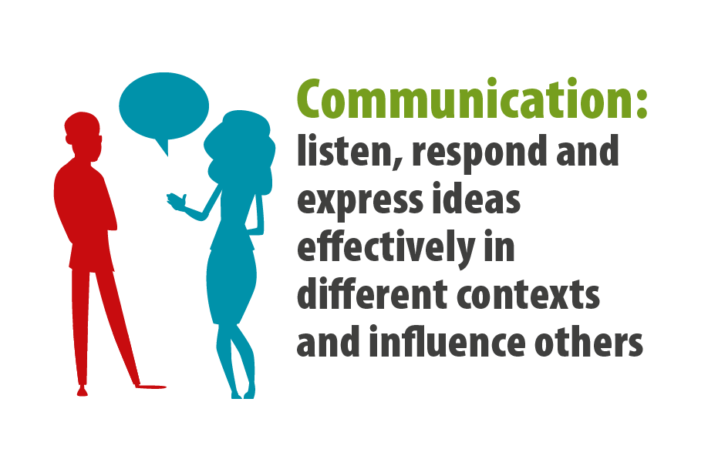
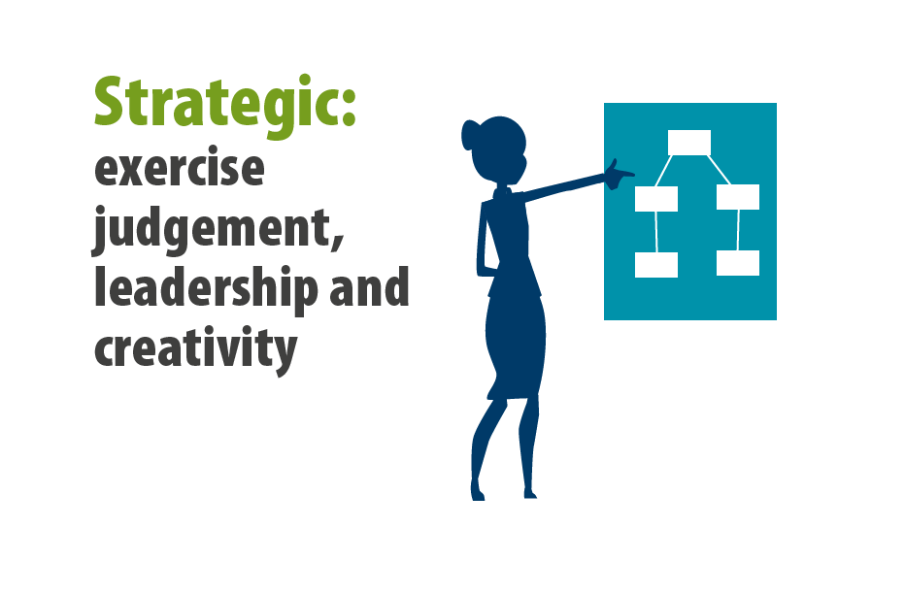
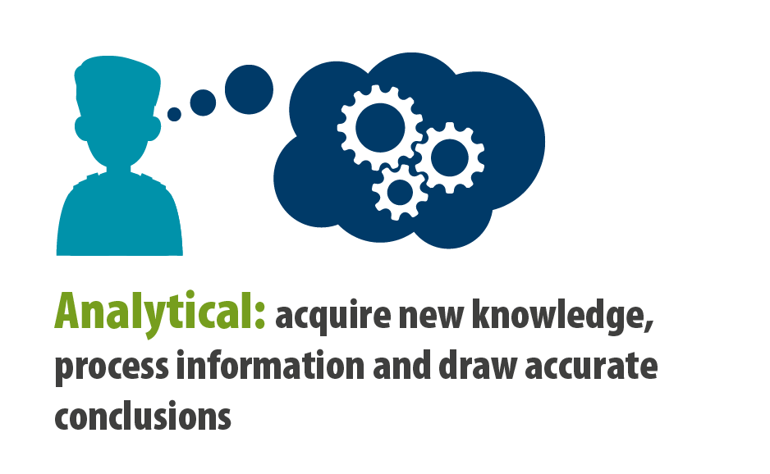
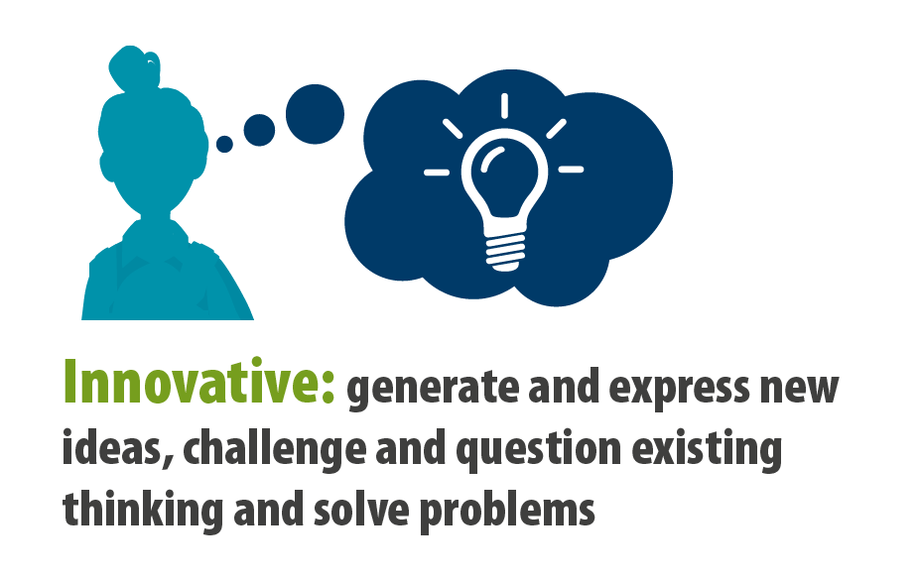

Underpinning these four core skills sets is the importance of digital skills, and a need to embed a digital culture within the workplace. According to Microsoft, in the next two decades, 90% of jobs will require some form of digital skills, and without further action to significantly increase understanding of programming (understanding the “how”, rather simply the “what” through increased utilisation), the skills gap is likely to continue to increase significantly.

- Careers and Education policy
The Government published a new National Careers Strategy in December 2017. This strategy sits alongside the new Industrial Strategy, and seeks to support the Government’s ambition to improve social mobility by ensuring that everyone has access to effective careers support. Through this strategy, the Government aims for:
- all young people to understand the full range of opportunities available to them, to learn from employers about work and the skills that are valued in the workplace and to have first-hand experience of the workplace;
- all young people in secondary school and college to get an excellent programme of advice and guidance that is delivered by individuals with the right skills and experience;
- everyone to get support tailored to their circumstances. All adults should be able to access free face-to-face advice, with more bespoke support for those who most need it
- everyone to get the information they need to understand the job and career opportunities available, and how their knowledge and skills can help them in considering suitable Careers.
The Government are also progressing plans to introduce a new education route through the development of “T Levels”. T Levels will follow GCSEs, will be equivalent to 3 A Levels, and will be 2-year courses focussing on technical education and training. The courses are being developed in collaboration with employers and businesses to that the content meets the needs of industry and prepares students for work. T Levels are expected to be introduced from 2020, although it will take a number of years until the full range of courses are available.
The development of this Warwickshire Careers Strategy will therefore help support the local implementation of the national strategy and enhance the delivery of Warwickshire relevant careers information and support to help young people navigate the increasing choices that they will be able to make as part of their journey through the education system. The Warwickshire Careers Strategy is also a fundamental component of the recently developed Warwickshire Education Strategy for 2018-2023, which includes a specific priority around employment outcomes (WE4: Our challenge is to champion employability by promoting the best opportunities for all learners).
In addition, the West Midlands Combined Authority is currently considering developing a new regional all-age Careers service, and a regional Careers Strategy. The development of a Warwickshire Careers Strategy will enable us to effectively influence, shape, inform and ultimately maximise the benefit from this regional approach.

4. VISION & PRIORITIES:
Our vision for this strategy is that:
“We want to ensure that all residents of Warwickshire are able to access the education and skills they need to enable them to secure fulfilling, appropriate, sustainable and well-paid employment throughout their lives, which supports the growth and prosperity of Warwickshire’s economy.”

By following this vision, and successfully implementing this strategy for residents of all ages, we hope to achieve the following key success measures:
- All young people within our schools, colleges and universities have access to high quality, relevant, inspiring and locally focussed careers information, guidance and support and are able to make informed choices
- All our young people successfully transition from education and learning into sustainable employment
- Our most vulnerable learners are particularly supported with this transition, and achieve positive destinations appropriate to their needs
- Our businesses are able to access the skilled labour that they need to grow and compete
- Our residents are able to develop and acquire new skills throughout their lives to meet the rapidly changing labour market. This applies to those in work who wish to progress or switch roles, those seeking work and those who are or wish to be self-employed.

We aim to achieve this by focussing on the following five key priorities:
- Raising the awareness of the range of career and employment opportunities locally, inspiring residents of all ages to develop their education and skills as far as possible

- Building the capacity of our education providers to deliver effective and sustainable Careers support and advice

- Providing targeted support and help to our most vulnerable learners

- Improving alignment of demand and supply of skills, now and in the future

- Encouraging and enabling businesses to recruit from a richer and wider talent pool

The following provides an overview to each of these five key areas, and summarises our key ambitions for activity. A more detailed Implementation Plan will sit alongside this strategy, outlining the shorter-term activities to drive this strategy forward.

4.1 Raising the awareness of the range of career and employment opportunities locally, inspiring residents of all ages to develop their education and skills as far as possible
Current existing careers information is relatively poorly marketed and promoted so that there is limited awareness and understanding of what is available, it can seem somewhat remote and detached from the real world that people find themselves in, and is often fairly generic and does not highlight the particular local economic opportunities and circumstances of Warwickshire.
Warwickshire’s economy is particularly dynamic and vibrant, with a huge range of activity in many areas of cutting edge technology, new business areas and disruptive industries. We want to excite our population – young and old, children and parents - about the range of opportunities and career pathways that exist in the county. We want to people to find the occupations that will engage and interest them, enabling more fulfilling and productive careers. Finally, we want to ensure that we capture and retain the local talent that we have in the local area.
A key focus of this priority will therefore be around developing a new, localised careers information service which is effectively marketed and promoted. It will be important that this service does not seek to duplicate or replace existing platforms (such as the National Careers Services), but adds value and acts as local hub that helps guide and signpost individuals to the most appropriate support, aided and supplemented with local economic and labour market information.
4.2 Building the capacity of our education providers to deliver effective and sustainable Careers support and advice
The National Career Strategy has placed greater requirements on education providers to provide careers support and advice, and the quality of provision will become an increasingly important part of inspections by OFSTED on schools and colleges. However, we know that our education providers face significant financial challenges and competing pressures for time and resources. We therefore want to work with our providers to develop an effective and appropriate support function that helps add value to their planned activity, and enables and facilitates the development of effective and sustainable careers support and advice. The County Council funded Skills for Employment programme will provide a strong focus for this activity, working in partnership with the Careers and Enterprise Company and other key stakeholders.

4.3 Providing targeted support and help to our most vulnerable learners
Our most vulnerable learners, on average, have poorer positive outcomes from education than their wider cohort. For example, the proportion of 16 & 17 year old Children Looked After who were Not in Education, Employment or Training (NEET) in 2017/18 was just under 20% in Warwickshire in 2017/18, compared to the average for all 16 & 17 years of just 3.8%. According to the British Association of Supported Employment, only 5.7% of people with Special Educational Needs and Disability (SEND) go into paid employment, despite 78% of people with SEND wanting to be in such employment. Given the average cost of putting a young person through a Special School education (upwards of £365,000), and the cost to society through lost income and increased social support, this is a significant loss of potential talent that could be utilised by businesses in an area that is facing a tight labour market and recruitment difficulties.
There are huge opportunities to work pro-actively with our education providers, vulnerable learners and businesses to better identify and promote employment and career opportunities, and to put in place support packages that help all three parties to enable significant improvement in the proportion of vulnerable learners to enter into sustainable employment. This priority will focus on developing a co-ordinated approach to this ambition.

4.4 Improving alignment of demand and supply of skills, now and in the future
Ensuring that our local education and training providers effectively provide the skills being demanded by our business base is critical to continued growth of our economy, and the employment prospects of our residents. However, within a dynamic labour market and with rapidly changing technologies, it can be hard for businesses to clearly articulate future skill requirements, and for education & training providers to adapt and change as demands change. Improving the connection between businesses and education - particularly in terms of communication flows and translating between the two very different cultures and language of education/training and business.
There is also a need to take a future-scanning role, looking at forecast and anticipated change in the economy and the different occupations and skill requirements that may be required. We also need to consider how changing technology, and the increase of automation, artificial intelligence and machine learning could transform occupations and require different skills sets, or even entirely new jobs that currently do not exist.
This priority will therefore focus on improving both the conversations and connectivity between education and business, and also look to future changes in the labour market and how we can seek to adapt and change our education and training provision in line with this in a strategic, considered and evidence based manner.

4.5 Encouraging and enabling businesses to recruit from a richer and wider talent pool, and to undertake training and development of their employees
With so many businesses in the local area regularly reporting skills shortages and recruitment difficulties, we need to work with employers to consider how they can widen their search pool of potential candidates.
Within Coventry & Warwickshire, there are over 130,000 people of working age but who are economically inactive for a variety of reasons (health conditions, disabilities, students, lifestyle choice, etc.). Some 25,000 of these have actively stated that would like to work, and it is likely that many others would be interested in employment if suitable arrangements and flexibilities could be put in place to meet their particular needs.
Many businesses have already benefitted from employing from this wider workforce and we need to better promote the opportunities that are available, and the help and support that can be secured to enable any required adjustments needed to job roles and the physical workplace.
This priority will therefore focus on raising awareness of the opportunities for business, and helping create new and enhanced careers and employment options for a wider range of Warwickshire residents.

5 MONITORING IMPACT AND SUCCESS
Measuring the impact of effective careers information and advice is difficult, as many academic studies have concluded. This is because it is often hard to clearly associate cause and effect over a sustained period of time, when many other factors and influences could be involved. It is also difficult to clearly articulate what a success might look like at the strategic level, given that these are often personal to the individual and hard to aggregate. Finally, there is difficult to identify a suitable “counter-factual” or control group with which compare outcomes against. Not only would we seek to ensure as many people as possible accessed effective careers and employment support and advice (and therefore consciously seeking to minimise a control group), it is very difficult and resource intensive to track people over the period of time that would be needed to really monitor and review impacts.
Based on these difficulties, we therefore propose to use a mixture of output data that is related to undertaking particular activities (i.e. number of students having an employer engagement experience, number of people accessing careers support, etc.), and a number of high level impact indicators (such as reduction in young people who are NEET, or the proportion of businesses reporting skills shortages). The link between these is explained through the logic chain, shown in Figure 2 below. Given the difficulties identified above, we are not stating that the outputs and the impacts are conclusively linked (even accounting for the time lag that would clearly exist between the two). Instead, we are suggesting that if we undertake the activities proposed both in this strategy and the accompanying Implementation Plan then, all other things being equal, we should see an improvement in the strategic impact indicators detailed in Figure 2.

Figure 2: Logic Chain Diagram
Through the implementation of our strategy, we will see…
…which, all other things being equal, should lead to…
…which in the long-run will help impact on…
ACTION
OUTCOME
IMPACT
- More people better aware of career opportunities in Warwickshire, and have access to employability activities and training
- Education providers more able to provide high quality and effective careers and employability support
- More young people (including vulnerable learners) have engagements with employers
- Stronger links between education and training providers and local employers
- Businesses better able to shape and inform skills and education activity locally
- Businesses recruiting from a wide and diverse talent pool
- People making more informed decisions about education & training, leading to better choices and more engaged learners
- Businesses more able to recruit people with the skills/aptitudes they want
- Education and training provision more aligned with the local economy
- Increase in use of apprenticeships by businesses, and take up by Warwickshire residents
- Increased retention of HE and FE graduates within the local economy
- Fewer young people not in education, employment or training (NEET)
- Fewer vulnerable learners not in education, employment or training (NEET)
- Lower levels of unemployment within the county
- Businesses reporting fewer skills shortages and recruitment difficulties
- Productivity of the local economy improves
Outputs:
- Number of visits to new careers website
- Number of young people benefitting from careers & employability activities
- Number of businesses engaged to support
- Number of projects/ initiatives undertaken
Outcomes:
- % of Warwickshire schools meeting new careers requirements
- % of schools reporting improvement in their careers provision yr on yr
- % improvement in awareness and perceptions of careers options by surveyed pupils, and from Careers Leaders
- Increase in apprenticeships
- Increased graduate retention locally
Impacts:
- NEETs levels better than national average
- Increased % of vulnerable learners achieving positive destinations
- Unemployment rate (16-64 year olds)
- Unemployment rate for 16-24 year olds
- % of businesses reporting skills shortages
- GVA per job filled increases

6. GOVERNANCE
This Warwickshire Careers Strategy will be overseen by the new Warwickshire Employability & Skills Group, which is contained within the wider governance model for the Warwickshire Education Strategy.
The Warwickshire Employability & Skills Group seeks to bring together a range of partners and stakeholders from education providers, public sector and key intermediary bodies. The voice of businesses will be clearly articulated to the Board by regular engagement and discussion with business groups, networks and sector bodies across the county.

7. DELIVERY
An annual Implementation Plan will be developed, setting out the identified key activities under each of the five priorities. A copy of the proposed Implementation Plan for 2019/20 is contained within Appendix A.

Warwickshire Careers Strategy Implementation Plan: 2019/20

Strategic Vision
We want to ensure that all residents of Warwickshire are able to access the education and skills they need to enable them to secure fulfilling, appropriate, sustainable and well-paid employment throughout their lives, which supports the growth and prosperity of Warwickshire’s economy.

Strategic Priorities
We aim to achieve this by focussing on the following five key priorities:
- Raising the awareness of the range of career and employment opportunities locally, inspiring residents of all ages to develop their education and skills as far as possible

- Building the capacity of our education providers to deliver effective and sustainable Careers support and advice

- Providing targeted support and help to our most vulnerable learners

- Improving alignment of demand and supply of skills, now and in the future

- Encouraging and enabling businesses to recruit from a richer and wider talent pool

Strategy Implementation Plan 2019/20
Strategic Priority | Tactics/activities | Output/Outcome Measure(s)
- Raising the awareness of the range of career and employment opportunities locally, inspiring residents of all ages to develop their education and skills as far as possible | Develop a new, locally relevant “Careers Portal” on the WCC website. This would provide information on key sectors and careers opportunities locally, provide labour market information, and provide clear links to the range of existing support services (especially the National Careers Service).  Implement year-round Communications campaign to promote the Careers Portal and raise awareness of the various careers and development opportunities that exist within the county, and the range of support services available through partners organisations and WCC.  Help enable schools and colleges to meet the requirements of the national Careers strategy by providing grants and Careers Leader development activity/resources through the WCC Skills for Employment Programme  Undertake and support projects and initiatives (such as My Hospitality World, My World of Work, TeenTech, Digital Schoolhouse, Digital Skills in North Warwickshire, Maker Space, etc.) to raise awareness and understanding of different career opportunities and pathways in the county  Seek to secure further funding of Skills for Employment activities from 2020, or develop legacy/exit plans | - Visits to new landing page and clicks through to each delivery organisation  - Number of people participating key initiatives, such as Digital Schoolhouse, My Hospitality World, TeenTech, Maker Space, etc.  - Number of businesses engaged in activities to support careers and employability activity  - Number of case studies/career journeys developed as content on website and for promotional activity  - Increased number of apprenticeships, particularly at Higher and Degree level  - Increased number of graduates staying within Warwickshire
- Building the capacity of our education providers to deliver effective and sustainable Careers support and advice | Provide small grants to schools and colleges through the Skills for Employment Programme to support development and implementation of careers activity  Develop and promote new materials (e.g. Hospitality & Tourism Careers film) and initiatives (e.g.TeenTech) to inspire and engage Careers Leaders and teaching staff  Support FE, Unis and ITPs to introduce more Degree/Higher Apps needed by future economy  Develop stronger links with CEC activity, and explore opportunities to secure funding/support for Warwickshire schools  Support business/education collaboration (particularly in our more deprived areas) to enable education leavers to find employment | - Number of grants awarded to schools/colleges  - Number of Careers Leaders taking advantage of training and development activity  - Number of schools meeting new requirements under National Careers Strategy  - Increase in awareness and improved perceptions about employment opportunities in key sectors by pupils and by Careers Leaders.  - Number of business/education collaborations undertaken
- Providing targeted support and help to our most vulnerable learners | Develop “Supportive Employers” forum to co-ordinate activity and engage businesses to explore opportunities to be more supportive employers  Increase provision of Supported Internships and accessible apprenticeships  Explore potential for ESF to support progression to employment programmes, and possible extension to Active Inclusion and Positive Futures projects  Continue the NEET co-ordination group to ensure a joined up approach to activity and monitoring.  Support uptake of apprenticeships for more vulnerable learners as part of the County Council’s Small Business Apprenticeship Support Programme. | - Number of businesses engaged to be supportive employers  - Numbers of vulnerable learners securing employer engagement activities  - Number of vulnerable learners moving into positive destinations  - Ensuring % of 16 & 17 year olds NEET is in line with or better than statistical neighbours  - Positive Futures programme for 15-24 year old NEETS meets its targets of 780 individuals supported. Planning completed for successor programme to deliver from 2020.
- Improving alignment of demand and supply of skills, now and in the future | Implement year-round Communication campaign for business highlighting Skills information, issues and support available e.g. Small Business Apprenticeship Support Programme, to enable sharing of WCC Apprenticeship levy  Continue to develop and enhance local labour market intelligence to make it more accessible and understandable  Seek to expand Digital Schoolhouse and engage with other priority sectors to identify their future skills requirements and develop career pathways sectors  Develop and implement the North Warwickshire Digital Skills Project  Work with Coventry and Warwick Universities to enable more graduates to be recruited by employers | - Number of businesses engaging with schools  - Career pathways and sector skills plans developed  - Increase in number of apprenticeships  - Increase in local graduates obtaining jobs in Warwickshire reported by HESA/universities  - Increase in Higher and Degree apprenticeships provided by employers (volumes reported by Skills Funding Agency).  - Labour Market Intelligence reports developed and promoted
- Encouraging and enabling businesses to recruit from a richer and wider talent pool | Continue to increase employer awareness of Advanced and Degree/Higher Apprenticeships and how they can recruit Year 11-13 leavers to jobs with these apprenticeships  Establish “Supportive Employers” Forum and implement Warwickshire Recognition Scheme  Develop improved local recruitment activity from FE and HE  Continue Business Skills Advisor support to increase engagement with SMEs and support their skills and employment needs.  Deliver the County Council’s Small Business Apprenticeship Support Programme to help support uptake of apprenticeships within the county, with a focus on priority sectors and on supporting vulnerable learners. | - Number of business engaging in “supportive employers” initiative  - Number of businesses engaging with new recognition scheme  - Uptake of WCC Apprenticeship levy sharing and number of new apprenticeships supported  - Increased number of vulnerable learners in employment  - Increased apprenticeships  - Number of business supported through Business Skills Advisor

