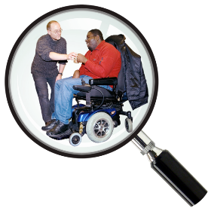  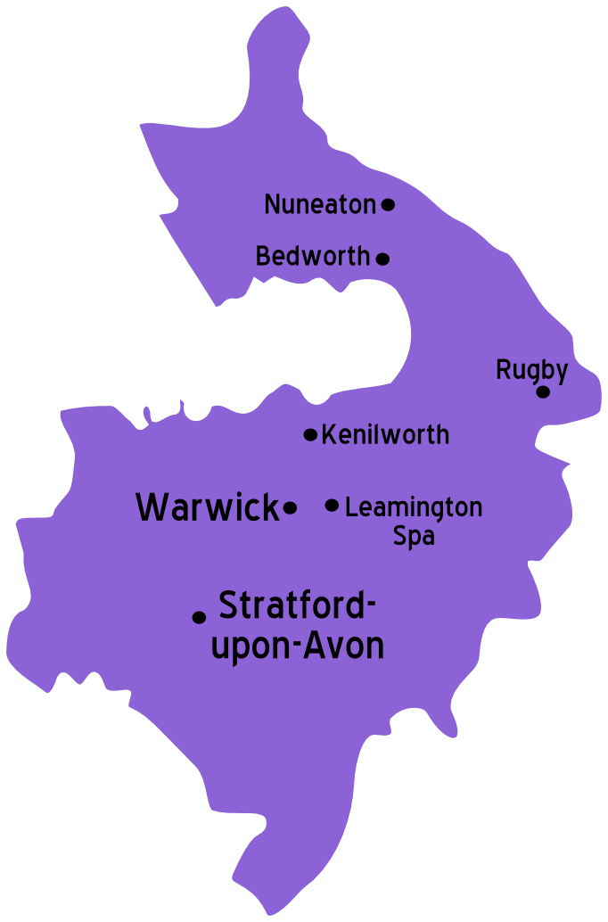 | We are looking at the support adults have in the community across Warwickshire.  We are doing this to make sure the services meet everyone’s needs.  This could be support at home, day service support or respite.
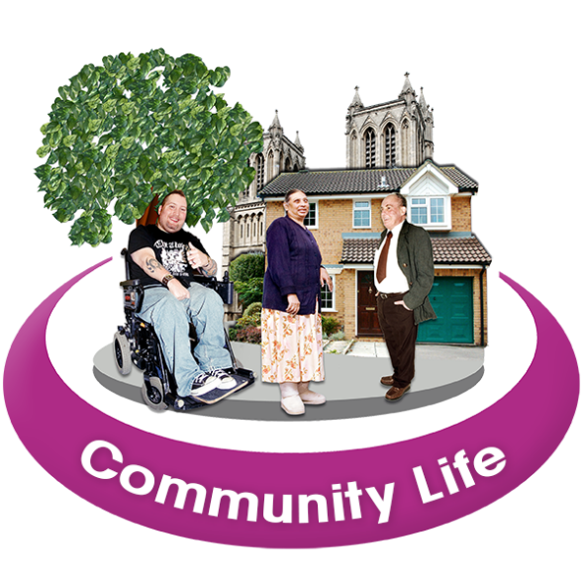 | What have we done so far?  Throughout October- December 2020 we spoke to people who use these services, families and carers and social work teams.  We have spoken to people online and on the phone to find this out. We held 46 online groups.  We also made a questionnaire for people to tell us what they think.  We had over 290 responses about services in Warwickshire.  What did we ask?  We asked people what is working well and what could be better.  We asked people what they would like to do in the future and what support they needed to make this happen.  What did you say?  People told us that these are what are important to them:  Community Activities  People told us they want to know what there is in their local community and be able to join this.  People also told us they wanted more to do in the evening and weekends.  Transitions  People told us that moving from children services to adult services can be difficult for some.  More information on what services are available would be helpful.  Families also told us that more support to prepare people for when families can no longer care for them was important.  Using Direct Payments  Some people spoke to us about their Direct Payment. They liked that they could choose how the money was spent on their support.  Some families also told us it is a lot of responsibility to manage money this way- especially when people have their own PAs.  Becoming more independent  People told us about lots of ways they would like to become more independent:  - Finding a job/ volunteering doing something that matched their likes/ hobbies.  - Those that are volunteering would like support to find paid jobs.  - Support for people to understand how they can keep themselves healthy.  People we spoke to told us they didn’t know much about Assistive Technology and how this can help some people be independent.  Assistive Technology is any device or equipment that helps people with daily living. For example, a talking clock or medication dispensers.  Transport  Lots of people told us that transport is important to their support. The right transport is needed to be able to access support and activities.  Choice of Services  People told us that having a choice of services across Warwickshire was important.
What next?
We will talk to people again between February - March so we can make sure the plan for future services meet your needs.

