DRAFT Warwickshire Health and Wellbeing Strategy 2020-2025
Foreword from Councillor Les Caborn, Chair of Warwickshire Health and Wellbeing Board
Our new Health and Wellbeing Strategy presents a real opportunity to make a difference to the health and wellbeing of everyone in Warwickshire. The Strategy has been produced in collaboration with Health and Wellbeing Board partners in a context of change which brings both challenges and opportunities. Much has happened since our first Strategy in 2014. There is significant pressure in the health and care system and the public sector more widely because of increasing demand and reducing capacity. This has been further amplified by the Covid-19 pandemic which has radically changed how society functions.
As we start to rebuild communities and reset services as part of our recovery from the COVID-19 pandemic, even more importance needs to be placed on tackling inequalities in health and creating engaged and cohesive communities that are able to thrive despite the ongoing challenges we all face. Helping our children and young people to get the best start in life is key to this, as is supporting people to look after their mental health and wellbeing particularly as 1 in 3 visits to mental health services during the pandemic were from new users. Our Covid-19 Health Impact Assessment (HIA) has highlighted two findings which will be key drivers behind our new Strategy and its implementation:
- An integrated recovery which looks across traditional organisational boundaries is required to understand the wider impact to services; and
- There is a double impact of harm which disproportionately impacts on Black, Asian and Minority Ethnic (BAME) communities, and the most vulnerable individuals facing multiple deprivation and inequalities in health
The NHS long-term plan and Coventry and Warwickshire Five Year Health and Care Plan both confirm a greater focus on prevention and a move to a more integrated health and care system. We want to build on the momentum from our previous Strategy and the Year of Wellbeing 2019 to drive further commitment around improving health and wellbeing. We have set out high level ambitions for the next five years, as well as specific priorities we think we should focus on over the next two years.
This Strategy sets out our commitments and vision for improving health and wellbeing for Warwickshire. It is however the first step, and next we need to deliver on these commitments. To make sure that we get this right for our communities, we are taking a place-based approach to delivery. In Warwickshire our 3 places are:
- North – covers North Warwickshire Borough and Nuneaton and Bedworth Borough
- Rugby – covers Rugby Borough
- South – covers Stratford on Avon District and Warwick District

Each place has a Health and Wellbeing Partnership and a Health and Care Executive that will play a key role in delivering the Strategy locally, making sure that action plans have been tailored to meet local needs, and build on the strengths, of each place.

1. Introduction – What is the Health and Wellbeing Strategy
The Health and Wellbeing Strategy is Warwickshire’s high-level plan for reducing health inequalities and improving health and wellbeing for our residents. The Strategy is owned by Warwickshire’s Health and Wellbeing Board, a collaborative partnership bringing together senior leaders from the county, borough and district councils, the third sector represented by Warwickshire Community and Voluntary Action (WCAVA), Healthwatch Warwickshire, Clinical Commissioning Groups (CCG), NHS trusts, Warwickshire Fire Service and the Police & Crime Commissioner.
The 2020-2025 Strategy is informed by data and engagement evidence from our Joint Strategic Needs Assessment (JSNA) and learning from our 2014-2020 Health and Wellbeing Strategy, as well as drawing on national research and good practice. We are undertaking engagement and consultation with stakeholders, communities and the public on our proposals and this feedback will be reflected in the final Strategy. The Strategy responds to the rapidly changing context for health and social care by setting out a five-year vision for health and wellbeing in Warwickshire. It will be used by local health and care partners to inform plans for commissioning services and shape how we will work together to meet health needs and address the wider determinants of health.
Our long-term strategic ambitions for Warwickshire are:
Figure 1: Coventry and Warwickshire's Strategic ambitions (HCP, 2019)

These ambitions are aligned to our shared vision for health and wellbeing across Coventry and Warwickshire’s Health and Care Partnership (HCP). Together we want to do everything in our power to enable everyone to pursue a happy, healthy life by putting people at the heart of everything we do.

“One Health & Care Partnership, Two Health and Wellbeing Boards, Four Places, Three Outcomes”
In order to deliver our ambitions, the Health and Wellbeing Board has agreed three priority areas to focus on over the next two years. These emerged as priorities within the findings from the JSNA and the Covid-19 health impact assessment (HIA).
- Help our children and young people have the best start in life
- Help people improve their mental health and wellbeing, particularly around prevention and early intervention in our communities
- Reduce inequalities in health outcomes and the wider determinants of health

After two years, we hope to see improvements in outcomes related to these priorities. We will then use our latest JSNA data to decide if these should remain our priorities for a further two-year period, or if we need to focus our attention on other areas to achieve our long-term strategic ambitions. We are shaping our priorities at ‘place’ – North, Rugby and South. Each place has a Health and Wellbeing Partnership and a Health and Care Executive to lead on the implementation of the Strategy, making sure local action plans are tailored to the local context.

2. Our journey – Where we are now
There has been ongoing commitment to deliver on the priorities of the 2014-2020 Strategy from each organisation represented on the Health and Wellbeing Board and our Annual Reviews highlight some of the achievements in delivering our ambitions of the Strategy over the last 5 years. Over this period, the role of wider partners in health and wellbeing has been increasingly recognised such as Housing and Planning teams in our District and Boroughs, the Police and the Fire and Rescue Service. There has been stronger partnership working, however it is recognised that we don’t always join up what we do and make the connections between different areas of work.

This means we may miss opportunities to identify synergies and complementary activity and don’t always get the best outcomes as a result. To do this better we are adopting a ‘population health’ approach which takes a holistic view of everything that impacts on people’s health and wellbeing and pays greater attention to the connection between the four pillars of: wider determinants of health, our health behaviours and lifestyles, the place and communities we live in, and with, and an integrated health and care system.

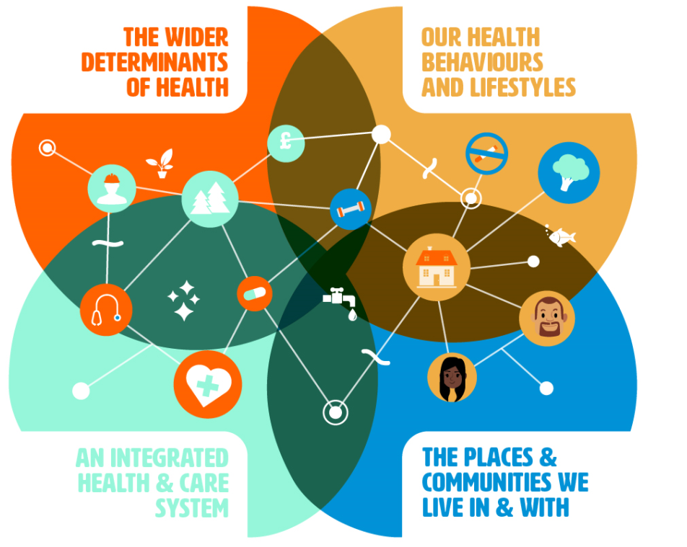
Figure 2: Population health model (Kings Fund, 2019) [to be adapted]

2.1 Place-based needs assessment
To inform the development of the new Health and Wellbeing Strategy we have undertaken research and engagement as part of the Joint Strategic Needs Assessment (JSNA) process. We developed a new place-based approach to understanding the health needs of Warwickshire residents. By undertaking this approach, we have been able to identify the needs and priorities within each area and ensure our recommendations are tailored to the needs of each place.

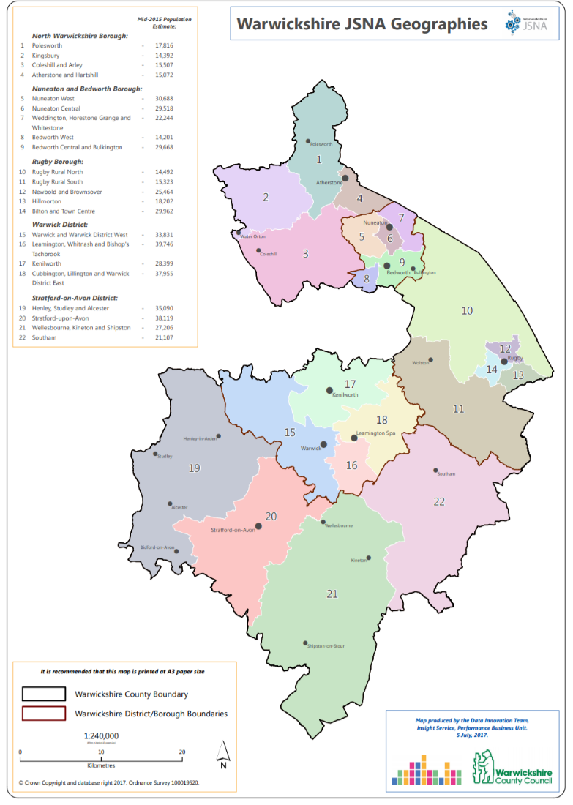
Figure 3: JSNA place-based approach
Over the last two years we have been building our understanding of assets and needs across the county through analysis of evidence from a wide range of sources. We have talked to over 2,000 residents and professionals and over 300 community organisations about the key issues facing local communities as part of our JSNA. In light of the Covid-19 outbreak we have undertaken further engagement and heard from over 2,500 residents on how life has changed for them since the outbreak. From this, we know that:
- Overall health in Warwickshire is above average but varies, with residents in more deprived parts living shorter lives and spending a greater proportion of their lives in poor health. In less deprived parts of the county males can expect to live over 9 years longer and females 5 years longer than those in more deprived areas. People are spending more of their later years in ill-health – over 18 years for men and nearly 20 years for women. There are avoidable differences in health outcomes, often linked to smoking, alcohol consumption, obesity and lack of physical activity. There is a need for better communication and advice to help people keep lead a healthy and independent life.
Covid-19 impact: Nationally mortality rates from Covid-19 during the first wave of the pandemic were more than twice as high in the most deprived areas compared to the least deprived areas for both males and females. Five areas in Nuneaton & Bedworth Borough and one in North Warwickshire Borough are in the 10% most deprived nationally. These are areas where residents are more likely to be working in essential services, be from a BAME group or living in more crowded housing and hence at increased risk of contracting Covid-19.

- Children and younger people have increasing needs. Nearly one in three children age 10-11 are overweight or obese. Increasing numbers of children aged 0-14 are being admitted to hospital with injuries and hospital admissions have also increased for alcohol specific conditions in under 18s,. There are growing concerns regarding mental health issues and self-harm rates among young people (age 10-24). With the number of school children forecast to increase by over 4,000 by 2025 the demand on support services is likely to increase.
Covid-19 impact: During the first lockdown period, referrals to RISE (the local Child and Adolescent Mental Health Service) reduced by 52% (February to May) despite mental health challenges increasing for many young people. Reductions in referrals may have reflected that the primary need of patients changed. The service often sees patients presenting with educational stressors, which were reduced during the Covid-19 outbreak period because of school closures. An increase in referrals for eating disorders was seen during this time.

- Around one in four adults experience mental health problems, but the county has seen an improvement in the suicide rate. Levels of suicide in Warwickshire have historically been higher than the England average. However, following a large programme of work aimed at suicide prevention, local rates are now in line with the England average. With awareness of mental health increasing and changes in underlying risk factors, more adults and young people are likely to present to health services with a mental health need by 2025.
Covid-19 impact: During the first lockdown period, the Office for National Statistics (ONS) highlighted across Great Britain the percentage of adults with high levels of anxiety reduced from 49.6% in the period 20th to 30th March to 33.3% in the period 24th April to 4th May. However local mental health support services reported seeing more people experiencing anxiety disorders.and the Warwickshire COVID-19 Survey found an increase in self-harming behaviours among people with pre-existing mental health conditions.

- Warwickshire has a growing older population. There are more people over the age of 65 than the national average (20.8% in Warwickshire and 18.4% for England) and those over 85 are expected to almost double from 16,561 in 2020 to 30,132 in 2040. The prevalence of dementia (all ages) is higher than the national average in South Warwickshire CCG (similar to the national average for Coventry and Rugby CCG and below the national average for Warwickshire North CCG). Across all three CCGs the estimated dementia diagnosis rate for those aged 65 and above is below the national average. These issues put pressure on services and carers who provide support. We need to focus on preventative health in the younger and working age population now to help manage future demand on health and care services. Covid-19 impact: Among people with a positive test, those who were aged 80 or over were 70 times more likely to die when compared to those under the age of 40. In Warwickshire a fifth of the population is aged over 65 and at an increased risk of mortality.

- Despite the county’s comparatively good performance on education and skills and economic growth, pockets of deprivation limit people’s opportunities to succeed in life. 6 Lower Super Output Areas (LSOAs) are in the 10% most deprived nationally. A further 16 LSOAs are in the second most deprived decile, and 26 are in the third most deprived decile. 12% of children (11,400) live in low-income households. Social inequalities and life chances are already established from these early years of life.
COVID-19 impact: Across Warwickshire the percentage of working age people receiving Job Seekers Allowance plus those receiving Universal Credit was gradually increasing since April 2019 from 1.9% to 2.2% in March 2020. Across Warwickshire the highest rates were in Nuneaton and Bedworth Borough which were consistently higher than the England rate, and the lowest were in Warwick and Stratford Districts. However, since the first lockdown, claimant rates increased significantly across the county, with each district and borough seeing at least double the number of claimants. North Warwickshire saw the biggest percentage increase in claimants when comparing rates between May 2019 and May 2020.

- Inequalities in health exist between White and Black, Asian and Minority Ethnic communities. People from ethnic minority groups are at higher risk of being out of work; prior to Covid-19 the rate of unemployment in some ethnic minority communities was 6.1% compared to 3.5% for people from a white background.
Covid-19 impact: People from black and minority ethnic groups were more likely to be at increased risk of exposure to Covid-19 than White British groups during the first wave of the pandemic, often due to working in frontline or essential services. Mortality rates were highest among South Asian and Black Caribbean groups.

- The county has a higher level of homelessness than other areas. We know that good quality housing leads to better health and wellbeing as it indirectly affects early years outcomes, educational achievement, economic prosperity, mental health and community safety.
Covid-19 impact: Under the ‘everyone in’ directive we supported 139 rough sleepers to access emergency shelter who had not been assessed formerly to be owed a statutory duty to accommodate. Wider financial impacts of the pandemic have led to an increase in people concerned about meeting housing costs.3

- Poor transport links in some parts of the county contribute to loneliness and social isolation. Nearly a third of people live in rural areas in Warwickshire, often with poor public transport links, which can make it difficult to access services, and over one in three of the population over 65 report they are lonely some or all of the time.
COVID-19 impact: Residents feel less comfortable about using public transport due to concerns of exposure to COVID-19.3

- Road safety issues, with a higher rate of people killed and seriously injured on roads in Warwickshire. This is compounded by rapid population growth in areas such as Rugby resulting in pressure on services, increased road traffic, and poorer air quality in some of our town centres.
COVID-19 impact: Warwickshire residents have walked or cycled more during the pandemic, however the most common barrier to opting to walk or cycle more is concern about traffic and other road users.3

- Air quality – improving air quality and taking action on climate change has significant benefits both for our local environment and our health and wellbeing, including reducing the risk of developing or exacerbating respiratory illnesses.
COVID-19 impact – reduced traffic during the pandemic has led to improved air quality; there is an opportunity to harness changes in behaviour made during the pandemic for longer-term environmental and health benefits. Additionally, when asked residents would feel most motivated to take local action on conservation and action on climate change within their local communities3.

- Community capacity – Our JSNA has highlighted a wealth of voluntary and community activity. Community organisations are often best placed to address health challenges as they have networks, understanding and legitimacy. However, their resources are limited and the public sector must change how it works with communities by shifting to an ‘enabling’ leadership style to join forces and build capacity.
Covid-19 impact: The grassroots response to mobilising mutual aid during the pandemic period has had a big impact on local volunteering, how it is perceived and how it can be promoted in the future.

- Improvements to access and integration of services are needed, with a focus on self-care and prevention to help people stay well and ensuring a seamless experience of accessing care when help is needed.
Covid-19 impact: Respondents reported access to services as a top priority and 1/3 were uncertain about accessing these facilities compared to other settings during the initial lockdown period. For some the shift to digital GP appointments represented a more convenient way of accessing services, whilst others felt this did not adequately replace face to face contact.

More information about the findings from our Joint Strategic Needs Assessment can be found at www.warwickshire.gov.uk/joint-strategic-needs-assessments-1
More information about the findings from our Covid-19 Health Impact Assessment can be found at: www.warwickshire.gov.uk/joint-strategic-needs-assessments-1/impact-covid-19/1

3. Where do we want to get to?
Based on this understanding of local needs, we are proposing three overarching strategic ambitions for the health and wellbeing of our residents.
Figure 4: Coventry and Warwickshire's Strategic ambitions (HCP, 2019)

The outcomes we hope to achieve are:
- People will lead a healthy and independent life.
By this we mean promoting healthy lifestyles and behaviours to help people stay healthy and well. It means working together to make sure that every child had the same opportunity to thrive and has the best start in life. If people have existing health problems, we want to prevent them from escalating to the point where they require significant, complex and specialist health and care interventions. It means helping people to age well and to slow the development of frailty in older people. The focus will be on empowering people to take action to improve their health and wellbeing and providing effective, timely support where needed.
Direction of travel will be monitored through indicators such as:
- Children and young people: healthy weight; admissions for injuries; under 18 alcohol admissions; Child and Adolescent Mental Health Services performance; children living in poverty; children and young people who self-harm; school readiness
- Working-age Adults: healthy life expectancy; physically active adults; overweight and obese; alcohol admissions; suicide
- Older people: falls; dementia diagnosis; flu immunisations

- People will be part of a strong community.
By this we mean working together to create communities that have a healthy environment, economic prosperity and where the social needs of people are met. We will work together to build community resilience and where everyone has the opportunity to thrive, with access to jobs, secure housing and feel connected to people around them. We will co-produce services with our communities where possible to make sure they meet people’s needs.
Direction of travel will be monitored through indicators such as:
- Economic inclusion: universal credit claimants; people in employment; gap in employment rate between those with mental health or learning disabilities and the overall employment rate
- Housing and homelessness: fuel poverty; statutory homelessness and priority need or in temporary housing; affordable housing
- Transport and air quality measures: level of air pollution; active travel
- Road Safety: killed and seriously injured (KSI) casualties on England’s roads
- Carers support: percentage of adult carers who have as much social contact as they would like

- People will experience effective and sustainable services.
These outcomes are also aligned to the Coventry and Warwickshire Health and Wellbeing Concordat, owned by the Health and Wellbeing Boards for both Warwickshire and Coventry. We will focus on the best way to achieve good outcomes for people, reduce the number of interactions people have with our services, and avoid multiple interventions. We will also focus on early intervention to prevent people from needing to use complex and specialist services. We will work closely with the Health and Care Partnership to do this.
Direction of travel will be monitored through indicators such as:
- Quality of services: emergency readmissions within 30 days of discharge; excess winter deaths
- Access to services: proportion of adults in the population in contact with secondary mental health services; proportion of patients satisfied with GP practice appointment time
- Early intervention: Uptake of health checks among people with learning difficulties and among people with serious mental illness
- Long term conditions: people feeling supported to manage their condition

4. How will we get there
We are working on a population health framework for Warwickshire to underpin everything we do as a health and wellbeing system to achieve our long-term vision for change. It is taken from a model developed by the King’s Fund and is based on four areas that impact on people’s health and wellbeing. For Warwickshire this means:

- Wider determinants – working in partnership to tackle health inequalities through addressing the social determinants of health such as education, employment, housing and a healthy environment.
- Our health behaviours and lifestyles – aligning and coordinating prevention programmes to maximise impact and tackle barriers to healthy lifestyle choices.
- The places and communities we live in and with – working together in our places and with our communities to mobilise solutions, informed by our understanding of local needs and assets from our place-based JSNAs.
- An integrated health and care system – health and social care commissioners and providers working together to commission and deliver services in Warwickshire.

Figure 5: Our approach to population health (Kings Fund, 2019)

We plan to invest in getting these foundations right and our plans will consider each of these components and the connections between them. Some of the outcomes related to our ambitions will be delivered indirectly by other strategies and plans, such as the Economic Growth Plan which will improve access to employment and training and therefore influence improvements in the wider determinants of health. Similarly, the Local Transport Plan will support a shift in transport modes to more sustainable, active travel that will provide greater opportunity for people to be physically active.

The importance of whole-system approaches for promoting health and wellbeing and strengthening the local economy is highlighted by the NHS Confederation report “NHS Reset: The Role for Health and Care in the Economy: a five- point plan for every system”. This identifies key areas for all systems to address covering the role of Anchor Institutions, strengthening recruitment of local residents, building the local supply chain, embedding health within planning frameworks and supporting civic restoration in the recovery from the pandemic. These have relevance to each of our strategic ambitions and our local recovery programme.

4.1 Our ways of working
The following principles, which form part of the Coventry and Warwickshire Health and Wellbeing Concordat, will underpin the way we work as Health and Wellbeing Board partners:
Prioritising prevention: we will tackle the causes of health-related problems to reduce the impact of ill-health on people’s lives, their families and communities. We will seek to address the root causes of problems, listening to local people’s priorities and acting on their concerns.
Strengthening communities: we will support strong and stable communities. We will listen to residents to understand what their want from the services we provide and encourage the, to lead change themselves where possible.
Co-ordinating services: we will work together to design service which take account of the complexity of people’s lives and their over-lapping health and social needs. We will focus on the best way to achieve good outcomes for people, reducing the number of interactions people have with our services and avoiding multiple interventions from different providers.
Sharing responsibility: we value the distinct contributions by all organisations that are represented on the Health and Wellbeing Board. We will maintain partnerships between the public sector, voluntary and community sector, local business and residents, recognising that we share a responsibility to transform the health and wellbeing of our communities. We will pool resources, budgets and accountabilities where it will improve services for the public.

4.2 Our priorities
We have identified three initial priorities where we can make a tangible difference in the short-term by working together in partnership. We will use these areas to test our new ways of working and bring our population health framework to life. There is a wealth of great work already being done in these areas and the challenge is to add value by making connections and creating energy and momentum to upscale existing activity. We will look at each area through the lens of the population health framework, identifying how each component contributes to addressing the issue and links to the others. We think that these are areas that, if we make a difference here, will impact positively on other health and wellbeing issues and priorities for the county.
We have chosen these priorities because we know that they are areas where we could do better. The first two priorities were identified through the JSNA findings and workshops with senior leaders and remain relevant now. Reducing health inequalities has long been a priority underpinning our work and now deserves more prominence due to the ‘double-impact’ of the pandemic. Our three initial priorities are to:
- Help our children and young people have the best start in life
- Help people improve their mental health and wellbeing, particularly around prevention and early intervention in our communities
- Reduce inequalities in health outcomes and the wider determinants of health
We will review our progress on these areas annually and, if necessary, change our priority areas after two years. To make sure that these priorities reflect the need of each place (North, Rugby and South) our place-based Health and Wellbeing Partnerships, as well as place-based Health and Care Executives will lead on implementation.
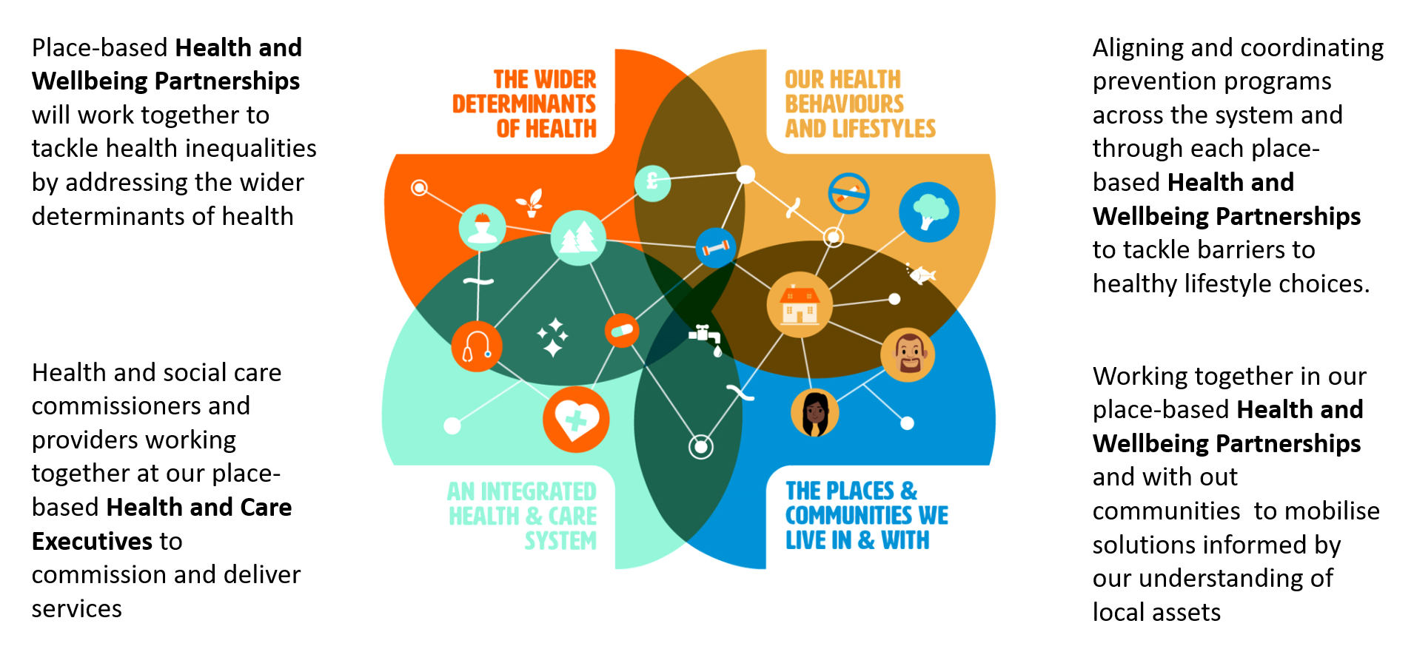
Figure 6: How we will operate at place (adapted from the Kings Fund Population Health framework)

Priority 1 – help our children and young people have the best start in life
We know that positive early experiences are vital to make sure children are ready to learn, ready for school, and have good life chances. Support need to start early, including support for parents in the “1001 Critical Days” (from conception to age two) when the foundations for development are laid.

Children and young people have experienced significant challenges throughout the Covid-19 pandemic. For many, disruption to education and homelife may have impacted on their mental health and wellbeing. Helping our children and young people catch up on their education is a key priority within WCC’s Covid-19 Recovery Plan.

Between March and April 2020, we know that there was an increase in the number of food parcels given to families with children, as well as an increase in the number of children newly eligible for a free school meal. We are developing a Social Inequalities Action Plan to tackle childhood disadvantage.

Childhood vaccinations are a vital health priority to protect against a number of diseases. Nationally and locally in Warwickshire there has been a decrease in the numbers of children being vaccinated during the Covid-19 outbreak. Good uptake in Warwickshire is important to avoid a resurgence of vaccine-preventable diseases, which could have a major impact on the health of children and vulnerable groups. This is why we have started our #Carryonvaccinating campaign and why we are committed to improving uptake of vaccinations across Warwickshire.

Providing extra support for mothers at risk of premature birth is a key priority within the NHS Long Term Plan. We know that the smoking status of mothers can impact on birthweight of babies and that this can impact on health outcomes over the life course. Rates of smoking at the time of delivery are higher in the North of Warwickshire compared to the South. To tackle this inequality in health we are working to implement the recommendations from our Local Maternity Services (LMS) Smoking in Pregnancy Review and making sure that access to services is proportionate to need. We are taking this same approach with our other services to support children and young people, such as Health Visiting. By taking a targeted approach to earlier intervention and prevention we will work together to give every child the best possible start in life.

Case Study: Establishing a pool of locally trained Youth support Workers

Our young people are growing up in an environment that makes securing these vital building blocks more difficult than it was for previous generations. Today’s young people face an unstable labour market, heightened by the economic impact from Covid-19, and a more challenging housing market. They are reporting higher levels of loneliness and poor mental health than previous generations.

In response to a lack of youth groups and youth-led support in North Warwickshire borough and across south Warwickshire, Young people first, a local youth organisation working across Warwickshire were approached by WCC and Borough and district partners to run an accredited training programme to establish pools of local youth support workers.

Once trained and having completed their portfolio based on a 6-month work-based placement in a youth setting successful applicants were awarded a Level 2 Award in Youth Work Practice by ABC Awards.

With a pool of accredited youth support workers in the local areas, youth projects could be better supported and able to provide a worthwhile initiative to work with young people.
The courses were free to join and funded through Warwickshire County Council with contributions in the North from the Borough Council also. In North Warwickshire 10 people took part in the course with people from all over the borough and Nuneaton and Bedworth, whilst 15 were selected from a pool of 25 in the south with approximately half from Warwick district and half from Stratford. There was a range of experience within both groups with some already working in voluntary or paid youth worker roles, whilst others looking to expand their skills to better support the local communities and offer additional services and some looking for a change of career.

The groups received 4 days of intensive training over 6 weeks covering topics such as: theory of youth work; safeguarding; young people’s development; engaging and communicating with young people. The group training was accompanied by individual portfolios of written and practical work followed by at least 6 months of paid or voluntary work with young people 2-3 hours per week.

Priority 2 – help people improve their mental health and wellbeing, particularly around prevention and early intervention in our communities
Delivering an all-age mental health system that is underpinned by prevention, building resilience, early intervention, recovery and self-care in the places people live and work is a key priority across Coventry and Warwickshire. This is an even greater priority now because of the impact that Covid-19 has had on mental health and wellbeing. People have reported experiencing more feelings of loneliness and heightened anxiety due to uncertainty about the virus and the wider implications of the outbreak20. In Warwickshire 85,000 people were furloughed during the initial lockdown period, and research suggests that an increase in hardship and economic recession can exacerbate mental health illness. We also know from our Covid-19 residents survey that respondents with a prior mental health condition were more likely to report engaging in less healthy behaviours as coping mechanisms, such as drinking more alcohol or making unhealthy food choices, and for a smaller proportion turning to self-harming behaviours.

Prevention and early intervention is key to supporting people to improve their mental health and wellbeing. Building community resilience and community capacity is crucial to this and involves working with wider partners from the community and voluntary sector, and not solely health. As part of this, the Working Together Partnership, led by Coventry and Warwickshire Partnership Trust (CWPT), brings together health and care partners and Voluntary and Community Sector organisations across Coventry and Warwickshire to improve holistic support for people to improve positive mental health.

Following the success of our Year of Wellbeing, we are launching Wellbeing for Life to continue with the positive action we saw during 2019. We want to ensure mental health and wellbeing is considered within our own policies, which is why we are committed to reviewing these to see how we can improve. Evidence shows that having a happy and healthy workforce increases staff productivity and job satisfaction, contributing to overall improvements in quality of life. In partnership with the WMCA we are supporting employers to sign-up to Thrive at Work, a commitment which promotes employee health and wellbeing by focusing on key areas such as: mental, musculoskeletal and physical health; and promoting healthy lifestyles.

Certain groups face inequalities in mental health and wellbeing due to existing conditions or specific life experiences. There are a number of key strategies that will help us achieve this priority including our Living Well with Dementia Strategy, that sets out how we will improve outcomes for people living with dementia. Our Homelessness Strategy aims to better address the needs of people who are homeless or sleeping rough. Individuals experiencing homelessness are less likely to engage with traditional services, which is why we have established a Mental Health Enhanced Care Pathway that aims to improve mental health support for people who sleep rough and reduce the risk of exacerbation of poor mental health, which can often result in A&E attendance.
To help reduce inequalities in mental health and wellbeing, the Health and Care Partnership is developing a transformation plan for improving services for priority groups, to help ensure that access is proportionate to need.

Case study: Creative Health interventions – helping residents improve their mental health and wellbeing during the Covid-19 pandemic

Artists have been helping defeat the loneliness of lockdown thanks to a special Covid 19 programme of activity called #creativecarecw.

Warwickshire County Council funded eight organisations across the county to create new activities specifically designed to beat the isolation that some people are suffering during the pandemic. The result has been a varied programme targeted at improving the lives of lots of different groups of people both young and old and activity in each of our District and Boroughs. The projects have reached over 450 people directly (virtually) plus 10,000 residents received an “Arts pack” to work on at home, and over 5,000 residents engaged with online activities.
Examples include:
- Sundragon Pottery provided clay modelling packs with a creative clay booklet for young people in a supported housing scheme.
- Arts Uplift organised online sewing, singing and drama classes, for groups including older people in care homes and people isolated at home
- Singer Juliet Russell provided choir practice for people with respiratory difficulties,
- Escape Arts' 'We are One' series included a printed pack which has been distributed widely in hospitals and the community, offering creative activities for all ages, including street homeless people who are in temporary accommodation.

Research shows creative activities like these can have a huge impact on people's physical and mental health and wellbeing. Here in Warwickshire, new links have been forged between arts groups and groups of people at risk of isolation through their disability, illness, age or a host of other reasons. We believe this approach could be a blueprint to help us develop our work with arts organisations and target activity on those people who need our help the most, at the same time reducing their dependency on health services.
We are working with Coventry University to evaluate the programme, the findings of which will inform the roll-out of a Warwickshire Arts on Referral programme in early 2021.

Priority 3 – Reduce inequalities in health outcomes and the wider determinants of health
Reducing health inequalities has always been at the heart of the work of the Health and Wellbeing Board and the Health and Wellbeing Strategy. Findings from national and local data has highlighted that the Covid-19 pandemic has had a disproportionate impact on specific groups, including those from Black, Asian, and Minority Ethnic (BAME) communities. We have set up a system-wide health inequalities group to help improve our response to these findings. From reports we know that BAME communities are over-represented in social care and lower income settings, which is why a longer-term focus on access to higher income employment is needed for these groups. This is why one of our WCC Recovery Plan priorities is to harness the power of our communities to tackle inequality and social exclusion. We are supporting this work in a number of ways for example:
- Two Connecting Communities Support Officer posts have been created to support the local Test and Trace team
- Commissioning collaborative research project to find out more about the Covid-19 in BAME communities
- Inclusive recruitment and employment policies and processes to improve diversity in our workforce
- Health partners being asked to improve ethnic to better understand access and outcomes of health and wellbeing

Other groups also tend to experience poorer health outcomes or access to services, including people living with disabilities, learning difficulties, people with serious mental illness, and people from lower socio-economic groups. We want to support people from these groups to keep fit and healthy and reduce their risk of developing Covid-19 through “prehab” activities. Health inequalities are multi-factorial with people with the worst health outcomes often experiencing a combination of risk factors and living in environments less conducive to good health. We know the environment in which we live can influence the choices we make, which is why the Warwickshire Health and Wellbeing Board endorsed local ‘Promoting Health and Wellbeing through Spatial Planning’ guidance in January 2020.

We have also established a system-wide group to lead on the response to address inequalities in NHS provision and outcomes. The Health Inequalities Task and Finish Group is identifying how best to respond to eight urgent actions on inequalities. As part of this a Call to Action has been made, aimed at employers and organisations, to ask them what they can do to help reduce health inequalities. Areas for action include: developing a shared approach to social value across anchor organisations; reducing barriers to work; and exploring the impact of Covid-19 on families with children 0-5s.

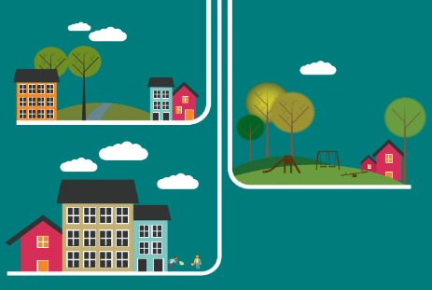
Case study: Promoting Health and Wellbeing through Spatial Planning

The environment we live in plays a vital role in both improving and protecting the health and wellbeing of our communities. Good planning and well-designed places can provide opportunities for people to be physically active and connect with others. The importance of our built environment has been highlighted more during the Covid-19 pandemic as poor housing conditions, such as overcrowding, have been associated with an increased risk of disease transmission. The value of accessing good quality green spaces has also proven beneficial for people’s mental wellbeing during this period.

We know that inequalities in health exist along the social gradient and those living in the most deprived areas are likely to have a lack of green space, poor air quality, and poorer housing compared to the least deprived areas. We don’t want this to be the case for Warwickshire, which is why we have developed a Spatial Planning for Health guidance document to support Health in All Policies (HiAP) and want to make sure that health and wellbeing is embedded within local and joint planning policies and decisions.

Health and wellbeing is also seen as a key strategic driver behind WCC’s place shaping programme. Place shaping describes local governments role in creating an environment for communities to flourish by improving infrastructure, services, connectivity and sustainability to deliver a better quality of life. Our Promoting Health and Wellbeing through Spatial Planning guidance document will help support this.
5. Monitoring - How will we know when we have got there
Leadership and accountability is key to knowing if we are getting things right. The Health and Wellbeing Board will have oversight of progress against our strategic ambitions. The direction of travel indicators will be developed into a performance dashboard for the Board, and the Board will receive an annual performance report on progress.

Each place-based Health and Wellbeing Partnership in Warwickshire will develop an action plan with clear performance measures based around the four components of the population health framework. The Partnerships action plans will be tailored to meet the specific needs of each place and will routinely report to the Board. We will evaluate the overall progress we have made on our three priorities after two years and take a view on if we should continue with these or focus our efforts on other priorities for the next two years.

References

2016-208 https://fingertips.phe.org.uk/profile/public-health-outcomes-framework/data#page/0/gid/1000049/pat/6/par/E12000005/ati/302/are/E08000025/cid/4/page-options/ovw-do-0
https://fingertips.phe.org.uk/profile/public-health-outcomes-framework/data#page/0/gid/1000049/pat/6/par/E12000005/ati/302/are/E08000025/cid/4/page-options/ovw-do-0
https://api.warwickshire.gov.uk/documents/WCCC-1350011118-2953
https://fingertips.phe.org.uk/profile/public-health-outcomes-framework/data#page/0/gid/1000042/pat/6/par/E12000005/ati/302/are/E08000025/cid/4/page-options/ovw-do-0
https://fingertips.phe.org.uk/profile/public-health-outcomes-framework/data#page/4/gid/1000042/pat/6/par/E12000005/ati/302/are/E10000031/iid/90284/age/26/sex/4/cid/4/page-options/ovw-do-0
https://fingertips.phe.org.uk/sexualhealth#page/4/gid/8000037/pat/6/par/E12000005/ati/302/are/E10000031/cid/4/page-options/ovw-do-0
https://fingertips.phe.org.uk/profile-group/mental-health/profile/cypmh/data#page/4/gid/1938133090/pat/6/par/E12000005/ati/102/are/E10000031/iid/90813/age/305/sex/4/cid/4/page-options/ovw-do-0
Warwickshire Education Team
https://api.warwickshire.gov.uk/documents/WCCC-1350011118-2946
https://fingertips.phe.org.uk/profile-group/mental-health/profile/suicide/data#page/0/page-options/ovw-do-0
https://api.warwickshire.gov.uk/documents/WCCC-1350011118-2946
https://fingertips.phe.org.uk/search/dementia#page/3/gid/1/pat/219/par/E54000018/ati/165/are/E38000038/iid/247/age/1/sex/4/cid/4/tbm/1/page-options/ovw-do-0_car-do-0
https://fingertips.phe.org.uk/search/dementia#page/3/gid/1/pat/219/par/E54000018/ati/165/are/E38000038/iid/92949/age/27/sex/4/cid/4/tbm/1/page-options/ovw-do-0_car-do-0
https://api.warwickshire.gov.uk/documents/WCCC-1350011118-2953
https://api.warwickshire.gov.uk/documents/WCCC-1350011118-2946
https://commonslibrary.parliament.uk/research-briefings/sn06385/
https://assets.publishing.service.gov.uk/government/uploads/system/uploads/attachment_data/file/892376/COVID_stakeholder_engagement_synthesis_beyond_the_data.pdf
https://data.warwickshire.gov.uk/housing/
https://api.warwickshire.gov.uk/documents/WCCC-630-2139
WCC Covid-19 resident survey report (October 2020)
https://www.nhsconfed.org/resources/2020/07/the-role-of-health-and-care-in-the-economy
Health Foundation, 2019
https://www.happyhealthylives.uk/our-priorities/mental-health-and-emotional-wellbeing/improving-mental-health-and-emotional-wellbeing-in-coventry-and-warwickshire/
https://www.wmca.org.uk/what-we-do/thrive/thrive-at-work/about-the-programme/
https://www.artshealthandwellbeing.org.uk/appg-inquiry/Publications/Creative_Health_Inquiry_Report_2017.pdf
South Asian Foundation
WCC Recovery Plan
https://www.ageing-better.org.uk/sites/default/files/2020-09/Homes-health-and-COVID-19.pdf

