Warwickshire Enhanced Partnership Scheme for
Buses

Supporting the development of bus services in the County of Warwickshire

Draft v1.4

Contents

Organisation Making the Enhanced Partnership Scheme for Warwickshire. 1
Schedule 1 - types of public services exempt from the Standards of Services 13
Signatory page 14

Organisation Making the Enhanced Partnership Scheme for Warwickshire.

THE WARWICKSHIRE ENHANCED PARTNERSHIP SCHEME FOR BUSES IS
MADE IN ACCORDANCE WITH SECTION 138R(1) OF THE TRANSPORT ACT 2000 (as amended)
BY: Warwickshire County Council having its principal administration offices at Shire Hall, Market Place, Warwick, CV34 4RL.

  - Definitions used in the document

NB: Not all definitions are currently used but are incorporated to recognise the intention to further develop the Scheme by way of variation and/or cause further Schemes to be made at future dates with consistent terminology.

Authority – means Warwickshire County Council.

Automatic Vehicle Location (AVL) – is a means for automatically determining and transmitting the geographic location of a vehicle, allowing it to be tracked in real time.

Board – means the Enhanced Partnership Board established in the manner provided for and with the remit set out in the Enhanced Partnership Plan.

Bus Gate – is a short stretch of road carriageway that is restricted to use by buses and (where specified) taxis and other authorised vehicles as indicated on appropriate signage on the approach.

Bus Lane – is a signposted lane, designated for use by buses and (where specified) taxis and other authorised vehicles, at the times also indicated by signage.

Bus lane enforcement – means the action taken to ensure that bus lanes are used only by authorised vehicles. This is often carried out by using cameras to record unauthorised use, with the issue of civil penalties to offenders under section 144 of the Transport Act 2000.
Bus Operators (or Operators) – means all providers of Qualifying Bus Services.

Bus Stand – means a bus stop clearway as defined in accordance with paragraph 1(a) of Part 1 to Schedule 19 of The Traffic Signs Regulations and General Directions 2002 but which will permit a local bus to stand within the clearway for as long as maybe necessary up to a maximum period of 10 minutes.

CCTV – means closed circuit television system, whereby static or mobile cameras are used to record offences or for surveillance and security purposes.

CVRAS – means Clean Vehicle Retrofit Accreditation Scheme (CVRAS) and is a certification scheme for manufacturers of retrofit emissions reduction technology that will enable Clean Air Zone (CAZ) compliance of legacy fleet vehicles to address the air pollution emissions from buses.

Designated feeder service – means a bus service that is specifically designed by the operator and accepted by the Authority as one that connects with another service allowing passengers to interchange at designated stops or stands

Enforcement camera – means a roadside camera that records and produces suitable evidence of unauthorised use of bus lanes or bus gates for the local highway authority to issue civil penalties under section 144 of the Transport Act 2000.

Enhanced Partnership Plan, or EP Plan – means the statutory plan made by Warwickshire County Council pursuant to section 138A of the Transport Act 2000 and which is required to be in place for an EP Scheme to be made and which was made by the Authority on the same date as but prior to the making of this Scheme.

EP Board – means the forum established in the manner provided for by the EP Plan.

EP Scheme Area – means the area to which this EP Scheme document applies.

Euro VI equivalent standards – Euro VI diesel bus or a bus with CVRAS approved technologies retrofitted to a diesel bus to reduce NOx and PM emissions and achieve Euro VI equivalent standards

Facilities – means the physical assets that are provided at specific locations along particular routes (or parts of routes) within the EP scheme area or new and improved bus priority measures.

Highway Works Permit – is a permit issued by Local Highway Authority to any organisation that wishes to undertake street works promoted by a public utility company or highway works promoted by the Local Highway Authority, with the aim of managing all works on the public highway. Local Authority have powers to operate permit schemes under Part 3 of the Traffic Management Act 2004 and The Traffic Management Permit Scheme (England) (Amendment) Regulations 2015.

Local Authority – as prescribed under section 23 of the Local Government Act 2003.

Local Highway Authority – for the purpose of this Scheme is the Authority.

Measures – means the improvements with the aim of:
- Increasing the use of local bus service serving the routes to which the measures relate or ending or reducing a decline in their use; or
- Improving the quality of local bus service.

Multi-Operator Capping – means a common fares and ticketing system, applied across multiple bus operators, that will cap a user’s travel cost according to the lowest price available for the journey or journeys made.

Multi-operator Travel Card (MTC) - means a ticket (or tickets) entitling the holder to make three or more journeys on three or more specified local public transport services operating on three or more routes provided that: (a) these routes are not substantially the same; (b) these local public transport services are not substantially the same; and (c) for each of these routes and local public transport services, the passenger usage and revenue received from the ticket and other such tickets purchased as a result of the relevant agreement, demonstrate that the ticket is not, in practice, a multi-operator individual ticket or a through ticket.

Qualifying Bus Services – means those Registered Local Bus Services operating within the EP Scheme area that must meet the requirements and obligations set out in this EP Scheme document unless exempt as set out in Schedule 1.

Real Time Information – using technology to track the location of buses in real time, information is transmitted to bus stops or devices to indicate to passengers the predicted arrival time at a particular point.

Red Routes - roads on which vehicles are not allowed to stop, including for loading or unloading, or for boarding or alighting from a vehicle, and are marked by red lines on the sides of the road.

Registered Local Bus Service – has the meaning set out in Section 2 of the Transport Act 1985.

Road User Charging – the levying of a fee or charge for road use, such as tolling and congestion charging.

Service Change Date - dates (published in advance by the Authority in accordance with the Service Change Protocol) at which alterations to service timetables may be carried out (subject to satisfaction of all regulatory requirements in respect of the same).

Service Change Protocol – a protocol established by the Authority following consultation with the EP Board setting out the basis upon which Service Change Dates are to be established.

Standards of Services – means the requirements that are to be complied with in relation to Local Qualifying Bus Services

Subsidised service – a service which receives financial support from the Authority.

TRO – means a Traffic Regulation Order, made under the Road Traffic Regulation Act 1984 or any other enactment regulating the use of roads or other places.

Workplace Parking Levy – a charge on employers who provide workplace parking.

Zero emission vehicle – means a vehicle that emits no pollutants at its tailpipe.
  - Introduction

    - This document fulfils the statutory requirements set out by in the Transport Act 2000 as amended by the Bus Services Act 2017 when the Authority wishes to exercise its power to make an Enhanced Partnership Plan and one or more Enhanced Partnership Scheme(s). In accordance with statutory requirements in section 138 of the Transport Act 2000, this EP Scheme document sets out:
      - the scope of the EP Scheme;
      - when the Scheme is to commence;
      - in detail the overall interventions to be made by the Authority under the Scheme – these comprise Facilities and Measures;
      - requirements in the form of Standards of Services imposed on Local Qualifying Bus Services; and
      - arrangements for the review and possible variation of the Scheme and its operation.

    - Certain types of public services (listed in Schedule 1) are exempt from the Standards of Services.

    - The EP Scheme is dependent upon there being in place an Enhanced Partnership Plan made by the Authority. The Warwickshire Enhanced Partnership Plan was made by the Authority on the same date as this Scheme has been made.

    - The EP Scheme has been jointly developed by Warwickshire County Council, District and Borough Councils, and those bus operators that provide local bus services in the EP Scheme area. It sets out obligations and requirements on both the Local Authority, District and Borough Councils, and operators of local services in order to achieve the intended improvements, with the aim of delivering the objectives of the associated EP Plan.
    - The EP Scheme aims to contribute towards meeting the following objectives of the EP Plan:

      - Provide more frequent buses.
      - Enable bus services to become faster and more reliable.
      - Offer ticketing solutions and fares which are cheaper for the user.
      - Provide a more comprehensive network.
      - Make the bus network easier to understand.
      - Make the bus network easier to use.
      - Provide a network which is better integrated

    - A number of objectives may only be achieved with investment the funding of which will in turn be dependent upon levels of grant funding provided by the Department from Transport and from other sources.

  - Scope of the EP Scheme

    - The EP Scheme will support the improvement of all Local Qualifying Bus Services operating in the EP Plan Area, namely the administrative County of Warwickshire, as illustrated in Figure 1.

    - The EP Scheme Commencement Date will be 7 days after it has been made, The EP Scheme will have no specific end date but will be subject to a review by the Authority in conjunction with the EP Board at least annually.

    - The Scheme applies to registered Local Bus Services with one or more stopping places within the EP Plan Area unless exempted under the Scheme. The following services are exempt from the requirements of the EP Scheme:

      - Any schools or works registered local bus service not eligible for Bus Service Operators Grant
      - Any cross-boundary registered local bus service with less than 10% of its registered mileage within the Enhanced Partnership area
      - Any services operated under section 22 of the 1985 Act
      - Any registered local bus service which is an excursion or tour
      - Any other registered local bus service that the Operators (through the Warwickshire EP Board voting mechanism) and County Council decide should be excluded from all or specific requirements of the Enhanced Partnership Scheme.

.

Figure 1 Map of the EP Plan and EP Scheme Area

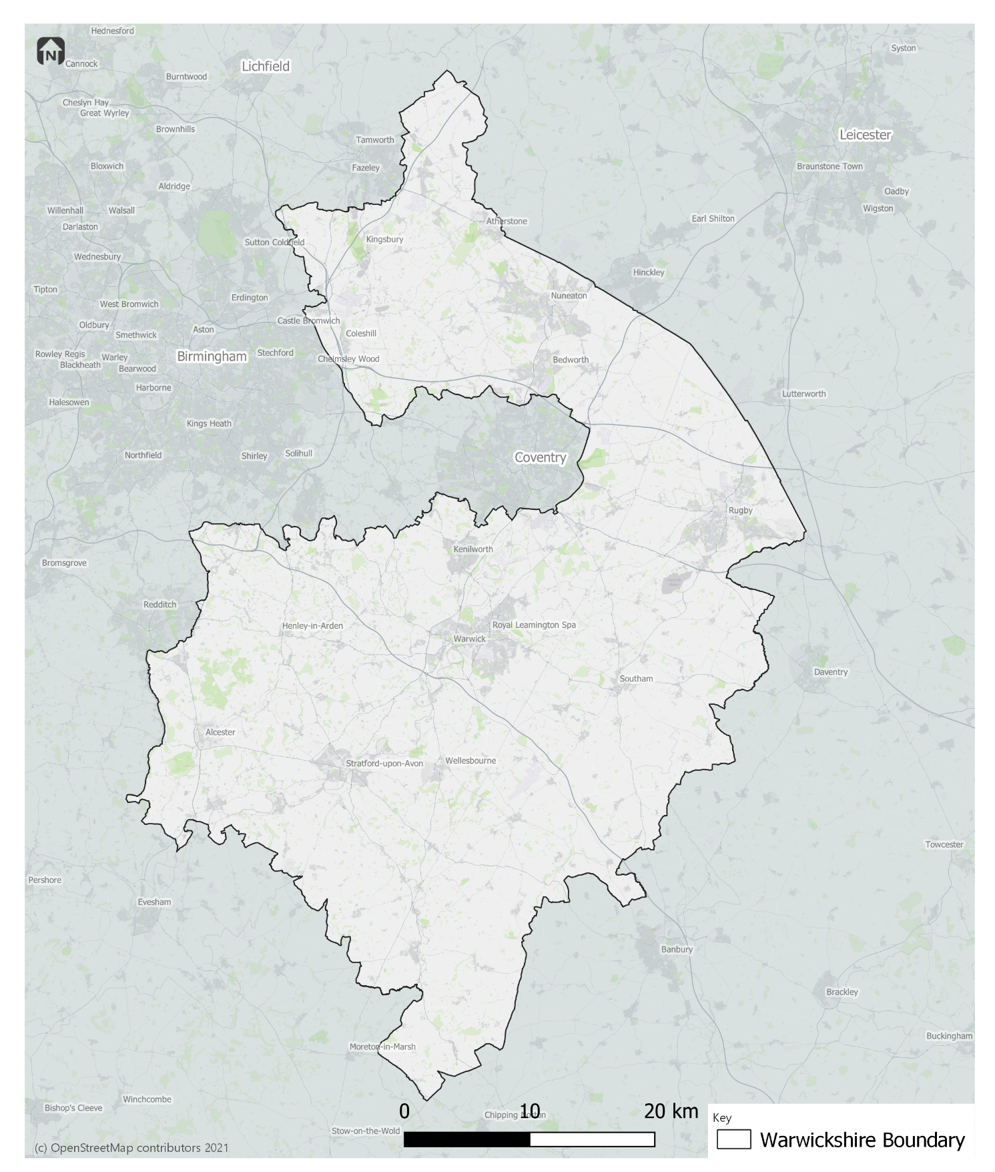

  - Obligations on the authorities

    - This Scheme document will be varied and, if relevant, further and/or substitute Scheme documents adopted to implement Facilities and Measures that have the objective of contributing to meeting the objectives of the EP Plan for Warwickshire.

    - Warwickshire County Council will implement the following Measures in the EP Scheme area; further detail of which is set out below:
      - Launch of a pilot DRT service
      - Define minimum standards for information.
      - Develop a marketing campaign, supplemented by the production of a Bus Information Guide.
      - Define vehicle quality standards
      - Parking policy and enforcement
      - Develop guidelines for large new developments
      - Review of S106 contributions
      - Maintenance of network, including a network review
      - Feasibility studies for supportive policies

    - Depending on the award of funding from DfT, Warwickshire Country Council will implement additional measures, and aim to build upon those measures outlined in this Scheme.

- Launch of a pilot DRT service

Warwickshire County Council will implement a pilot Demand Responsive Transport (DRT) service to the west of Warwick including the west part of Kenilworth town, as set out in the Rural Mobility Fund bid to the DfT. The service will launch in 2022 and will be funded for five years.

- Define minimum standards for information.

To work with Bus Operators to define and agree consistent minimum standards for roadside, printed, and online bus information.

In developing these minimum standards, consideration will be given to:

- The availability and accessibility of online timetables, including ability to print at home
- The opportunity to standardise the content of roadside information, whether provided by operators or the LTA
- The availability of printed timetable information
- The provision of disruption information through a centralised social media feed, in addition to operators’ own information
- The timeline for providing customer-facing information on forthcoming service changes, and how these changes are communicated by operators and the LTA
- The opportunity to develop the Warwickshire County Council website to include maps and timetables for all bus services, whether hosted directly on the LTA website or as links to operators’ own websites, with the potential to include a county-wide journey planner
- The opportunity to include information on DRT and Community Transport services in roadside and online information

These minimum standards will be developed during the 2022/23 financial year.

- Develop a marketing campaign, supplemented by the production of a Bus Information Guide.

Define and agree, in partnership with Bus Operators, a county-wide marketing campaign to entice new and old passengers to public transport with a specific focus on encouraging modal shift, de-mystifying public transport to non-bus users, and encouraging lapsed users to return to bus. This will include defining the scope of the marketing campaign and the distribution of materials. This will be developed during the 2022/23 financial year.

To support the marketing campaign, the Authority will develop a Bus Information Guide. The general tone and necessary contents, such as how to use a timetable and where to find information, will be developed in consultation with the EP Board and Stakeholder Reference Group.

- Define vehicle quality standards

The Authority will work with Bus Operators to jointly define and agree minimum standards of vehicle quality operating Qualifying Bus Services, set by type of service. These will be defined during the 2022/23 financial year, and implemented over a timescale to be agreed with Bus Operators.

- Parking policy and enforcement

From April 2022, and for the life of this EP Scheme, the Authority will convene a meeting every six months with Bus Operators; Warwickshire County Council’s Parking Management Team; and District and Borough Councils within Warwickshire as appropriate, to discuss the strategic view of parking availability and pricing. Localised meetings will be held quarterly with Warwickshire County Council’s Parking Management Team; each of the District and Borough Councils within Warwickshire, and the bus operators relevant to that District, to discuss enforcement for unlawful parking; issues affecting bus reliability and access to bus stops; and problematic places on the network where indiscriminate car parking currently causes issues to bus service performance; with a view to solving issues affecting bus reliability and access to bus stops as a result of unlawful or poorly planned car parking, and repositioning the bus as a priority mode.

- Develop guidelines for large new developments

During 2022, the Authority will, in partnership with neighbouring Local Transport Authorities and Bus Operators, define and agree a set of guidelines for use by developers, and planners reviewing development plans, of large new developments (e.g., a significant residential site with over 150 no. dwellings or a commercial site comprising 3 or more units of B1, B2 or B8 employment purposes) in or close to the EP Scheme Area (where it is reasonable that people will travel into or through the EP Scheme Area). The guidelines will provide guidance the layout and design of new developments to ensure that developers actively incorporate bus provision into the design and delivery of the development through highway design, internal road configuration, bus stop infrastructure, prioritising bus routes over those of the car, marketing and welcome packs.

- Review of S106 contributions

The Authority will work in partnership with Bus Operators when new S106 monies are secured, to agree how such monies shall be spent to ensure S106 funding is used in the most effective and efficient way. This will be effective from April 2022 and will continue throughout the life of the Scheme.

- Maintenance of network, including a network review

The Authority will review, or commission a review, of the bus network by August 2022 and, working closely with Bus Operators, develop recommendations outlining the most effective way of meeting the transport needs of the residents and visitors of Warwickshire, and agreeing appropriate service levels within the constraints of the budget available. Subject to receiving BSIP funding to the value required, and until the network review is completed, the Authority will financially support a) services which are subsidised by the Authority as of November 2021, and b) services that were commercial prior to the Covid pandemic, but are not commercial as of April 2022.

Subject to receiving BSIP funding, and relevant associated DfT guidance, the Authority will liaise with bus operators to agree a mechanism for supporting commercial services until the outcomes of the bus network review is known and actioned. .

- Feasibility studies for supportive policies

The Authority commits to undertaking feasibility studies into schemes to support modal shift initiatives, namely Red Routes; Workplace Parking Levy; and Road User Charging. These studies will be undertaken after the impact of other measures is known, and not before April 2023, subject to agreement from the EP Board.
  - Requirements in respect of Local Qualifying Bus Services

    - Operators of Local Qualifying Bus Services are expected to fulfil the following obligations:
      - Define minimum standards for information.
      - Develop a marketing campaign, supplemented by the production of a Bus Information Guide.
      - Define vehicle quality standards
      - Define and implement a Bus Passenger Charter
      - Develop guidelines for large new developments
      - Review of S106 contributions
      - Support the Authority in undertaking a network review

- Define minimum standards for information

To work with the Authority to define and agree consistent minimum standards for roadside, printed, and online bus information.

Operators will continue to comply with the requirements of local bus service registration and the Bus Open Data Service (BODS) in providing and maintaining accurate information relating to timetables, routing, and service changes.

- Develop a marketing campaign, supplemented by the production of a Bus Information Guide.

Define and agree, in partnership with the Authority, a county-wide marketing campaign to entice new and old passengers to public transport with a specific focus on encouraging modal shift, de-mystifying public transport to non-bus users, and encouraging lapsed users to return to bus. This will include defining the scope of the marketing campaign and the distribution of materials. This will be developed during the 2022/23 financial year.

- Define vehicle quality standards

Define and agree, in partnership with the Authority, minimum standards of vehicle quality operating Qualifying Bus Services, set by type of service. These will be defined during the 2022/23 financial year, and implemented over a timescale to be agreed with the Authority.

- Define and implement a Bus Passenger Charter

Operators will define, and agree with the Authority, minimum standards for a Warwickshire Bus Passenger Charter to include, but not be limited to, agreeing the scope, format, content and aspirations. This will include a defined set of achievable principles and will a written representation of the acme of bus services in Warwickshire.

Operators will adopt and adhere to the Bus Passenger Charter by September 2022, and will promote the Charter through information sources following the definition of minimum standards of information as set out in (1).

- Develop guidelines for large new developments

During 2022, Operators will work in partnership with the Authority and neighbouring Local Transport Authorities, to define and agree a set of guidelines for use by developers, and planners reviewing development plans, of large new developments (e.g., a significant residential site with over 150 no. dwellings or a commercial site comprising 3 or more units of B1, B2 or B8 employment purposes) in or close to the EP Scheme Area (where it is reasonable that people will travel into or through the EP Scheme Area). The guidelines will provide guidance the layout and design of new developments to ensure that developers actively incorporate bus provision into the design and delivery of the development through highway design, internal road configuration, bus stop infrastructure, prioritising bus routes over those of the car, marketing and welcome packs.

- Review of S106 contributions

The Operators will work in partnership with the Authority when new S106 monies are secured, to agree how such monies shall be spent to ensure S106 funding is used in the most effective and efficient way. This will be effective from April 2022 and will continue throughout the life of the Scheme.

- Support the Authority in undertaking a network review.

Operators will cooperate with the Authority in the process of reviewing the network, by providing the data appropriate to the review in accordance with The Franchising Schemes and Enhanced Partnership Plans and Schemes (Provision of Information) Regulations 2017, within a timescale agreed between the Authority and each individual Operator.
  - EP Scheme REVIEW, Management and Governance

EP Board

    - The EP Scheme has been made by the Authority having been developed in conjunction with the EP Board, whose members comprise:
      - Warwickshire County Council officers (Public Transport and Highways teams)
      - All bus operators operating qualified bus services
      - Bus user representative (Chair)
      - Train operating companies
      - Local business representatives

    - The future content and arrangements for the variation and revocation of the EP Scheme will be considered by the EP Board.

    - Going forward, the EP Board established under the Warwickshire County Council Enhanced Partnership Plan will be responsible for oversight of the Scheme including considering future variations, in accordance with the processes detailed in Sections 7 of the EP Plan.
  - Variations to the EP Scheme

    - Consideration will be given to potential EP Scheme variations highlighted by one or more of the organisations represented on the EP Board. The proposer of a variation should demonstrate how this might contribute to achieving the objectives set out in the EP Plan and current local transport policies. Such requests should be set out in writing and submitted to Nigel Whyte at Warwickshire County Council by email (nigelwhyte@warwickshire.gov.uk).

    - On receipt of a request for a variation the Council will consider the validity with regards to the proposal. The Council may, in exceptional circumstances, exercise veto over whether a proposed variation is put to the Board where it reasonably believes or suspect as having anti-competitive implications or being otherwise significantly against the public interest or there exist circumstances under which the Council would be unable to comply with any obligations that would be imposed upon the Council were the decision to be implemented.

    - The decision of the Council would be shared, in writing, with the proposer and the Council would also share the decision with the Board at the next Board meeting convened.

    - On receipt of a valid request for a variation, the Council will reconvene the EP Board, giving at least 14 days’ notice for the meeting, to consider the proposed variation. Providing that a quorum of at least the top three operators according to mileage operated in Warwickshire, plus a Warwickshire County Council representative, can be achieved, the council will make the EP Plan variation if the proposed variation is agreed unanimously by all bus operators and County Council representatives present. Stakeholders not represented at the meeting will be deemed to be abstaining from the decision.

    - If there is not full agreement of all stakeholders present, then the proposed variation will be put to the operator objection mechanism, but with a reduced objection period of 14 days replacing Part 2 of the Transport Act 2000 section 138L (2) (c). The proposed variation will be advertised on the Council’s website and emailed to operators of qualifying local services in the EP Plan area. If the proposed variation passes the operator objection mechanism, the Council will make the variation, subject to the approval of Warwickshire County Council.

    - Procedures, as set out at s138L and 138M of the TA 2000 (as amended), will be followed for major variations and to initiate new Schemes.
  - Review of the EP Scheme

    - Once the EP Scheme is made, it will be reviewed by the EP Board every six months following publication of data on progress towards targets, as required by the BSIP –this will ensure any necessary action is taken to deliver the targets set out in the BSIP. The Authority will initiate each review.

    - The EP Board can also decide to review specific elements of the scheme on an ad-hoc basis. EP Board members should contact the Authority using the email address (nigelwhyte@warwickshire.gov.uk) explaining what the issue is and its urgency.

    - The Authority will then decide whether to table at the next scheduled meeting or make arrangements for all or the necessary EP Forum members to gather more quickly.

  - Revocation of the EP Scheme

    - If the Authority, or another member of the EP Board, believes it is necessary for the EP Scheme to be revoked, the EP Board will be reconvened. If the decision is taken to revoke the EP Scheme it will follow the same process as outlined in the section 7 ‘Variations to the EP Scheme’ (noting that the agreement will be for revocation and not variation).

    - If at any point in the future the EP Scheme area is included in a Bus Franchising Area, the relevant requirements set out in this EP Scheme document will cease to apply from the commencement date of the Franchising Scheme.

Schedule 1 - types of public services exempt from the Standards of Services
- Any schools or works registered local bus service not eligible for Bus Service Operators Grant
- Any services operated under section 22 of the 1985 Act
- Any registered local bus service which is an excursion or tour
- Any other registered local bus service that the Operators (through the Warwickshire EP Board voting mechanism in section 7) and County Council decide should be excluded from all or specific requirements of the Enhanced Partnership Scheme.

For the avoidance of doubt, any cross-boundary qualifying local bus service entering Warwickshire will be in the EP, unless by mutual agreement between the bus operator and Warwickshire EP Board, that it is excluded.

Signatory page
THIS DEED is dated _____________________________

PARTY SEALS

(1) WARWICKSHIRE COUNTY COUNCIL of Shire Hall, Market Place, Warwick, CV34 4RL affixed hereto in the presence of its duly Authorised Officer

______________________________

