Warwickshire Enhanced Partnership

Plan and Scheme

THE WARWICKSHIRE COUNTY COUNCIL ENHANCED PARTNERSHIP PLAN FOR BUSES IS MADE IN ACCORDANCE WITH SECTION 138G(1) OF THE TRANSPORT ACT 2000 BY:

WARWICKSHIRE COUNTY COUNCIL

Version 1-4

December 2021

Table of Contents

0. Definitions 2

1. Introduction 4

2. Extent of the Enhanced Partnership 5

Area Covered 5

3. Bus travel in Warwickshire 7

Bus Travel Trends 7

More recent Covid-19 patronage impact 10

Bus Network 11

Bus Fleet 14

Fares and Ticketing 16

Timetables and Information 16

Other Factors that Affect Use of Local Bus Services 17

Parking provision 17

Branding 18

4. Public Perceptions and Priorities for Improvement 18

5. Bus journey speeds and the impact of congestion 20

6. Enhanced Partnership Plan Aims and Objectives 22

Interventions 23

Funding Sources 24

7. Enhanced Partnership Plan Governance 25

Monitoring progress 27

Small and medium sized operators 28

Competition 29

Reviewing the EP Plan 29

Variations to the Plan 29

Revocation of EP plan 30

# Definitions

* 1. In this Enhanced Partnership Plan and Scheme document, the following capitalised terms shall have the meanings ascribed to them below:

|  |  |
| --- | --- |
| 1985 Act | Transport Act 1985 |
| 2000 Act | Transport Act 2000 |
| 2017 Act | Bus Services Act 2017 |
| Bus Operators (or Operators) | All providers of Qualifying Bus Services |
| County Council (or Council) | Warwickshire County Council. |
| Enhanced Partnership Scheme Variation | A formal variation of the relevant Enhanced Partnership Scheme(s) as a result of the mechanism set out in Section 7, which will then constitute a formal variation of the relevant scheme for the purposes of s.138E(1) of the 2000 Act. |
| Facilities | Those facilities referred to in Part B which shall be deemed such for the purposes of s.138D(1) of the 2000 Act. |
| Warwickshire Bus Service Improvement Plan (or Warwickshire BSIP, or BSIP) | The Bus Service Improvement Plan published by Warwickshire County Council. |
| Warwickshire Enhanced Partnership Board (or Board or EP Board) | The committee of Warwickshire Bus Operator representatives, County Council representatives and stakeholders, responsible for considering recommendations put forward for inclusion in Enhanced Partnership Plans, Schemes or Scheme Variations using the mechanism in section 7. |
| Warwickshire Stakeholder Reference Group | The committee of identified stakeholders, providing external insight and challenge on priorities included with any EP Plan or Scheme, and making recommendations to the Warwickshire Enhanced Partnership Board. |
| Warwickshire Enhanced Partnership (or Enhanced Partnership or EP) | The Enhanced Partnership covering the geographic extent of the administrative boundary of the county of Warwickshire shown for identification purposes only at Figure 2-1. |
| Measures | Those measures referred to in Part B which shall be deemed as such for the purposes of s.138D(2) of the 2000 Act. |
| Non-qualifying Bus Service | Services excluded from classification as Qualifying Bus Services. |
| Qualifying Bus Service | A registered local bus service with one or more stopping place within the geographical area of the Enhanced Partnership, with the exception of:  Any schools or works registered local bus service not eligible for Bus Service Operators Grant  Any services operated under section 22 of the 1985 Act  Any registered local bus service which is an excursion or tour  Any other registered local bus service that the Operators (through the Warwickshire EP Board voting mechanism in section 6) and County Council decide should be excluded from all or specific requirements of the Enhanced Partnership Scheme.  For the avoidance of doubt, a list of Qualifying Bus Services will be published at the start of each County Council financial year. |
| Requirements | Those requirements placed upon Bus Operators identified as such within Part B, which shall be deemed as such for the purposes of s.138C 2017 Act. |

Part A Enhanced Partnership Plan

**The Warwickshire Enhanced Partnership for Buses is made in accordance with Section 138G(1) of the Transport Act 2000 by Warwickshire Council.**

**The Plan comes into effect on 1 April 2022 and will remain valid until revoked.**

# Introduction

* 1. Warwickshire County Council recognises the very important role that buses and other passenger transport services have to play in keeping people and places connected, especially in a county such as Warwickshire with a mixture of both urban and rural districts (North Warwickshire and Stratford-on-Avon). Use of such services rather than private car travel also helps reduce congestion, improves air quality in our towns, and limits carbon emissions.
  2. This document presents the Enhanced Partnership Plan for delivering the Warwickshire Bus Service Improvement Plan (BSIP). The BSIP has been developed by Warwickshire County Council and consultants, ITP, in collaboration with bus operators in the county. It takes account of views expressed by residents and visitors to Warwickshire and other interested parties and organisations, as gathered through a countywide public engagement exercise. Other stakeholders that have been engaged during the development of the BSIP include representatives of business and community groups, Borough and District Councils, local MPs, neighbouring local authorities, passenger representatives, National Highways, rail operators, and the cross-party working group.
  3. Warwickshire County Council, together with its bus operators, wishes to improve public transport and provide a viable alternative to car use. This aim is reflected in the Warwickshire Bus Service Improvement Plan (BSIP) published in October 2021.
  4. Drawing on the BSIP, this document fulfils the statutory requirements set out by the Bus Services Act 2017 of an Enhanced Partnership (EP) Plan for Warwickshire. Initially, this will facilitate the introduction of an EP Scheme aimed at supporting and developing bus services across Warwickshire, with the aim of starting to achieve the objectives set out in the BSIP.
  5. In accordance with the statutory requirements for an EP Plan, this document includes:
* Overview and map of the geographical area covered
* Factors affecting the local bus market
* Summary of passengers' experiences in using bus services and the priorities of users and non-users for improvements
* Trends in bus journey speeds and the impact of congestion on bus services
* Objectives that are sought for bus service provision
* Interventions needed to achieve the desired outcomes
* Governance arrangements
* Competition test

# Extent of the Enhanced Partnership

## Area Covered

* 1. The area covered by the Warwickshire Enhanced Partnership is the administrative area of Warwickshire County Council, as shown in Figure 2-1.

Figure 2‑1: Warwickshire EP area (county boundary)

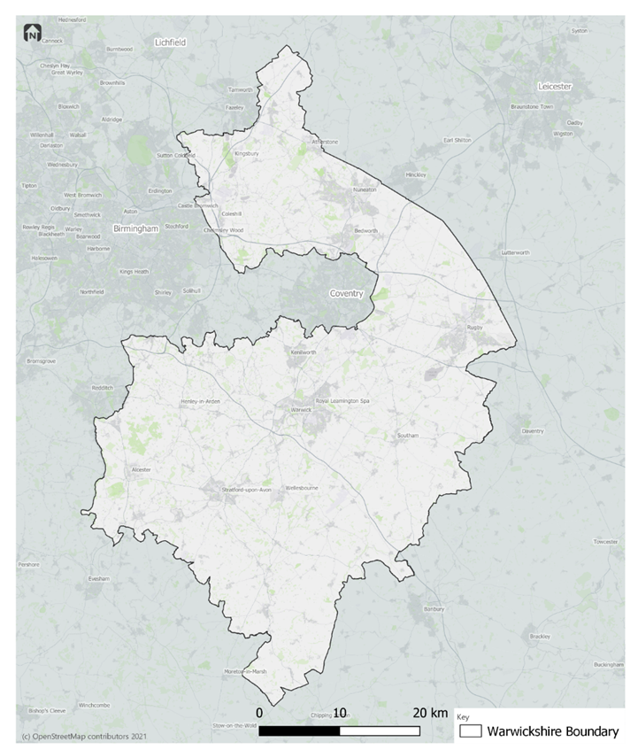

* 1. The area has a mix of distinct urban and rural characteristics and contains a number of market towns where buses serve wider destinations.
  2. The county is amongst the least deprived administrative areas in England[1], ranking 121st out of 151 Councils, although this masks considerable variance by district and borough. For example, Nuneaton and Bedworth falls within the 30% of most deprived districts in the country, while Stratford-on-Avon and Warwick lie within the 20% least deprived.
  3. In October 2021, those claiming Universal Credit or Job Seekers Allowance ranged from 5.1% of residents aged 16+ in Nuneaton and Bedworth Borough to 2.8% in Stratford-on-Avon District and Warwick District. In particular, claimant count among 18-24 year olds is notably higher in Nuneaton & Bedworth than elsewhere in the county. As such this is a priority cohort that we are seeking to support with improved access to employment and training opportunities through local public transport services. Over half of the county’s population of around 584,000 inhabitants are concentrated into the following locations:
* Nuneaton
* Rugby
* Leamington Spa
* Bedworth
* Stratford-on-Avon
* Warwick
* Kenilworth
  1. These also reflect the strongest market areas and opportunities for bus travel in the county. However, high levels of car ownership[2] in Warwickshire, place significant pressure on road-space and result in traffic congestion in urban areas of the county that limits the ability of bus services to offer competitive journey times along many routes. This is especially the case on the main routes into urban centres in Warwickshire.

# Bus travel in Warwickshire

## Bus Travel Trends

* 1. In general, Warwickshire has seen a downward trend in bus passengers over the last decade as shown in Figure 3‑1, decreasing by 19% between 2009/10 and 2018/19, whilst England saw a decrease in patronage of 7% during the same period from 4,611.4 to 4,306.1 million[3].
  2. Passenger journeys (million) on local bus services by local authority (DfT Bus0109a) is shown in Figure 3‑1 below.

Figure 3‑1: Warwickshire bus passenger trends

* 1. Table 3‑1 shows that although the proportion of passengers travelling with an English National Concessionary Travel Scheme (ENCTS) pass has fallen over recent years (in line with the rise in age of eligibility), in 2019/20, 38% of all bus passengers in Warwickshire were concessionary travellers. This is significantly higher than the England average of 21%. The concessionary section of the bus market is also taking the longest time to recover post-Covid; according to September 2021 ENCTS reimbursement claims for all operators in Warwickshire, concessionary trips are 55% of the number of trips witnessed in September 2019.

Table 3‑1: Concessionary travel trends in Warwickshire[4]

| **Year** | **Total passenger journeys (million)** | **Of which ENCTS (million)** | **% ENCTS** | **% ENCTS England** |
| --- | --- | --- | --- | --- |
| 2009/10 | 17.0 | 6.2 | 36 | 23 |
| 2010/11 | 17.6 | 6.4 | 36 | 23 |
| 2011/12 | 17.6 | 6.5 | 37 | 23 |
| 2012/13 | 17.1 | 5.8 | 34 | 22 |
| 2013/14 | 19.2 | 6.4 | 33 | 22 |
| 2014/15 | 18.8 | 6.4 | 34 | 22 |
| 2015/16 | 19.2 | 5.4 | 28 | 22 |
| 2016/17 | 15.5 | 5.2 | 34 | 22 |
| 2017/18 | 14.0 | 4.8 | 34 | 22 |
| 2018/19 | 13.7 | 4.6 | 36 | 22 |
| 2019/20 | 11.0 | 4.2 | 38 | 21 |

* 1. Over the past decade, there has been a steady decline in the number of bus passenger journeys per head of population in Warwickshire (DfT Bus0110a), (Figure 3‑2), reducing by 23% from 31.3 in 2009/10 to 24.1 journeys per person in 2018/19. This trend reflects the challenges the authority has faced in maintaining service levels, which have resulted in supported service frequency reductions and removal of certain under-used services.

Figure 3‑2: Bus passenger journeys per head of population[5]

### More recent Covid-19 patronage impact

* 1. As witnessed across the UK, the Covid-19 pandemic and associated government guidance implementing movement restrictions, requiring social distancing and mask-wearing on public transport, has had a significant impact on bus patronage.
  2. Figure 3-3 below compares the number of bus passenger trips per month (as provided by four of the county’s main bus operators) in May 2019 (pre-pandemic) and in May 2021. It shows there has been a 49% reduction in bus patronage as a result of the pandemic.

Figure 3‑3: Bus passenger trips pre-Covid vs current

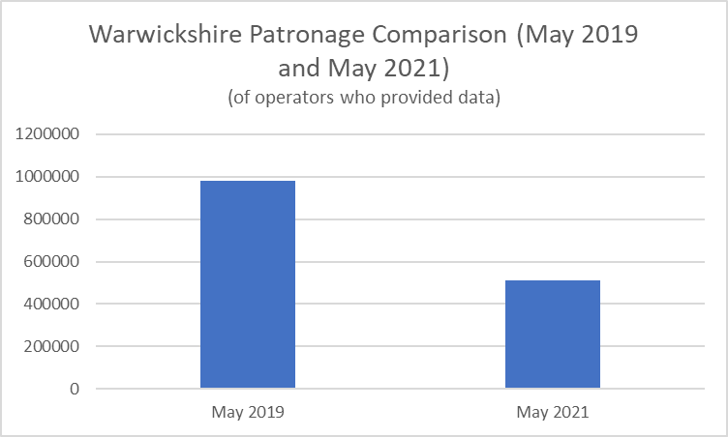

* 1. Both commuter and concessionary bus trip numbers have decreased significantly and appear set to remain below pre-pandemic levels for the foreseeable future – with more flexible working patterns, higher levels of online retail and leisure activity, and lingering uncertainty among some people about returning to using public transport all combining to change the peak times for travel and overall volumes of trips that people are making.

## Bus Network

* 1. The primary providers of passenger transport services in Warwickshire are commercial organisations that operate local bus services on a profit-making basis, as envisaged when the local bus service market outside London was de-regulated in 1985. It is generally in the interests of the people of Warwickshire for commercial bus networks to be attractive, efficient, and stable; also commercial networks require no subsidy and there is, therefore, no cost to the taxpayer. Such networks can meet the needs of many people in providing a means of collective transport that reduces congestion on our roads, limits vehicular emissions and provides access to work and life opportunities.
  2. Facilitating and supporting an appropriate mix of services, working with communities and commercial and 3rd sector operators, is a key aim for the Council, against a backdrop of a challenging funding situation. These are intended to meet statutory requirements, help Warwickshire County Council deliver on its strategic priorities and outcomes, and support the people of Warwickshire in accessing key services.
  3. The map in Figure 3-4 below shows the extent of the network, highlighting the hourly link frequency at the AM peak, showing the combined frequency of bus services along each road, regardless of service or operator. A significant portion of the county does not have access to a regular bus service, reflecting sparsely populated, more rural areas.

Figure 3‑4: Link frequency of bus services



* 1. There is no dominant operator of commercial routes – Arriva and Stagecoach together account for approximately 85% of the local bus market. Johnsons Coach and Bus, and National Express, make up most of the remaining market share, with a number of other operators running a smaller number of services, mainly through cross-border routes.
  2. There are several bus services operating in the county which the County Council considers appropriate to secure and financially support, in addition to those operated commercially, in order to meet priority social needs. In 2019/20, Warwickshire County Council provided £3,633,000 of financial support for bus services, which equates to £6.29 per head of population.
  3. Warwickshire County Council fully subsidises 60 routes and partly subsidises 17 routes.
  4. Analysis of the local bus network was undertaken to identify the proportion of the population within walking distance (determined as 400m) of a bus service. It reveals that over half (56%) of the population is within 400m access to a service operating at a frequency of 30 minutes or more in the weekday morning peak; 66% within access of an hourly service. The comparison with the same service frequencies for the evening period (off-peak) is stark - but typical of many similar locations elsewhere in England. It shows that public transport connectivity diminishes (by around half of its peak-time scale) in the evening, when 27% of the population lives within 400m of a half-hourly service and 45% is within 400m of an hourly service.
  5. In practice, the available scheduled local public transport network ‘shrinks’ substantially during the evening to focus upon key local towns and a small number of inter-urban routes. This is largely a function of the extent to which the bulk of the county’s population is focused on Warwickshire’s largest towns, and the major roads that connect them to each other. It also reflects traditionally lower levels of travel demand away from morning and evening (school and work-related) travel peaks, which many predict may evolve and change post-pandemic as a consequence of accelerating changes to working practices, retail and leisure habits.
  6. In addition to conventional bus services, the County Council currently funds demand responsive transport (DRT) services which are essential in providing access to bus services in both rural and semi-urban areas of the county where conventional scheduled bus services are challenging to sustain financially. These DRT services operate cars and minibuses on specific days of the week. Journeys only operate if bookings are received, with bookings being made directly with the operator. ENCTS passes are accepted for travel on these services.
  7. The council also funds some community transport services across the county which complement the local bus network, and provide lifeline services for those who are unable to use conventional bus services. Whilst being a valuable offer, they are heavily dependent on the availability of volunteers and resources to co-ordinate such schemes. Access can be variable, and they tend only to serve those who are unable to use public transport and pre-registered users – with limited coordination or integration to scheduled bus and rail services that operate in the county.
  8. Several rail lines operate through Warwickshire, providing connectivity to London, Birmingham and other towns and cities across the Midlands. With significant development planned, and the arrival of HS2 through the county, rail services will be improved, including new rail stations – as set out in the Warwickshire Rail Strategy. Whilst there is currently some integration between bus and rail services, there is significant opportunity to improve this to provide a better integrated network.
  9. The map in Figure 3-5 below shows the rail lines and airports in Warwickshire and where the main interchanges are located.

Figure 3‑5: Warwickshire Public Transport interchanges

## Bus Fleet

* 1. The bus fleet deployed in Warwickshire predominantly has Euro VI (see Figure 3-6) as of October 2021, which equates to 57% out of 269 buses. There is currently 1 electric bus, which represents less than 1% of the total number of buses.
  2. In general terms, older buses are more polluting than newer buses. The average age of buses in Warwickshire is 8.9 years old, (Figure 3‑7). The tendency among operators is to cascade vehicles as they age from more profitable urban services onto county services.
  3. Warwickshire will see a significant uplift in bus fleets on cross boundary routes into Coventry with the introduction of electric buses on these corridors as part of the Coventry All Electric Bus City project. WCC has committed funding towards on-street electric vehicle charging infrastructure and local bus operators are making a significant contribution (£78m) to the total cost of the programme. Further opportunities to expand the zero emission buses will be sought, although this is likely to be beyond 2024/25 after the rollout of electric vehicles on the cross-boundary routes

Figure 3‑6: Composition of Warwickshire bus fleet[6]

Figure 3‑7: Average age of Warwickshire bus fleet

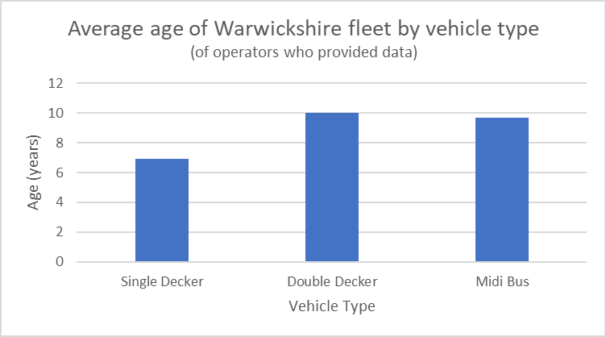

## Fares and Ticketing

* 1. In Warwickshire, single fares can vary from one location to another, which is understandable given the size of the county and the varying lengths of route. Nonetheless, fares are generally more expensive when compared with those in nearby urban areas.
  2. A range of tickets are available by different operators, focussed on attracting different markets according to the types of service they operate. There are different products available in the county, catering for different demographics, travelling at different frequencies; 23 different day tickets; 8 different weekly tickets; and 15 different season tickets. ENCTS travel accounts for around 39% of all passenger journeys.
  3. Tickets are not consistent across operators, for instance, different operators offer different tickets for children and young people, defining different ages and different discounts. Child and young person’s ticket discounts range from 20% - 50% off the cost of an adult equivalent ticket; student ticket discounts are around 30% off the cost of an adult equivalent ticket, but not all operators offer student tickets.
  4. Tickets are available for purchase on-bus; on-line; and via apps for the main operators. Contactless payment is available on most services.

## Timetables and Information

* 1. Operators in Warwickshire provide information through their own websites, social media, and apps including: Journey planning; Route maps; Timetables; Real-time information (in some locations) and service disruption updates. They also maintain timetable information for bus stops and interchange points.
  2. Warwickshire has its own [public transport webpage](https://www.warwickshire.gov.uk/public-transport) that includes links to various bus service information, including maps, timetables, school transport, community transport, concessionary passes, and timetable changes, though keeping abreast of changes is a challenge. The maps are updated by the County Council and links to operators’ websites are included to provide up-to-date timetable information. Whilst the County Council’s website covers basic public transport information, additional content could be included online to support new and existing bus users.

## Other Factors that Affect Use of Local Bus Services

### Parking provision

* 1. Car parking is plentiful in most towns across Warwickshire. While parking charges vary from place to place, they are comparable to – or cheaper than – return/all-day adult bus fares (typically £4 - £6 for a direct bus journey) in many locations. This is particularly true for parking stay durations of up to 3 or 5 hours, which are more common for leisure trips than for commuting.
  2. In some locations free parking is available on weekday evenings and on Sundays, which challenges the aspiration to extend bus operations at these times. The range of weekday parking prices Warwickshire’s main towns, as set by the District and Borough Councils in the area, is summarised in the table below:

Table 3-2 Car parking prices in Warwickshire towns

|  |  |  |  |
| --- | --- | --- | --- |
| **Location** | **Up to 1 hr** | **Short Stay**  **(3-5hrs)** | **All day**  **(11 – 24 hrs)** |
| Bedworth: | £0 | £1 (up to 3 hrs) | £4 - £6.50 |
| Nuneaton: | £0 | £1 (up to 3 hrs) | £0 - £6.50 |
| Kenilworth | £0 - £50p | £2.50 (up to 3hrs) | £5.50 |
| Leamington Spa: | £1.10 | £2.00 (up to 3hrs) | £4.40 - £8.00 |
| Rugby: | £1 (up to 2 hrs) | £2.50 (up to 5 hrs) | £5 - £10 (11 hrs) |
| Stratford-on-Avon | £1.20 | £3.50 (up to 3 hrs) | £12.00 |
| Warwick | 70p - £1.10 | £2 (up to 3hrs) | £4 - £6 all day |

* 1. For anyone travelling by car with a passenger, car travel is likely to be significantly cheaper than the equivalent bus fares. Car parks are also indirectly prioritised in some locations by virtue of their proximity to key town centre destinations when compared with bus stop locations and interchanges.

### Branding

* 1. Most bus services in Warwickshire are operated by national commercial operators. Consequently the branding of bus services across the county aligns primarily with each of these operators, and their regional designations, as opposed to any specific branding for routes in Warwickshire. Most buses are wrapped in the operators’ respective branding colours.

Generally, there aren’t any exclusive colours used to differentiate Warwickshire’s services from services operated in other parts of the country by the same operator. This is also reflected in the timetables and maps online. There are some exceptions to this, such as the ‘Unibus’ for the University of Warwick.

# Public Perceptions and Priorities for Improvement

* 1. An online public engagement survey, which was live between 26th July and 19 September 2021, sought to gather the views of Warwickshire residents and visitors regarding their use of bus services and measures that would encourage them to increase their bus travel. A total of 1,653 responses were received, which included councillors and representatives of organisations.
  2. Figure 4‑1 shows the top eight measures residents and visitors considered would increase their bus use in Warwickshire ‘a great deal’. The public engagement survey also identified the following priorities for the Warwickshire BSIP on the basis they would be most likely to encourage Warwickshire residents to use local buses in Warwickshire more frequently:
* More comprehensive services - particularly more frequent bus services serving more destinations.
* Better journey information - including provision of real-time information provision at bus stops.
* Better journey planning websites and apps, as well as better provision of static timetable information and on-bus information; and
* Faster, more environmentally friendly, and more-reliable services.
  1. Among regular users and infrequent / non-users, two of the top three measures were the same – ‘more frequent services’ and ‘easier access to bus service information’. ‘Lower fares’ were considered more likely to increase bus use by infrequent and non-users than by regular users. The capability for contactless fare payment was considered more effective at encouraging increased bus use by infrequent / non-users than by regular users.

Figure 4‑1: Measures that would encourage Warwickshire residents and visitors to increase their bus use



* 1. Key stakeholders regularly mentioned the issue of access to and from rural areas and new developments by bus. This was reflected by stakeholders’ highest ranked potential BSIP measures, which included:
* Improving the reliability of local bus services (highest ranked)
* Improving the frequency of services
* Extending bus service hours earlier and later in the day and at weekends,
* Providing for a more comprehensive network and
* Addressing the issue of the cost of using the bus.
  1. Focus groups were undertaken with people from Black, Asian, and Minority Ethnic backgrounds; younger people; and people with hidden disabilities in Warwickshire. There were differences in opinions, both within and between the three groups, with respect to prioritisation of potential measures to increase bus use.
* There was general consensus amongst residents from BAME backgrounds that more frequent and reliable services, better journey information, more comprehensive services and cheaper and easier to understand fares would be the measures most likely to encourage non-users to try using bus services in Warwickshire.
* There was less consensus amongst the group of residents with hidden disabilities, with the obvious exception that better facilities on the bus and at the bus stop should be the main priority areas to be addressed. Better on-bus information through provision of next stop displays and audio announcements was a popular request for this group to assuage their anxiety when travelling by bus.
* Younger people tended to be more positive about their experiences of bus use in general, but requested more comprehensive services, lower and simpler to understand fares (with a particular preference for contactless, multi-operator ticketing solutions) and the provision of better journey information, both in static and digital form (but with an emphasis on providing improved bus planning and journey tracking apps).
  1. The full survey analysis report can be accessed on the Warwickshire public transport website.

# Bus journey speeds and the impact of congestion

* 1. According to DfT’s Road Traffic Statistics, 6.27 billion vehicle miles were travelled on roads in Warwickshire in 2019, of which 4.84 billion (over 77%) were travelled by cars and taxis. For cars and taxis and all motor vehicles, this is an increase of 8% compared to the equivalent figures for 2014[7].
  2. Pre-pandemic, the trend in Warwickshire has been for increasing volumes of vehicular traffic leading to worsening levels of congestion at key highway junctions and in the county’s towns. This has partly been driven by local housing and employment growth - over 4,000 new homes were completed in each of 2018/19 and 2019/20[8], generating more local car trips. The numbers of LGV and HGV trips on local networks also continue to grow, a by-product of rapid growth in online retail and expanding logistics operations.
  3. Post-pandemic, the local picture has changed, with lower total numbers of person trips now spread across the whole week (not concentrated into weekday peaks) and a greater portion made by car. Long-term, the number of households is forecast to increase significantly – by anywhere between 50,000 and 160,000 additional homes over the next 10-20 years[9] - putting further pressure on local highway networks unless people’s travel choices and options change.

Figure 5-1 Projected number of households in Warwickshire (ONS)

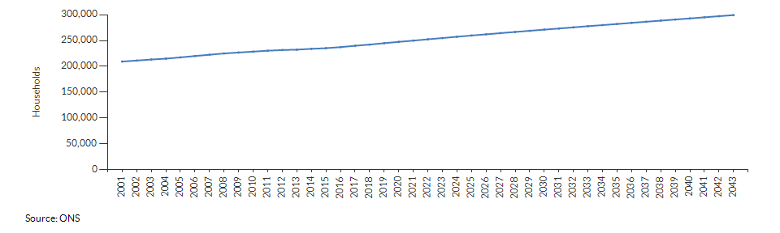

* 1. There are currently very few bus lanes in the county, which means that on most routes buses are running in mixed traffic and exposed to the same congestion and delays as other vehicles. Those which do exist, encounter challenges of infringements by private cars, resulting from a lack of enforcement, causing delays to bus services on a regular basis. Some traffic signals in the county afford priority for bus services – by extending green-time cycles when buses are detected on approach to junctions – but these are not centrally coordinated, so there is limited scope to optimise bus services along priority corridors.

Dialogue with bus operators through the BSIP development process has identified key traffic congestion ‘pinch points’ for bus services in a number of locations, including:

* Rugby - Town Centre generally and Clifton Road in particular
* Kenilworth - Abbey Hill
* Bedworth - Mill Street
* Nuneaton - A444 approaching Nuneaton Bus Station from Coton Road.
* Leamington Spa - Town Centre generally with slow movement from Kenilworth Road via The Parade to High Street.

The result for bus operators has been a rising Peak Vehicle Requirement on many routes – with more buses needed to maintain service frequencies as average in-service bus speeds drop – which has exacerbated the previously identified shortage of bus drivers. As new housing growth extends the urbanised areas of Warwickshire, and with it the typical travel times to local centres and rail stations from residential areas, it is likely that bus journey lengths and journey times may lengthen further.

Although contributions from new development (including S106 monies) can be used to mitigate this impact and enhance local bus services, wider measures will be required to ensure enough mode shift and bus priority measures are in place to ensure bus reliability and decreased journey times.

# Enhanced Partnership Plan Aims and Objectives

* 1. The overall aim of the Warwickshire Enhanced Partnership is for the parties to work together to deliver measures to improve bus use, to the extent that is feasible with available funding. The aim is for **bus services in Warwickshire to better meet the aspirations of local communities by becoming more frequent, more reliable, and better integrated with other travel options. New ticket options, marketing campaigns, promotional fares and supportive local policies will help to drive growth in local bus patronage. Along with emerging technologies and clearer information about bus schedules, all components will help to reduce and simplify the cost of bus travel while sustaining a comprehensive network of bus services across the county**.
  2. Within this overall aim, the objectives of the EP are:

1. Provide more frequent buses.
2. Enable bus services to become faster and more reliable.
3. Offer ticketing solutions and fares which are cheaper for the user.
4. Provide a more comprehensive network.
5. Make the bus network easier to understand.
6. Make the bus network easier to use.
7. Provide a network which is better integrated.

## Interventions

* 1. The Plan provides the backdrop for specific EP Schemes that will detail actions and developments to be taken jointly by partners to deliver a significant improvement in bus services in Warwickshire that will help meet the above objectives. The table below sets out the interventions required to meet these objectives.

Table 6-1 Interventions to meet objectives

| **Objective** | **Intervention** |
| --- | --- |
| More frequent buses | * Deliver more frequent bus services on routes providing access to key employment sites. * Improve bus service frequencies across the county’s network into the evenings and on Sundays. |
| Faster, more reliable | * Enforce bus clearways across the county. * Improve targeted bus priority with a particularly early focus on two key corridors:   + Stratford – Warwick – Leamington – Kenilworth   + Nuneaton – Bedworth – Coventry * Work with District/Borough Councils to review parking supply and charges to improve bus service competitiveness. * Deliver the Nuneaton bus bridge, to reduce delays for services operating into the town centre. |
| Cheaper | * Maintain the existing subsidised bus network in Warwickshire to meet customer needs (routes, flexibility and accessibility). * Deliver a multi operator bus ticket in Nuneaton; Warwick; and Rugby in the lead up to the Commonwealth Games in 2022, before developing a county wide solution. * Introduce a jobseeker support scheme to provide discounted bus travel for people who would otherwise struggle to access employment opportunities. |
| More comprehensive | * Support services to maintain the pre-Covid Warwickshire Bus Network. * Pilot an app-based Demand Responsive Transport (DRT) service to serve rural settlements to the West of Warwick and parts of Kenilworth. * Use growth-related funding (S106 monies), and collaboration with district planning authorities and bus operators, to expand local bus networks and include bus priority ‘by design’ in new housing/employment area developments. |
| Easier to understand | * Phased delivery of real-time information along key corridors. * Establish a one-stop gateway for access to information. * Coordinating and minimising timetable changes across bus operator networks. * Improve roadside/in-street route and timetable information, including the use of digital displays. |
| Easier to use | * Fit ‘next stop’ audio-visual information systems to buses. * Produce a guide encouraging people to use bus services. * Phased roll-out of ‘Top-on / Tap-off’ technology on key corridors. * Align bus ticket options to simplify existing fares. * Adopt a passenger charter across all bus operator networks. * Introduce Super Stops at key bus stop locations. |
| Better integration | * Integrate bus services and timetables to maximise scope for multi-modal connections. * Pilot rural mobility hubs in targeted locations identified through a full review of the network. * Annual Warwickshire bus conference to resolve key issues. |

* 1. An EP Plan can only exist if there is at least one associated EP Scheme in place. Therefore, for as long as an EP Scheme is in place, a Plan must also be in place.

## Funding Sources

* 1. The Enhanced Partnership will draw on multiple funding sources to deliver the desired outcomes of the Enhanced Partnership Scheme(s), as appropriate:
* Funding provided by Central Government
* County Council capital funding
* County Council revenue funding
* Developer contributions
* Operator investment
* Reinvestment of operator revenue generated by schemes
* Other external funding opportunities.

# Enhanced Partnership Plan Governance

* 1. The County Council and all operators supported the proposal for an Enhanced Partnership (EP) and the Council published a notice of intent to develop an EP on 22nd June 2021. A Warwickshire Visioning Group was created, consisting of Warwickshire County Council and all operators to develop the BSIP. Monthly meetings were held, chaired independently to allow authority officers and operators to discuss things freely on equal terms. All operators are invited to attend meetings and contribute to its work.
  2. This Visioning Group has been developed into an Enhanced Partnership Board to develop this Plan and the accompanying Scheme.
  3. The Enhanced Partnership Board has overseen and championed the development and introduction of the EP, whilst also prioritising enhancements and improvements set out in the BSIP based on the funding received from Government. The Board will develop any future Schemes and any variations to existing Schemes.

Membership of the Enhanced Partnership Board comprises:

* Warwickshire County Council officers (Public Transport and Highways teams)
* All bus operators operating qualified bus services
* Bus user representative (Chair)
* Train operating companies
* Local business representatives

#### Meeting arrangements

* 1. Warwickshire Enhanced Partnership Board meetings will take place four times per year at regular intervals, with provision for additional meetings as required to make recommendations which in the opinion of the Chair cannot be deferred to a scheduled meeting, provided that a quorum (at least the top three operators according to mileage operated in Warwickshire, plus a Warwickshire County Council representative) can be achieved, with not less than one week’s notice being given. Meetings will be arranged, and minutes taken, by the County Council or its consultants, and may be held virtually. Meeting length will vary according to agenda content but ordinarily be one to two hours.
  2. Agendas and meeting papers will be circulated to all Board members no less than one week in advance of each meeting date, and draft minutes circulated no more than two weeks after each meeting. Copies will also be distributed to neighbouring authorities so any issues or concerns can be raised at the Warwickshire Enhanced Partnership Board meetings. Draft minutes will be approved at the following Warwickshire Enhanced Partnership Board meeting.
  3. An Enhanced Partnership Stakeholder Reference Group provides external insight and constructive challenge. This group consists of, where relevant, Council officers, other public transport operators, district and borough councils, community transport operators, bus user group representatives, business group representatives and other relevant key stakeholders.
  4. In addition, a cross-party members group, at a political level, has been established to provide input and guidance to the EP Board.
  5. Continuous dialogue is held with neighbouring authorities to ensure the EP delivery is compatible with neighbouring EPs.
  6. An Enhanced Partnership Scheme Delivery Group(s) will be responsible for implementing the measures set out in the EP Scheme(s). This group will consist of representatives from the Council, bus operators and other relevant stakeholders and experts as appropriate. It will establish specific task and finish groups to implement particular measures, and will report directly to the Enhanced Partnership Board.
  7. The Board has consulted the following in the development of this Plan:
* Transport Focus
* Traffic Commissioner
* Chief Officer of Police
* Competition and Markets Authority
* Neighbouring authorities
  1. The relationship between these different groups is shown in Figure 4.2.

Figure 7-1 – Warwickshire EP Governance Structure

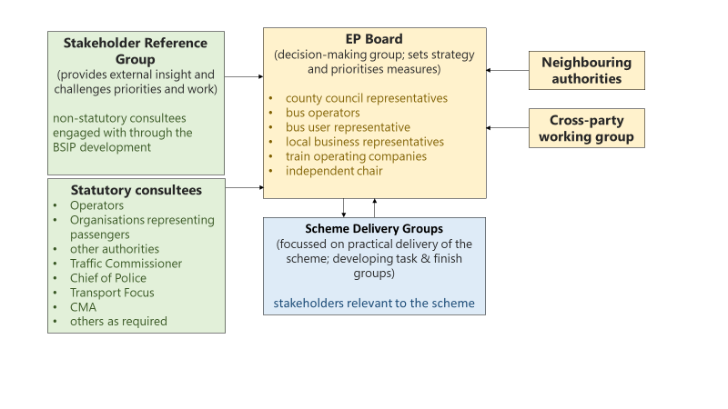

## Monitoring progress

* 1. The success of the EP will be monitored in a number of ways:
* **Passenger satisfaction** will be monitored at a global level across the whole of the county. National Highway and Transportation (NHT) surveys will be used, the most recent of which were conducted in 2017 in Warwickshire[10], and which will be commissioned to repeat each year. Additional, targeted passenger satisfaction surveys will be completed on an as-needed basis – for example to monitor the specific before and after impacts of bus route/priority infrastructure improvements on passenger satisfaction and willingness to use local bus services.
* **Patronage** will be monitored regularly but benchmarked annually based on the statistical data returns all local bus operators submit to DfT via the County Council. Both total passenger trips and the number of passenger trips per capita of population, will be measured, to account for changes in total bus trips linked to local housing and employment growth. Targeted data analysis of operator patronage data will be undertaken so as to understand – on a route-by-route basis – what the impact of specific service improvements and interventions delivered through this EP has been. Where possible a group of ‘control’ routes– that have not received improvement – will be monitored to establish a counterfactual indication of what is happening on parts of the local bus network that have not received upgrades.
* **Punctuality** will be monitored using aggregated operator data that reports the proportions of bus journeys that are on-time / early / late relative to registered timing points. This will be built up across individual routes and measured over each 12 month period to provide a global view of punctuality. This will enable trends in individual routes to be explored – including those operating along corridors where priority bus measures are implemented – and a control group of routes that do not benefit immediately or directly from our EP Schemes.
* **Journey times** will be monitored on an annual basis – aggregating all published schedules and establishing the average amount of time taken to travel ‘one scheduled bus Km’. The purpose of this approach is to create a comparable (across routes, and over time) measure of bus journey times in the local area – with the less time taken to travel 1km, the better. It will identify what overall impact the EP Schemes have on bus journey times across Warwickshire (and compare that with patronage impacts), as well as observing whether significant changes (positive or negative) on any individual routes’ journey times have an immediate or latent impact on patronage and satisfaction.
  1. Consultation and engagement with partners, businesses, special interest groups, elected representatives, and passenger representatives, including those who were engaged with during the development of the BSIP, will continue throughout the life of the EP and is integrated into the EP Governance structure. This will be through regular meetings, public consultation, and through passenger research. Engagement will occur at the same time as the review of the BSIP and EP Plan, and, where appropriate, when specific schemes are being developed, monitored, and evaluated**.**

## Small and medium sized operators

* 1. Given the variety of bus operators involved (in terms of market share, fleet size, company turnover and structure), it is important to ensure that the effects of the Enhanced Partnership do not unduly negatively impact smaller operators’ ability to engage or to comply with requirements.
  2. As such, the needs of small and medium-sized operators (SMOs) have been considered in the development of the Enhanced Partnership, with opportunities for all bus operators to participate throughout, either through individual discussions or through attendance at the Partnership meetings. The Plan seeks to support improvements in all aspects of bus provision, regardless of the size of operators providing services. Within the Enhanced Partnership Schemes, smaller operators may be given extended periods to comply with certain standards.

## Competition

* 1. The Enhanced Partnership has been subject to the Competition Test as set out in Part 1 of Schedule 10 of the Transport Act 2000. The assessment, undertaken by Warwickshire County Council and shared with the Competition and Markets Authority, concluded that there will be no adverse impact on competition. The implementation of an Enhanced Partnership Plan and associated Scheme is aimed at delivering improvements to bus services for passengers in a deregulated environment. The Enhanced Partnership will not impact on competition, as operators will be free to amend and introduce services in the area, provided that the standards that apply to all operators are met.

## Reviewing the EP Plan

* 1. Once the EP Plan is made, it will be reviewed by the EP Board at least annually, following the review of the Warwickshire BSIP. The Council will initiate each review and it will take no longer than 6 months to complete. Monitoring reports for the BSIP will be produced every 6 months to demonstrate progress towards the objectives and targets set.

## Variations to the Plan and Schemes

* 1. Consideration will be given to potential EP Plan and Scheme variations highlighted by one or more of the organisations represented on the EP Board. The proposer of a variation should demonstrate how this might contribute to achieving the objectives set out in the EP Plan and current local transport policies. Such requests should be set out in writing and submitted to Nigel Whyte at Warwickshire County Council by email ([nigelwhyte@warwickshire.gov.uk](mailto:nigelwhyte@warwickshire.gov.uk)).
  2. On receipt of a request for a variation the Council will consider the validity with regards to the proposal. The Council may, in exceptional circumstances, exercise veto over whether a proposed variation is put to the Board where it reasonably believes or suspect as having anti-competitive implications or being otherwise significantly against the public interest or there exist circumstances under which the Council would be unable to comply with any obligations that would be imposed upon the Council were the decision to be implemented.
  3. The decision of the Council would be shared, in writing, with the proposer and the Council would also share the decision with the Board at the next Board meeting convened.
  4. On receipt of a valid request for a variation, the Council will reconvene the EP Board, giving at least 14 days’ notice for the meeting, to consider the proposed variation. Providing that a quorum of at least the top three operators according to mileage operated in Warwickshire, plus a Warwickshire County Council representative, can be achieved, the council will make the EP Plan variation if the proposed variation is agreed unanimously by all bus operators and County Council representatives present. Stakeholders not represented at the meeting will be deemed to be abstaining from the decision.
  5. If there is not full agreement of all stakeholders present, then the proposed variation will be put to the operator objection mechanism, but with a reduced objection period of 14 days replacing Part 2 of the Transport Act 2000 section 138L (2) (c). The proposed variation will be advertised on the Council’s website and emailed to operators of qualifying local services in the EP Plan area. If the proposed variation passes the operator objection mechanism, the Council will make the variation, subject to the approval of Warwickshire County Council.
  6. Procedures, as set out at s138L and 138M of the TA 2000 (as amended), will be followed for major variations and to initiate new Schemes.

## Revocation of EP plan

* 1. If, for some reason, it becomes necessary for the EP Plan to be revoked, the EP Board will be reconvened and follow the same process as outlined in the section ‘Variations to the Plan’ (noting that the agreement will be for revocation and not variation).
  2. If at any point in the future the EP Plan area is included in a Bus Franchising Area, the relevant requirements set out in this EP Plan document will cease to apply from the commencement date of the Franchising Scheme.

1. IMD (2019), available at: https://api.warwickshire.gov.uk/documents/WCCC-644-576
2. [KS404UK (Car or van availability) - Nomis - Official Labour Market Statistics (nomisweb.co.uk)](https://www.nomisweb.co.uk/census/2011/ks404uk)
3. DfT Bus 0109a - [bus0109.ods (live.com)](https://view.officeapps.live.com/op/view.aspx?src=https%3A%2F%2Fassets.publishing.service.gov.uk%2Fgovernment%2Fuploads%2Fsystem%2Fuploads%2Fattachment_data%2Ffile%2F1030632%2Fbus0109.ods&wdOrigin=BROWSELINK)
4. Based on DfT bus statistics Tables BUS0109 and BUS0113, as published June 2021
5. Dft Bus0110a - [Local bus passenger journeys (BUS01) - GOV.UK (www.gov.uk)](https://www.gov.uk/government/statistical-data-sets/bus01-local-bus-passenger-journeys)
6. Based on data supplied by the majority of bus operators
7. [Road traffic statistics - Local authority: Warwickshire (dft.gov.uk)](https://roadtraffic.dft.gov.uk/local-authorities/60)
8. Warwickshire CC (2021) *Net additions for Warwickshire*. Available at: <https://data.warwickshire.gov.uk/housing/>
9. ONS estimates forecast +50,000 households to 2043 (from 2021), while the [Warwickshire Rail Strategy](https://ask.warwickshire.gov.uk/communities/draft-warwickshire-rail-strategy-2019-2034/supporting_documents/WRIS%20DRAFT%20for%20consultation%20201934%20FINAL.pdf) (2019) references +160,000 additional homes in the county by 2033.
10. National Highways and Transport Network (2017) *NHT Survey Report – Summary Report for Warwickshire CC*. Available at: <https://ask.warwickshire.gov.uk/business-performance/national-highways-and-transport-network-survey/results/authority_summary_report-wcc-2017.pdf>