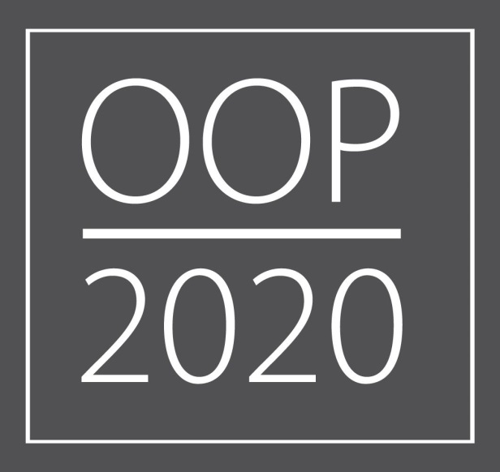

EQUALITY IMPACT ASSESSMENT/ ANALYSIS (EqIA)

PL-CSOC-21 Children's Centres

To ensure sustainability of services to the most vulnerable and hard to reach, the OOP 20/20 savings target of £1.12M will be delivered via a community led approach to specialist early years community development. Revised funding formulae have been developed to look at different ways of distributing the budget in order to focus on areas of deprivation and poor school readiness. This will ensure funding will be allocated to those communities that have more vulnerable children and families. The 0-5 offer may be provided in a different way at some Children’s Centres by community groups, voluntary, private and independent early year’s providers and schools. The proposal being consulted on in summer 2017 is for 12 locations to remain designated as Children's Centres, with the ability to operate differently using a hub and spoke model. The vision for 2020 is to integrate the commissioning of Children's Centres with the commissioning of health visitors and family nurse partnerships to provide an enhanced range of services at Family and Community Hubs with the focus on services rather than buildings. The change to children’s centres is foundational to this vision, and to longer term sustainability.

Warwickshire County Council

Equality Impact Assessment/ Analysis (EqIA)

Group | People
Business Units/Service Area | Children & Families
Plan/ Strategy/ Policy/ Service being assessed | OOP PG_CF_14-18  OPP PG_CF_05  £1.12M savings
Is this is a new or existing policy/service?  If existing policy/service please state date of last assessment | Existing  Children’s Centres Group/Collaboration Model  (Contracts 1st September 2014 – 31st August 2017); newly commissioned (Sep 2014) following service re-design resulting from budget reductions.  October 2014
EqIA Review team – List of members | Bill Basra  Fiona McCaul
Date of this assessment | 29/6/17
Signature of completing officer (to be signed after the EqIA has been completed) | Bill Basra
Are any of the outcomes from this assessment likely to result in complaints from existing services users and/ or members of the public?  If yes please flag this with your Head of Service and the Customer Relations Team as soon as possible. | Yes, Head of Service aware.
Name and signature of Head of Service (to be signed after the EqIA has been completed) | 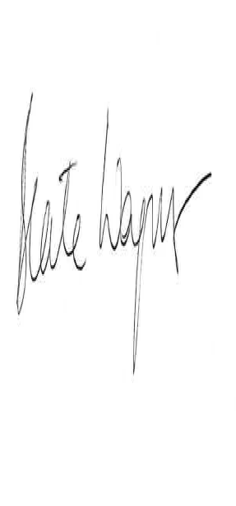  Beate Wagner
Signature of GLT Equalities Champion (to be signed after the EqIA is completed and signed by the completing officer) | Chris Lewington  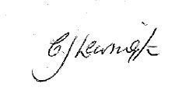

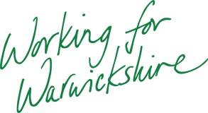
A copy of this form including relevant data and information to be forwarded to the Group Equalities Champion and the Corporate Equalities & Diversity Team
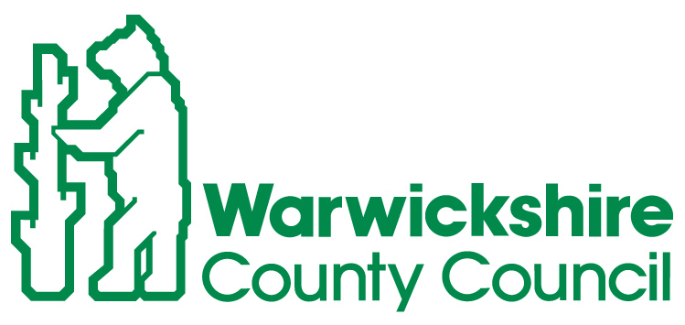

Form A1

INITIAL SCREENING FOR STRATEGIES/POLICIES/FUNCTIONS FOR EQUALITIES RELEVANCE TO ELIMINATE DISCRIMINATION, PROMOTE EQUALITY AND FOSTER GOOD RELATIONS

High relevance/priority Medium relevance/priority Low or no relevance/ priority

Note:
1. Tick coloured boxes appropriately, and depending on degree of relevance to each of the equality strands
2. Summaries of the legislation/guidance should be used to assist this screening process

Business Unit/Services: | Relevance/Risk to Equalities
State the Function/Policy /Service/Strategy being assessed: | Gender |  |  | Race |  |  | Disability |  |  | Sexual Orientation |  |  | Religion/Belief |  |  | Age |  |  | Gender Reassignment |  |  | Pregnancy/ Maternity |  |  | Marriage/  Civil Partnership (only for staff):
0-5 Community Redesign of Children’s Centre Services

Are your proposals likely to impact on social inequalities e.g. child poverty for example or our most geographically disadvantaged communities? If yes please explain how.  Warwickshire’s 39 Children’s Centres currently deliver the same offer across Warwickshire, based on a model of 10 groups and collaborations. The model: - proposes a targeted approach that focuses on delivery of services rather than the maintenance of buildings - proposes to ensure that services can be accessed easily by the most vulnerable children & families that are hard to reach. - produces greater integration under the Children & Families Transformation agenda. - will deliver a budget reduction of £1.12M to this service ensuring resources remains focussed on the most vulnerable children, families and communities in Warwickshire. By working with communities and early years providers we hope to reduce the impact on communities in a manner that is most appropriate to need. Any impact will be in areas of greater affluence where there is more community capacity and resilience, so reducing the impact on the most vulnerable. YES  Are your proposals likely to impact on a carer who looks after older people or people with disabilities? If yes please explain how. An overall reduction in services may impact on families who have children with disabilities. Currently Childrens centres work closely with IDS in supporting referrals and some centres offer 2Help nurture nurseries that will be supporting some children with disabilities. YES |  |  |  |  |  |  |  |  |  |  |  |  |  |  |  |  |  |  |  |  |  |  |  |  | YES

Form A2 – Details of Plan/ Strategy/ Service/ Policy

Stage 1 – Scoping and Defining

(1) What are the aims and objectives of Plan/Strategy/Service/Policy? | This presents the opportunity for greater promotion of family hubs and whole family approach and for the consolidation of services and centres where the need is greatest and to ensure that services can be accessed easily by the most vulnerable children & families that are hardest to reach.  In order to remain sustainable, £1.12M savings must be made from managing and providing Children’s Centres service, mandated in the OOP2020 plan but this plan will ensure that WCC will uphold its statutory duties so that every child in Warwickshire will have the best start in life that builds independence, school readiness and resilience.
(2) How does it fit with Warwickshire County Council’s wider objectives? | WCC core purpose of:  “Develop and sustain a society that looks after its most vulnerable members, delivers appropriate, quality services at the right time, and seeks opportunities for economic growth and innovation.”  In additions the work links with the following plans, strategies and programmes:  - One Organisational Plan 2020  - Smart Start Strategy 2016-2020: Giving Warwickshire’s children the best start in life  - Community Capacity Programme
(3) What are the expected outcomes? | - A re-focussing of resources on the most vulnerable children, families and communities in Warwickshire to improve their outcomes and support children to be school ready  - A budget reduction of £1.12M
(4)Which of the groups with protected characteristics is this intended to benefit? (see form A1 for list of protected groups) | Age – as a result reshaped 0-5 provision
Stage 2 - Information Gathering

(1) What type and range of evidence or information have you used to help you make a judgement about the plan/ strategy/ service/ policy? | Smart Start Foundation Programme has a Needs Assessment and has undertaken extensive asset mapping and engagement work across all communities of Warwickshire, recognising the protected characteristics. This has helped informed the Smart Start Strategy and has helped inform proposals. We have also relied on extensive work undertaken by Commissioning since 2015.
(2) Have you consulted on the plan/ strategy/ service/policy and if so with whom? | Consultation 29th June to 11th September 2017  See Cabinet paper of 15th June 2017
(3) Which of the groups with protected characteristics have you consulted with? | The reduction in services has the potential to impact upon our ability to engage with children and parent/carers across all protected characteristic and of no specific protected characteristic. No specific consultation or those with protected characteristics has been undertaken at this point; consultation is taking place as per (2) above.  However as part of the consultation and redesign we shall be taking account of the learning and feedback from community members involved in the Smart Start engagement and asset mapping programme undertaken in 2016 and this will be included in the EIA Action Plan accordingly. This involved a total of 1,127 parents, 42% had used Children Centres’ often and 58% did not use children’s centres very often. The methods incorporated:  - 574 online survey responses  - 377 Face to face interviews  - 36 Focus groups  The range of methods used was to reach those who would not normally engage or have less of a voice and in relation to engaging families within the protected characteristic ;  - 17% of the respondents identified as non- white British  - 10% stated that English was not the first language spoken at home  - A total of 6% considered themselves to disabled  - 10% stated they had at least one child with disability  - When asked if anyone in the household was employed? 13% of the respondents said no; this is broadly in line with the 11% of households in receipt of out of work benefit  - 12% of respondents identified as receiving lone parent benefit
Stage 3 – Analysis of impact | Through the re-design and reduction in budget, there will be an inevitable impact on all services and service users, which will affect all families including those with protected characteristics. We will consider the impact of groups with protected characteristics alongside how we support their consultation within the process as part of our planning. All relevant characteristics have been taken into account in the design of the consultation survey which captures information in regard to a range of protected characteristics; we also considered it in the planning and delivery of the consultation events; consideration of impact forms a key part of how the consultation questionnaires are analysed and fed into the redesign of 0-5 services.
(1) From your data and consultations is there any adverse or negative impact identified for any particular group which could amount to discrimination?  If yes, identify the groups and how they are affected. | RACE  - Approximately 16% of 0-4s in Warwickshire were identified in the 2011 Census as having an ethnicity other than White English/Welsh/Scottish/Northern Irish/British/Irish.  - The ethnic breakdown varies across the county and therefore some children’s centre groups may identify some communities within their target groups.  - Those with English as a second language may need to use interpretation and translation services in order to gain access to provision. | DISABILITY  - A reduced range of services may have an impact for families with disabled child or disabled parents as a consequence of reduced provision distance to travel to services, lack of transport and use of community provision lacking specialist support.  - Children’s Centre Groups and Collaborations collect data on children with special educational needs and disabilities currently and some have chosen to target services for these groups | GENDER  - The service specification requires that services are accessible at a range of times to all members of the family. Whilst both males and females are registered for Children centres; females are, the predominate users.  - As a result both genders will be potentially affected with larger number of females affected  - Targeted groups such as ‘father groups’ may no longer we available due to redesign and lack of resources to fund them.  - A potential reduction in centres may make access an issue with lack of transport and access to a car  - A much larger proportion of staffing within the Children’s Centres is female and therefore women will be disproportionately affected by potential re-design, re-structures, reduction in hours, etc.
AGE
- Between 1 April 2013 and 31 March 2014, there were 229 births to teenage mothers in Warwickshire:

- Teenage parents may be affected by a potential reduction in services however the Family Nurse Partnership is a targeted programme aimed at vulnerable teenage parents.

- Teenage parents are identified as target groups by some children’s centre groups.
PREGNANCY MATERNITY

- The potential reduction in services will inevitably have an impact on this key client group for children’s centres.

- The service redesign and move to integrated services with Health Visiting and Family Nurse Partnership is to help mitigate the adverse impact and support a universal offer for pregnant women.

.
(2) If there is an adverse impact, can this be justified? | We are building on what parents and carers have already told us about services through the Smart Start Programme; the engagement work to take place in the Autumn 2016.  We aim to engage parents from a range of protected characteristic by using a range of methods and working with other organisation that have the relationship with these groups where appropriate.  Although this EIA focuses on the re-design of the service, consideration will be given to the impact of options on staff. Some of the staff within centres may fall within groups with protected characteristics. It is likely staffing structures will alter, hours may reduce and some roles will be lost. With significant budget savings to make this will be an inevitable consequence and therefore can be justified on cost grounds.
(3)What actions are going to be taken to reduce or eliminate negative or adverse impact? (this should form part of your action plan under Stage 4.) | Consultation  Alignment with development of Community Hubs, Health Visitor re-commissioning  Modelling of key alternatives based on feedback  Detailed evaluation and analysis of outcomes and impacts  Final detailed proposal to Cabinet Q3 2017/18  Detailed implementation planning and engagement
(4) How does the plan/strategy/service/policy contribute to promotion of equality? If not what can be done? | By re-targeting our services to those most in need having regard to local circumstances
(5) How does the plan/strategy/service/policy promote good relations between groups? If not what can be done? | WCC works closely with a range of partners across Children Services and the community and has been undertaking a programme of Protect training in line DfE requirements. Warwickshire County Council is committed to addressing inequality and discrimination, evidenced through their policies, practice and staff development and training. This proposal will promote community cohesion by operating the services in a more integrated way rather than separately.
(6) Are there any obvious barriers to accessing the service? If yes how can they be overcome? | The model places more emphasis on vulnerable families. With significant budget savings to make, and in order to keep barriers to access to a minimum, we will need to explore a range of options for service delivery potentially involving both community and provider led services.  During the consultation we will not only be keen to hear from users of Childrens Centres but also those families who have not, in order to better understand any barriers to access.  When we undertake the engagement and consultation we will be using data we gather and use this to inform the decision making process. We will consider the impact of those families within the protected characteristics.
(7) What are the likely positive and negative consequences for health and wellbeing as a result of this plan/strategy/service/policy? | Children’s Centres were established to improve health and wellbeing outcomes for children and parents and a reduction in resources may reduce the range of health related services available.  Through the consultation and service redesign we will ensure a wide range of partners are engaged to help mitigate the impact and that effect sign posting is in place to support families. The broadening of the age range will also extend and cover a broader remit.  Staff well-being may also be affected by the uncertainty of redesign, tender process and potential changes to services, which may include staff redundancies. The providers all are aware of their responsibility to their staff and we will endeavour to work with them and keep them engaged through the process to reduce the impact where possible.
(8) What actions are going to be taken to reduce or eliminate negative or adverse impact on population health? (This should form part of your action plan under Stage 4.) | This issue will be consulted on and addressed following the consultation process
(9) Will the plan/strategy/service/policy increase the number of people needing to access health services? If so, what steps can be put in place to mitigate this? | The key health services offered through children’s centres relate to universal pre/post natal provision, so numbers should not be affected; we encourage early intervention and sign-posting to other health services as appropriate. This proposal is in line with preventative early care to produce a reduction in the need for access higher tier services and improved population health outcomes
(10) Will the plan/strategy/service/policy reduce health inequalities? If so, how, what is the evidence? | The current service and proposed redesigned services will be expected to reduce health inequalities by targeting services to those most in need and giving children the best possible start in life.

Stage 4 – Action Planning, Review & Monitoring

If No Further Action is required then go to – Review & Monitoring  (1)Action Planning – Specify any changes or improvements which can be made to the service or policy to mitigate or eradicate negative or adverse impact on specific groups, including resource implications. | EqIA Action Plan  Action Lead Officer Date for completion Resource requirements Comments  Consultation documents and resources Jenny Bevan July – Sept 2017 Lead for consultation/research within the project plan To be designed in plain English and with consideration of client group and target  Events Work to support community redesign of 0-5 services / Community Capacity Transformation Team Sharan Panesar July to Sept 2017 C&F Transformation Team Administrative support of the : to organise room hire, publicity costs, staffing, refreshments Series of community events at a series of local venues to support engagement and encourage people to have a voice through completing the consultation questionnaire  Wider communication and engagement through use of, media, social media, forums, on line surveys and face to face meetings Helen List July to Sept 2017 Lead for the communications and media/ social media part the project plan Range of communication, media and social media methods to support awareness and understanding and some targeted consultation to ensure voices of more vulnerable groups are heard  Wider engagement with a range of key stakeholders and members Bill Basra Ongoing Bill Basra, those on the 0-5 Redesign Group and Marina Kitchen, Beate Wagner To encourage productive involvement and encourage people to make use of the formal consultation  Analysis & Evaluation & Report Jenny Bevan July to Sept 2017 Lead for consultation/research part of the project delivery plan Sufficient time is allocated to do a comprehensive analysis and ensure we consider inequalities appropriately  Staff consultation, staff communication and support Lucy Vial Sept 2017 HR support Period of uncertainty for staff. Potential outcomes for staff will not be fully clear until the final detail of the recommended proposal goes to Cabinet in Q3
(2) Review and Monitoring  State how and when you will monitor policy and Action Plan | This plan will be monitored and reviewed by the 0-5 Redesign Project Group which is a delivery group of the Children & Families Transformation Programme, accountable to Customer & Transformation Board.

