Consultation for Warwickshire County Council (WCC) on the proposal to close the Warwickshire Employment Support Team (WEST)

This part of the consultation was conducted by Grapevine Coventry and Warwickshire on behalf of Warwickshire County council (WCC). Our aim was to consult with people who have a learning disability on the proposed closure of the WEST service by WCC. We were asked to consult with current service users, former service users and with people who could be potential service users.
Methodology
There were three ways we were able to obtain people’s feedback on the proposed closure of WEST:
- A paper questionnaire.
- An online questionnaire.
- Focus groups.
All three methods contained the same questions and included gathering equalities information. People had the opportunity to attend both a focus group and complete the other questionnaires. This meant that people may have responded more than once to the consultation. When spotted, Grapevine staff informed people that they should only respond in one way to the questions. Some people also attended the focus groups more than once. When this happened we added any qualitative data to their existing responses in order to gather extra information, all the quantitative data remained the same and we only counted it once.
Paper Questionnaire
This was sent out to existing WEST customers with pre-stamped return envelopes, to ensure people could easily send the forms back to Grapevine. The forms were in large font and each question was accompanied by pictures the help people fill them in.
Online Questionnaire
This online form was hosted on a survey website and included questions accompanied by pictures to aid people filling in the form.
The focus groups
During the consultation period we held 26 focus groups across Warwickshire. Some of the groups were specifically for WEST customers and others were open to everyone with a learning disability and/or autism. We also visited some of our existing contacts and hosted focus groups for their customers. We ran sessions in schools and colleges specifically for young people who could be future service users.
At the beginning of each session the Grapevine staff gave context to the consultation and the reasons why we were asking for people’s opinions on WEST. During the focus groups people were offered as much, or as little, support as they needed to participate in the consultation and were offered a choice on how they took part where appropriate. To help collate the responses, people were asked to put their initials on everything they wrote on during the consultation session. Grapevine explained clearly that this information would remain with Grapevine only, and their contribution to the consultation would remain anonymous.

The consultation questions and activities
The consultation consisted of five questions plus equalities questions:
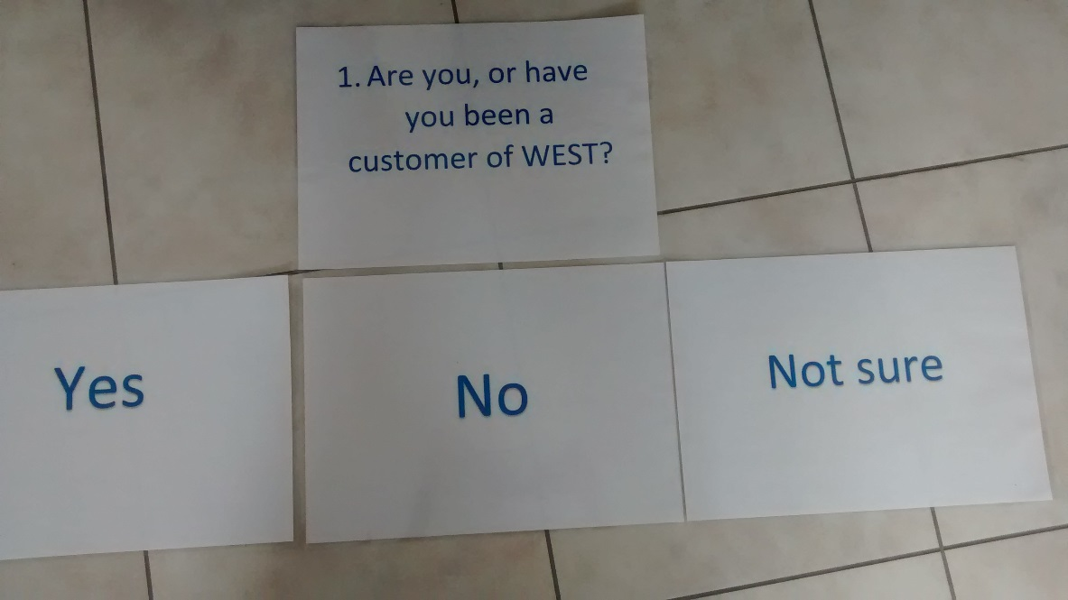
- Are you, or have you been a customer of WEST?

People were given a post-it note and asked to write their initials on it. The question was then read out and people were asked to place their post-it note on the appropriate answer.

- What support do you need to:
  - Get a job?
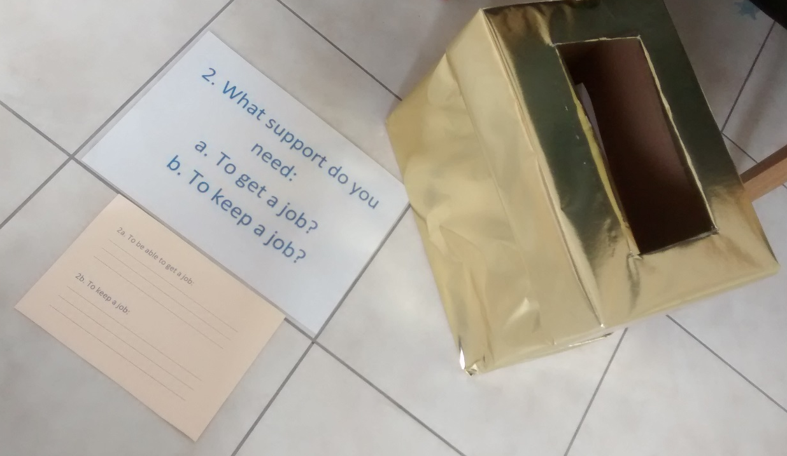
  - Keep a job?
People were asked the question above and asked to write down what support they felt they needed for both parts ‘a’ and ‘b’.
Grapevine supported people to think about the help they needed by drawing on their past experiences, the support they have had from WEST, finding a job and what support people needed in work and in their daily lives. People were then asked to put their response in the gold box.
Prompt cards were used to support discussions and help people write their answers.
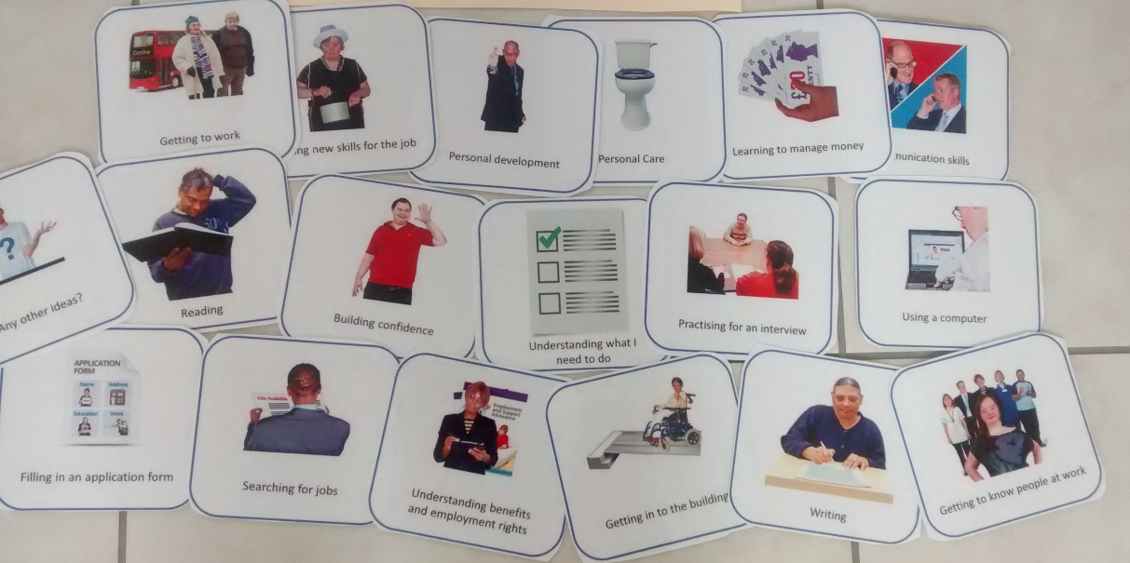

- What would it be like for you if WEST closed?
People were asked to put their initials on a post-it note and to place their post-it note on one of the response cards. People were then asked to write the reasons why they had put their post-it note on that particular response and post their answer in the gold box again.
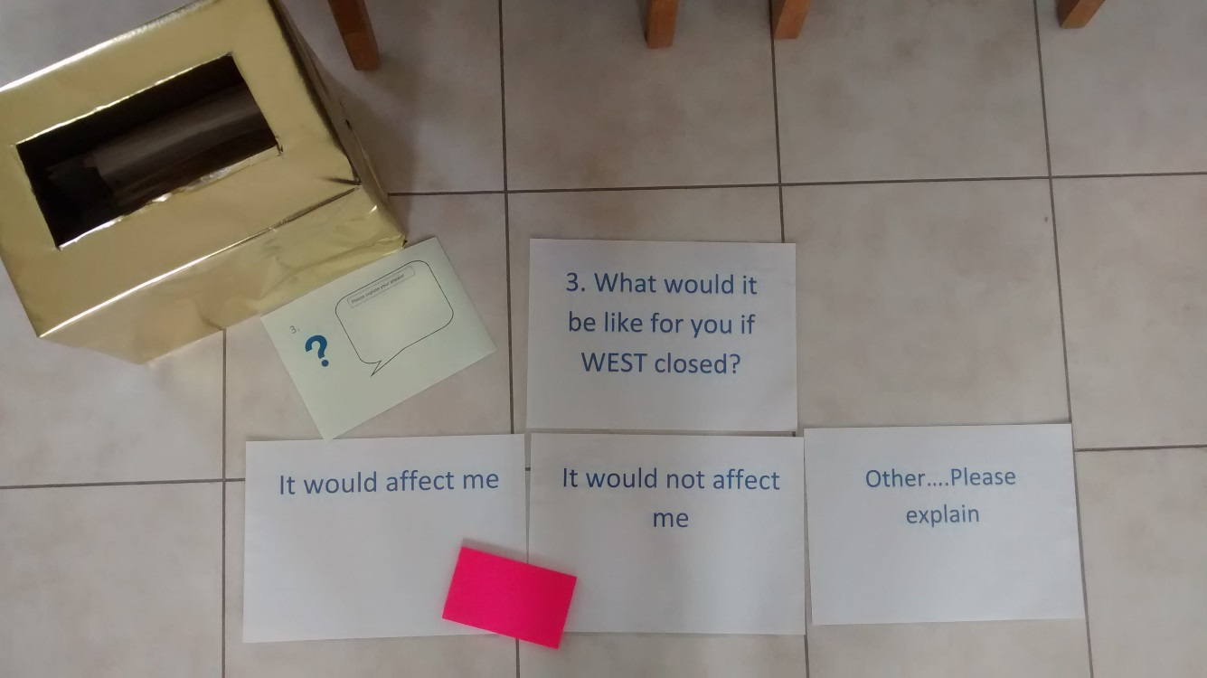

- Overall, do you agree with the proposal to close WEST?
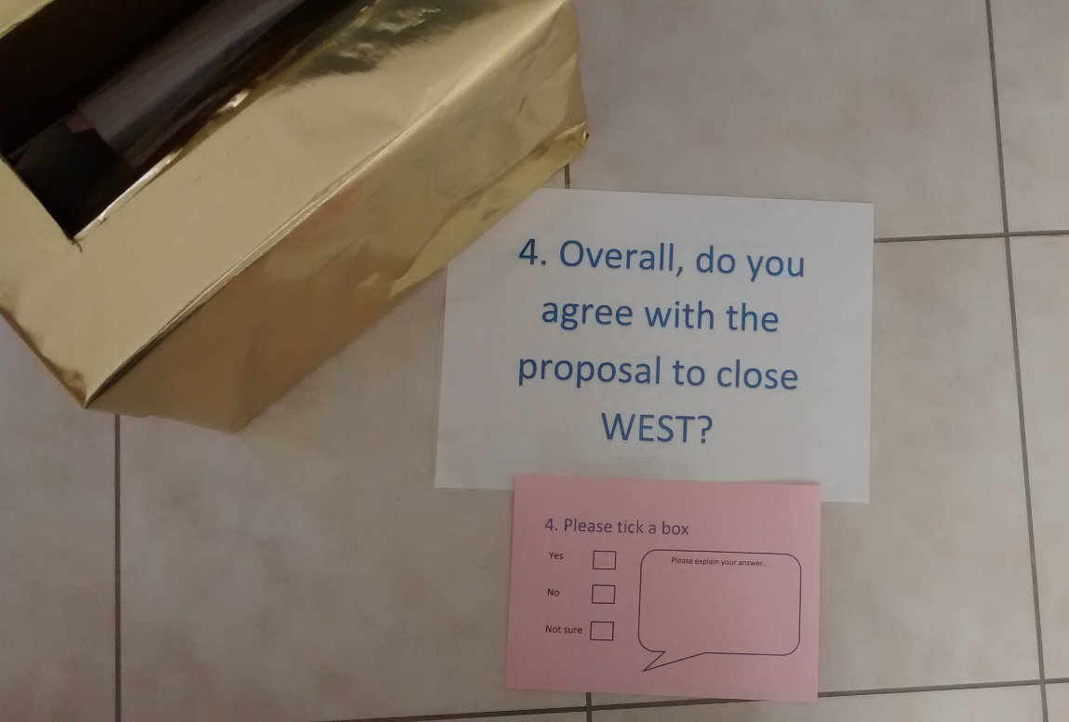

People were asked this question after having thought about the support they needed when searching for and keeping a job as well as whether they would be affected by the potential closure of WEST. This helped people to prepare for answering this question.
People were asked to tick either ‘yes’, ‘no’ or ‘not sure’ and explain the reason why they ticked that particular box. Once they had finished, people put their response in the gold box.

- Can you think of any other ways to provide this service?
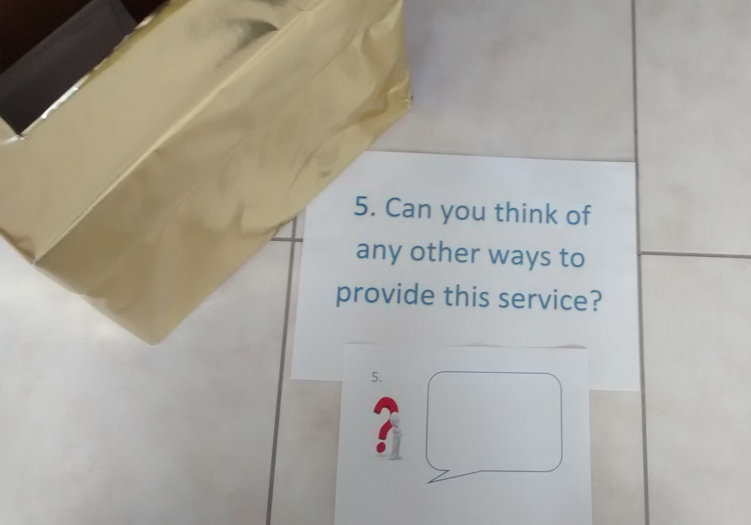

This final question was about asking people whether they could think of other ways to provide the service WEST offers. People were asked to think of other people/services who could help them find a job and anything that could be done differently. People were asked to write their answers on the sheet and put them in the gold box.
- Equalities information monitoring
People completed an easy-read equalities data questionnaire at the end of the consultation.

Consultation responses
319 people responded to at least one part of the consultation.
How did people participate?
 | Number of people | %
Focus group | 187 | 58.6
Postal | 97 | 30.4
Online | 35 | 11.0
Total | 319

Question 1: Are you or have you ever been a customer of WEST?
There were 3 possible responses. YES, NO, NOT SURE
Yes – 163
No – 141
Not sure – 12
No response - 3
Total - 319

Question 2: What support would you need to:
- Get a job
The respondent’s answers were categorised and collated with other similar statements. Below is a list of what people said they needed help with in order to get a job and the percentage of people that said this.
20% - Application forms, CV’s, paperwork to apply for a job.
19% - Help at interviews, both to prepare and have support whilst attending
17% - said they needed help to search for an appropriate job
9% - said they would need help to build up their confidence and other skills needed to take on employment including where to gain relevant qualifications
8% - would need help to sort out transport arrangements in order to get to work. This included help to look into travel training
5% - would need help with general reading and writing tasks
3% - would need support to use technology
3% - would need someone to help them search for volunteering and work experience opportunities
2% - needed help to look at how their current benefits would work whilst in paid employment.
1% - need guidance on the different option available apart from employment
Other suggestions, that individually represented less than 1% of the responses, included- help to overcome stigma attached to having a disability, learning about correct clothing, learn about workplace conduct, understanding their disability, support to remember to apply for jobs, help to become motivated to find employment and personal care support.
Summary
20% of the people consulted said they need support to fill out application forms, CV’s and job paperwork in order to find employment. 19% need help at preparing for interviews and/or would need some support during the actual interview itself. People also stated that finding an “appropriate” job that matched their abilities and skill sets was essential and 17% of people would need help to do this. Other things people would need support with to get a job include ‘skills-building’ and training (9%), help to find appropriate transport arrangements (8%) and general reading and writing tasks (5%). A small number of respondents (3%) said that they would need support to use technology like a computer or iPad and another 3% would need help to search for work experience and volunteering opportunities that may lead to paid work.
- Keep a job
As with part A, the data was sorted into categories based on the responses. Below is the percentage of people who said they needed support to keep a job and what support they would need.
22% - general ongoing support to review what has been happening at work
15% - someone to liaise with the employer to ensure that they understand the persons needs and how to best support them.
9% - someone to put strategies in place to help the person stay organised and ‘on track’
9% - ongoing transport support to attend work
7% - said they would need some form of ongoing training and skills building that would adapt to suit the needs of the job
7% - would need close support during the initial transition into a workplace including getting settled into a routine.
7% - Ongoing reading and writing support
6% - Learning about their rights and entitlements whilst in employment
5% -require support to be punctual and need help with timekeeping
5% - said they would need ongoing support to understand health and safety requirements
2% - support with using equipment
2% - money management
2% - personal care and hygiene support
2% - said they would need 1 to 1 support in all aspects of a job
1% - need help to find, and remember to wear, the correct clothing
Summary
The largest proportion of people (16%) said they would need ongoing support from someone to keep a job. This would include reviewing what has going on recently and helping to solve problems that they have had. This included any change in their roles and additional responsibilities they may have been asked to take on. It was suggested that this review could be done more frequently at the start followed by less frequent meetings once they had settled into employment. 15% said they needed someone to be in close contact with an employer in order to make sure they understand, and consider, their individual needs. Respondents also mentioned that, as part of liaising with an employer, they would need people to suggest appropriate strategies an employer could take to effectively support the employee at work. 9% of people specifically stated they needed support from someone to “stay on track” and stay “focussed”. Another 9% of the respondents said they would need ongoing transport support to attend work regularly. 8% of the respondents would need an ongoing review of their skills and make sure that there was someone who could identify, and help them build upon, any skills deficits that need addressing. 8% highlighted that the initial transition into a workplace would have to be monitored closely in order to sustain employment and be happy at work.
__________________________________________________________________________________
Question 3: What would it be like for you if WEST closed?
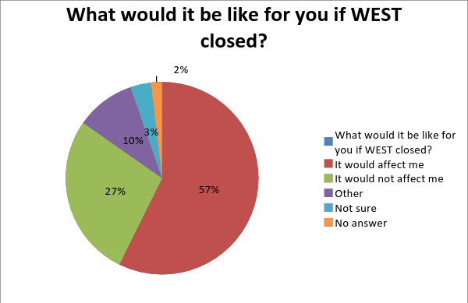

In total, 315 people answered this question. Of that total 132 said they were current WEST customers and 183 said they were not currently using WEST.
When asked what it would be like for people if WEST closed, 57% said it would affect them if WEST closed. A further 27% said it would not affect them if WEST closed. Some people were not sure how it would affect them (3%) and 10% of respondents gave ‘other’ as their response.
Of the 315 responses, 132 were from current WEST customers. Out of them, 122 said it would affect them if WEST closed (92%). Just 10 current WEST customers said that it would not affect them if WEST closed (8%).
People were asked to comment on why they felt they would or would not be affected if WEST closed. Some common themes emerged from this information.
It would affect me
Potential WEST customers
During the consultation period, Grapevine met with school and college students who would be preparing for their future, and possible employment.
Many students felt they might like to use WEST in the future and said that if WEST closed, they would not know where to go to find employment support.
“If they could help me get a job in the future and they closed it would affect me.”
“Because we would still need help when we leave school”
“I might want to use WEST in the future. I have a job (3 hours a week), but will want to get a job with more hours when I leave college. It will be easier for me to get a job WITH support. It would be difficult without.”
Other people who were not WEST customers felt that it was good to have the option of using WEST in the future if they wanted help looking for employment. People said it was helpful to know that there is a service that can help them to get a job if they need it.
“If WEST closed I wouldn't be able to use it in the future.”
“In the future I might go to WEST to look for work.”
“I would like to use WEST and couldn't if it wasn't there.”
Emotional Impact of WEST closing
Customers of WEST talked about the emotional impact it would have on them if WEST closed. People described feeling upset, sad, worried, anxious, and depressed about the prospect of WEST closing.
Some people talked about how they rely on WEST and some described WEST as their “rock”. People said they would not know what to do if WEST closed.
“It would be sad as I may need their help again in the future.”
“I rely on their support.”
“…be depressed again.”
“Because I would worry I would not get a job.”
“Upsetting. No one to turn to.”
“It would make me feel useless without job.”
“I will feel very low. They are my rock WEST.”
The results suggest that WEST provide a lot of emotional support for people they support, through their journey to finding employment and also for other life difficulties. This is something that WEST customers appear to value highly.
“I get anxious when my job changes and WEST help me. I nearly lost my job once due to the changes but WEST helped me adjust. “
“Without the support from WEST I would not be able to work and I would be depressed again and may have to go back into hospital.”
“I wouldn't be able to cope at home if I didn't have WEST or my friends from job club! I also wouldn’t have hope to survive on my own without WEST!”
“I would have no one to support me. I would have no refuge, no caring support- nothing!”
Lack of support for people with learning disabilities and autism to find work
People were worried that there would be less support available from services who can help people with learning disabilities and autism to find work. People said it was very important to them to have support in finding a job and without the support from WEST, people said they would be left without support.
“Because I won't get the help I need”
“Because it gives me a chance of finding a job and the staff supports me in doing that”
“It would leave me with the daunting task of finding work; a job that I can do without the pitfalls that are present in today's society.”
“It would affect me a lot. I wouldn't know how to apply for a job. I wouldn't have anyone to ask me what I like. I wouldn't know who to talk to about benefits I am entitled to. I wouldn't know how to get to a job. I wouldn't have anyone to talk about my problems at work.”
“There is no other establishment locally that could be of help to me”
“I wouldn't find a job”
“It would be difficult because no one would take notice, job centre are too busy”
Loss of skills
Many people were concerned that if WEST closed, the skills that they have developed with the support of WEST would be lost. People have valued the support of WEST in gaining confidence, preparing for job interviews, improving social skills and developing other life skills.
“It would be a complete disaster for both myself and my twin brother. We're both on the autistic spectrum. Confidence would sink to an all-time low. We both need WEST. Minimal job prospects. WEST speak on my behalf.”
“They help me to seek employment in the company of others. Encourages me to go to Warwick and make an effort to find work. Also gives me interaction with like-minded job seekers.”
“The weekly session would stop. I am learning living skills and help with IT. I need support to keep working at the charity shop where I am an assistant.”
“Because I won't be able to go to the groups any more so how will I learn work skills?”
“It would affect me badly. In the past WEST have always been there and if they go it will affect me badly. My support and confidence will go.”
“It would affect me because I haven't got any much confidence and I want to get a job.”
“I would lose my steadily gained confidence in job interviews and my new found independence in travel training.”
Loss of support in work
Lots of people who have a job benefit from ongoing support from WEST in relation to things like resolving problems, and helping their employer understand their needs. A number of people who were in work were worried that if WEST closed, they would lose their jobs.
“They can contact employers and talk about making a job I can do.”
“Because I could not go to work without the support of staff at WEST.”
“I would lose my job as I would have no support or transport.”
“I wouldn't have the support or supervision I need in my current role.”
“I would lose my job.”
“I would either lose my job or have to leave my job because I am on supported permitted work.”
“Without WEST I'm going to lose my job.”
“My future would look grim if I could no longer depend on WEST for the support they've given me prior my apprenticeship and when my apprenticeship ends if I am unable to continue my career I don't know what I'll do.”

It would not affect me
27% of people consulted said that the closure of WEST would not affect them.
These respondents gave a number of reasons why they thought they would not be affected. The most common reason was that they had never heard of WEST. Other themes in these responses were:
- Not currently looking for a job
- Already having a job so not in need of support to find one
- Not being a resident of Warwickshire
- Being able to find a job without support
- Having other sources of support to find work, for example, support workers, family or Remploy
- Feeling that if WEST were not there then another organisation would provide support

Question 4: Overall, do you agree with the proposal to close WEST?
284 people responded to this question. The majority of respondents (248 people / 87.3%) said ‘no’. 11 people (3.9%) said ‘yes’. 20 people (7%) said they were not sure. 5 people (1.8%) did not answer the question.
The people who said they did not agree with the proposal to close WEST generally did so in strong and unambiguous terms:
“Absolutely not...”; “Don’t close it. Don’t do it.”; “The service should not be lost.”; “This group must stay open...”; “Closing WEST would be a very BAD thing.” People used words like ‘upset’, ‘angry’, ‘struggling’ and ‘lonely’ to describe how they felt about the potential loss of the service and the effect it might have on them.
Lots of people went into detail about the reasons why they did not want WEST to close. A common theme was concern about losing support to find or keep a job. Many people were anxious about losing this support themselves and some people were worried about how the proposed closure of the service would affect other people:
“Would find it harder to keep my job.”
”I need regular support and help to get and stay in a job.”
“Because there are other people with disabilities that need help getting a job.”
A number of people commented on the good quality of service that they feel WEST has provided to them or others. They talked about particular types of support they have appreciated from WEST: people mentioned travel training, confidence building, support with communication and interview skills amongst many other things. There was a strong feeling that other organisations might not offer a comparable level of quality:
“I would never have got a job without Carol’s / WEST’s help...”
“I think WEST is a good service and the staff are really nice and help me.”
“They are the only people who care if the autistic work.”
“WEST is unique...all the staff are helpful and friendly...”
“...WEST does a lot of fantastic good work for us young people...”
The feedback from people who agreed with proposal to close WEST and those who said they were not sure, when analysed along with their responses to the other consultation questions, usually indicated that they had either not fully understood the question or had never heard of, or had any contact with WEST.

Question 5: Can you think of any other ways to provide this service?
298 people responded to this question, however approximately 80 of the responses were “no”, “I don’t know” and “I’m not sure”.
Many people commented on who else would be available to offer support to people for job support if WEST were not there. The majority of people stated that their parents or family members would be their next ‘port-of-call’ for support if WEST were no longer available. People also said that their College or School could offer support, for example teachers, support staff and “job ready” support. They stated that teachers could be specifically trained to offer the same support that WEST do.
Other responses for people who could offer support if WEST closed down included; the library, looking for jobs on the internet or in newspapers, carers, staff, friends, Warwickshire County Council, other Learning Disability service providers, Learning Disability Hubs, job clubs, Support Workers, Social Workers, Connexions, outreach, Serina Russo, National Careers service and ATC shelter and Remploy. A few people said that different organisations should work together to offer support and two people said “Grapevine”. One person said “The syndicate centre has computers and help with employment, the service could be extended, do it on more days, or at Brunswick street healthy living centre, or pound lane”.
A number of people said they could go to the job centre for support, however many people said that this would not offer the level of support required. A lot of people said that the job centre “don’t help people” and that “the job centre wouldn’t support me in my needs”. A lot of people said that for the job centre to provide adequate support, they would need to employ and train people specifically to work with and help people with a learning disability, which is not currently available. People were concerned that “people there might not be able to help all people. They might need new people at the job centre who can work with people with disabilities”. A lot of people also said that they would need to have a separate service within the job centre, different from the service offered to mainstream job seekers and there is a need for more experienced staff. One person wrote:
“No one else could help. Job centre were too harsh. They did not give me the right support. They rushed me when I was on the work programme”.

Some responses stated that staff from WEST should move over to have a base at the job centre.
Other ideas to provide the service included offering online support, or text/phone support to people, however they stated that this would be “isolating” people. Some people suggested opening another centre. There was an overriding concern that regardless of who provides the service, a specialist support service to enable people with a learning disability and autism to gain employment was needed. Some people suggested that a new service could be found to take over, or the Council could pay another organisation with the same experience to provide the service, or for a care agency to take on this role, however this would still be “costly”. Some people suggested having volunteers to support people may help to provide the service, if volunteers could be found. People commented that we need to listen to people’s ideas and that support is not available without a budget. If WEST did not exist, people said a more tailored 1:1 service would be needed to replace it. People were concerned about location and transport, stating that there is nowhere else to go close by for help.
An overwhelming amount of responses highlighted the concern that people have with the prospect of closing the WEST service and that this should not be an option, stating things such as “why close something that works?”, “I don’t want it to change”, “don’t close”, “I don’t think there is anyone else who can help” and “don’t cut it”. Many people said to “keep WEST” and they are “the only group for the job”. Peoples view on the idea of closing WEST included “shocking” and “upsetting”. Many people spoke about the service that WEST offer, in regards to building people’s confidence and self-esteem, support in applying for jobs and interviews. Other responses included:
“make cuts elsewhere”
“perfect helping group to help us find jobs”
WEST are “unique” and “helpful”.
“WEST is the last resort for people like me, alone with no support”
“I don’t like change. I am autistic. I have autism. I find it hard with change!!!!!!!”
“No one could give the service like WEST gives to clients and care like they do”
“No. WEST must stay open to help me and many others like me. Please re-think and keep WEST going for our local community. Thank you”

“As usual the council are trying to save money and the first thing they consider cutting is learning disability services. Even if WEST does go it WILL NOT save them any money at all because there will still need to be an organisation to go to for job search/support. To stay WEST could downsize because their room may be what's costing so much in rent. They could start baking and cooking and sell their creations to the public like a bake sale, have a good number of these or look to alternative funding”.

“All the other people I have been to didn't want me as my needs were too much”.

Some people came up with alternative ideas to save money to keep WEST open. These included; rebranding the service, changing the logo, advertising more through posters and leaflets and finding cheaper ways to access the service. Some people said that WEST should “get a sponsor” and some people suggested fundraising events to keep WEST open, for example cake sales and sponsored walks/swims. Others suggested a small charge to access the service, or to have “drinks subs” or open a youth clubs and pay “subs”. However, one person said “I don’t think I would want to pay for this service if a private company takes over”. One person suggested that employers could contribute an amount towards the WEST service, as “WEST can help with training. The employer does not have to train the staff themselves”. Some people suggested WEST having a smaller building or working with smaller groups. People said having shorter service hours would help to still provide the service. One person suggested reducing the service to offer support with particular skills. Many people suggested getting funding support from charities.
A few responses were also from parents, including things such as;
“This is ridiculous! You should be telling us this not asking my daughter! This is not a consultation this is silly. If you’re asking this you’re saying you don’t have someone to provide my daughters supported permitted work. This means my daughter will have to leave her job which has improved her quality of life so much. Since working her confidence has shot up and you’re trying to take that away from her”.

“It’s blindingly obvious that getting rid of WEST will lead to job losses and further problems for you to resolve in the future”.
To summarise, many people think there are barriers to other services offering employment support although there have been lots of different suggestions posed. A lot of respondents said support offered, outside of WEST, currently is not adequate and services like the Jobcentre would struggle to fill this void unless it contained a specialist service within it. Many people believe that providing the service in another form would be counter-productive and not offer a comparable level of support.

Demographic data
Gender
Male | 191
Female | 117
Transsexual | 0
No answer | 11
 | 319
Age
16-18 | 38
19-30 | 128
31-40 | 55
41-50 | 46
51-60 | 29
61-70 | 9
71+ | 1
Prefer not to say | 1
No answer | 12
 | 319
Sexuality
Heterosexual / Straight | 230
Gay/Lesbian | 13
Bisexual | 3
Prefer not to answer | 44
Other | 9
No answer | 20
 | 319
What ethnic group do you belong to?
White British | 286
White Irish | 2
Asian or Asian British Pakistani | 2
White European | 3
White Any other background | 3
Mixed- white and black Caribbean | 2
Mixed- white and Asian | 4
Mixed- any other mixed background | 1
Asian or Asian British Indian | 3
Black or black British Caribbean | 1
Prefer not to say | 1
No Answer | 11
 | 319
Religion
Christian | 166
Hindu | 0
Muslim | 3
Sikh | 2
Buddhist | 3
Jewish | 0
No religion | 93
Prefer not to say | 27
No answer | 13
Other | 12
 | 319
*Are you someone who has a...
Learning Disability | 251
Autism/Asperger’s | 107
Mental health problem | 29
Physical Disability | 41
Long-standing illness | 32
Dementia | 1
Terminal Illness | 2
Sight or hearing loss | 20
Problems connected to aging | 2
Misusing alcohol or drugs | 1
None of the above | 2
Prefer not to say | 3
Other | 12
No Answer | 11
 | 514
*People were given the choice of ticking as many boxes as were applicable to them with this question which is why the total is higher than the 316 participants.

Which area of Warwickshire do you currently live in?
North Warwickshire Borough | 35
Nuneaton and Bedworth Borough | 57
Rugby Borough | 50
Stratford District | 60
Warwick/Leamington District | 85
Outside Warwickshire | 17
Not Sure | 2
Prefer not to say | 1
No Answer | 12
 | 319

