Pharmaceutical Needs
Assessment (PNA)
Warwickshire

Introduction

Coventry’s and Warwickshire pharmaceutical needs assessment (PNA). It has been prepared by Midlands & Lancashire Commissioning Support Unit. The PNA has been prepared to support how decisions are made about pharmacy services in Coventry, we hope that it will generate discussion and debate as to how we can make the most of the pharmacy services and identify areas for improvement going forward

The PNA is also a tool used to inform commissioners of the current provision of pharmaceutical services and identify any gaps in relation to local health needs. These gaps can therefore be addressed by improving services or even access to those services in those local areas.

PNA’s as a statutory requirement must be updated at least every 3 years. This document provides an update to Coventry’s and Warwickshire previous PNA. It includes data from an in-depth assessment of needs for pharmaceutical services in Coventry and Warwickshire. This needs assessment was produced by evaluating the health need of the local population with consideration
of the existing services that are provided by pharmacies.

c

APPENDIX xxx: Patient Survey Questionnaire – paper copy

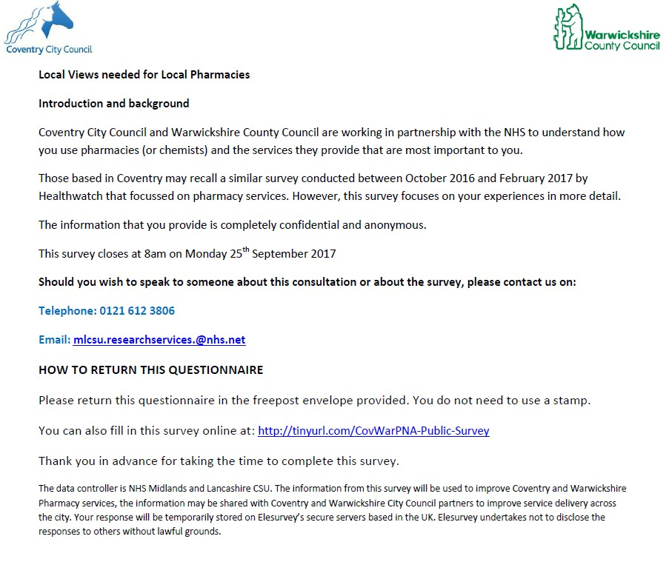

c

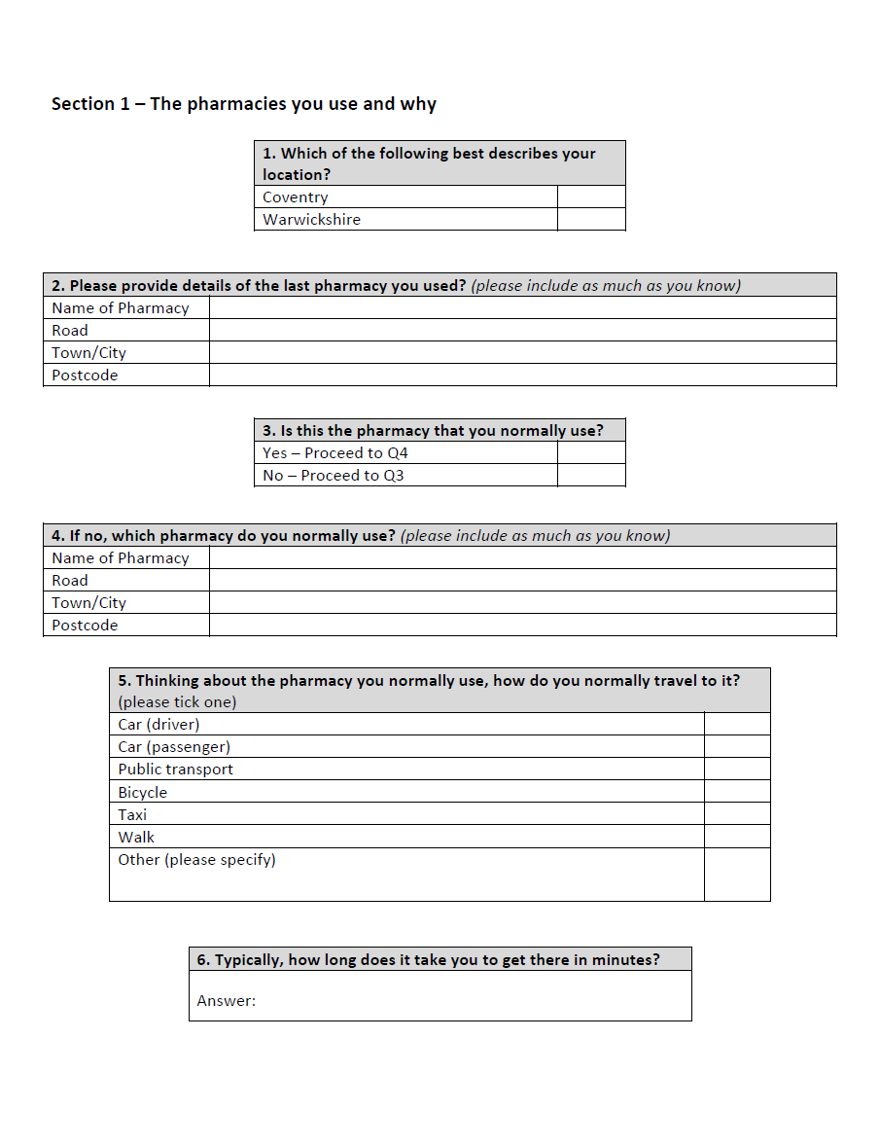

c

c

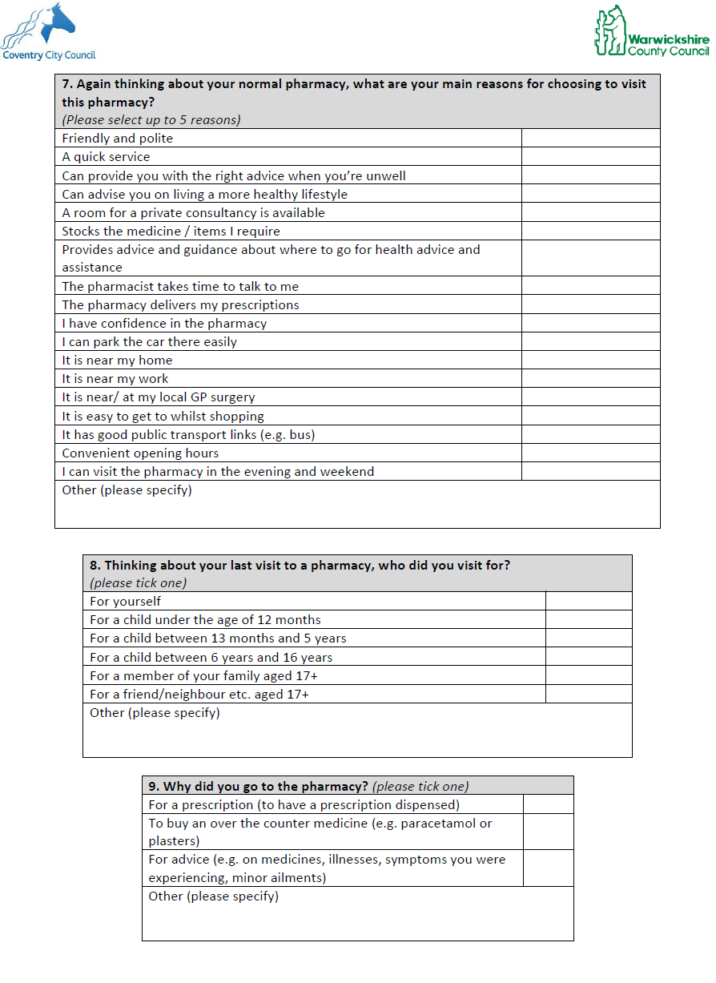

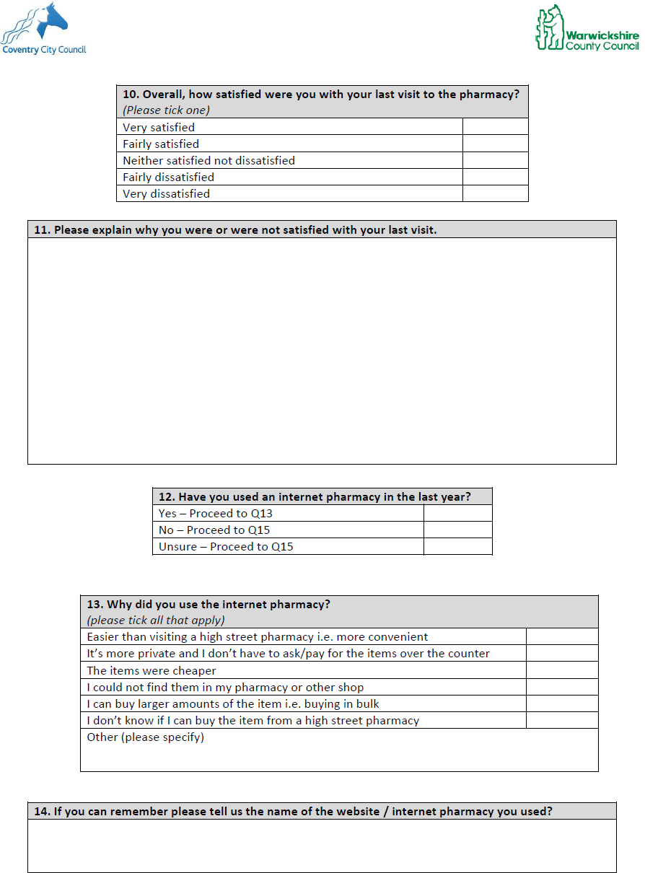
c

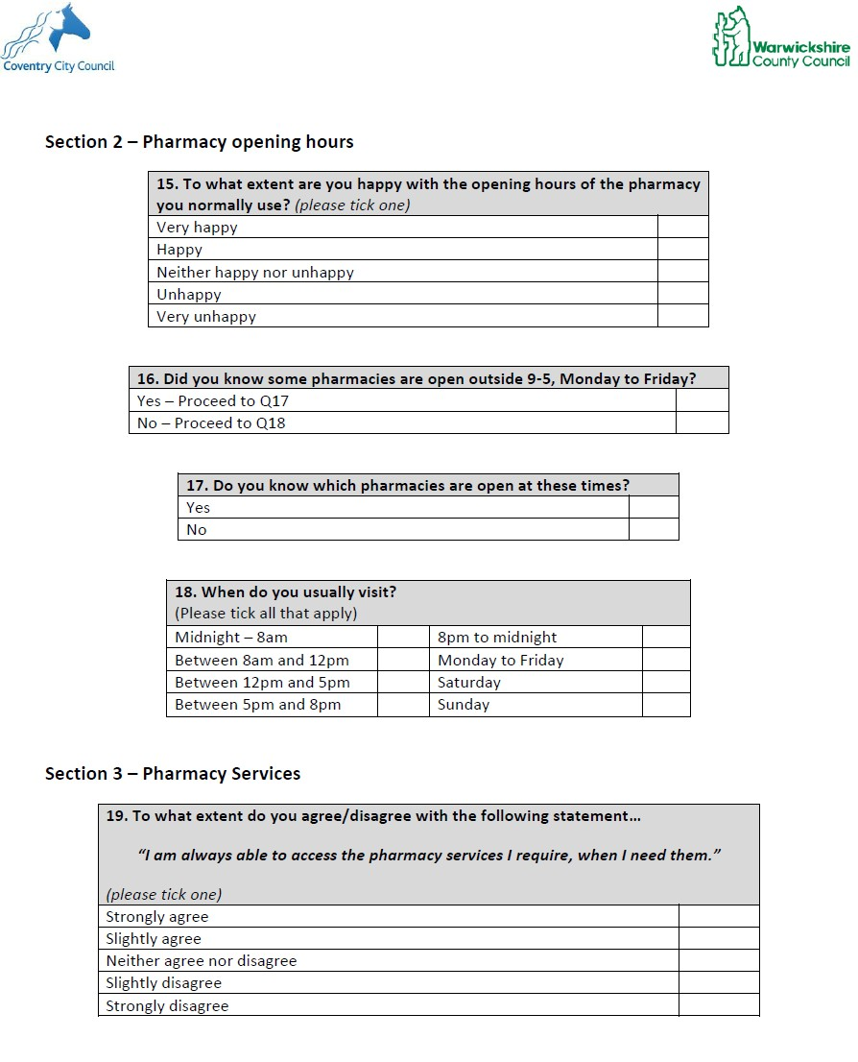

c

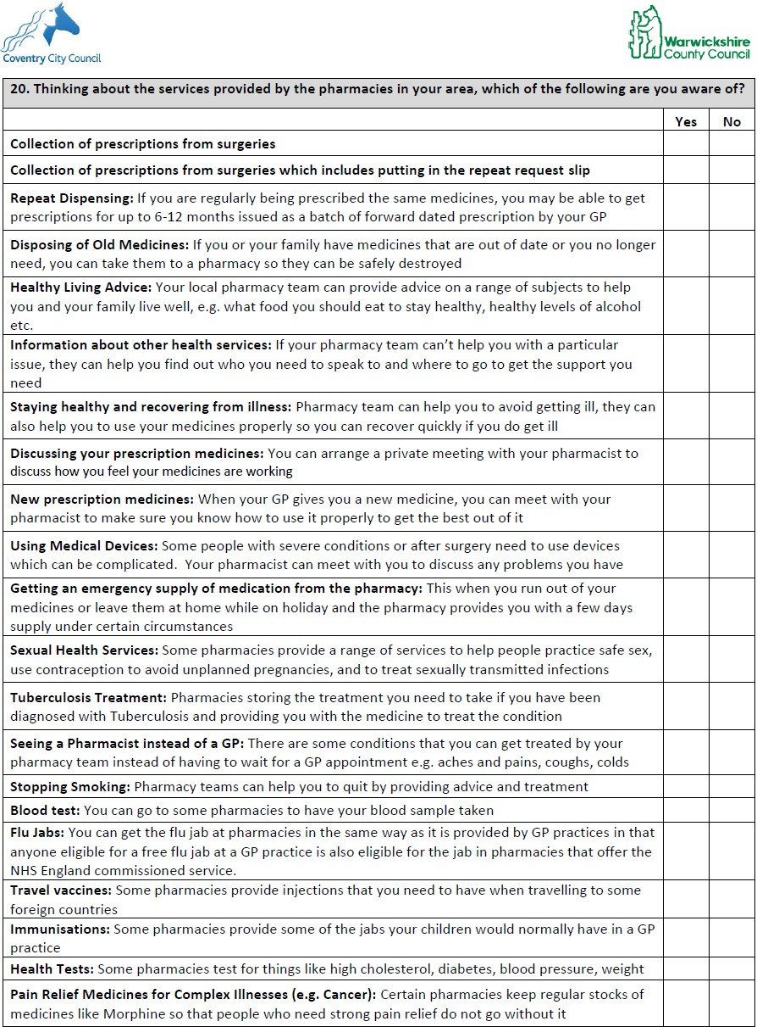

c

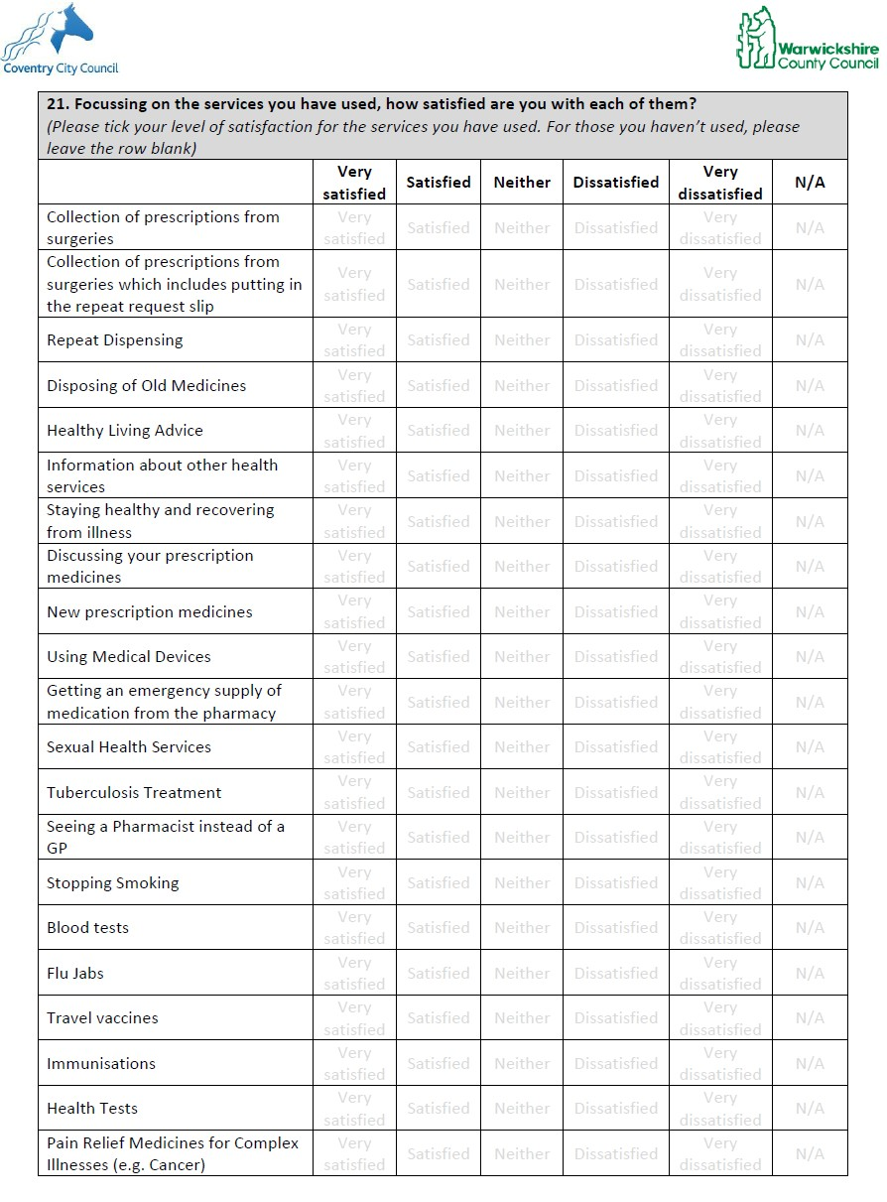

c

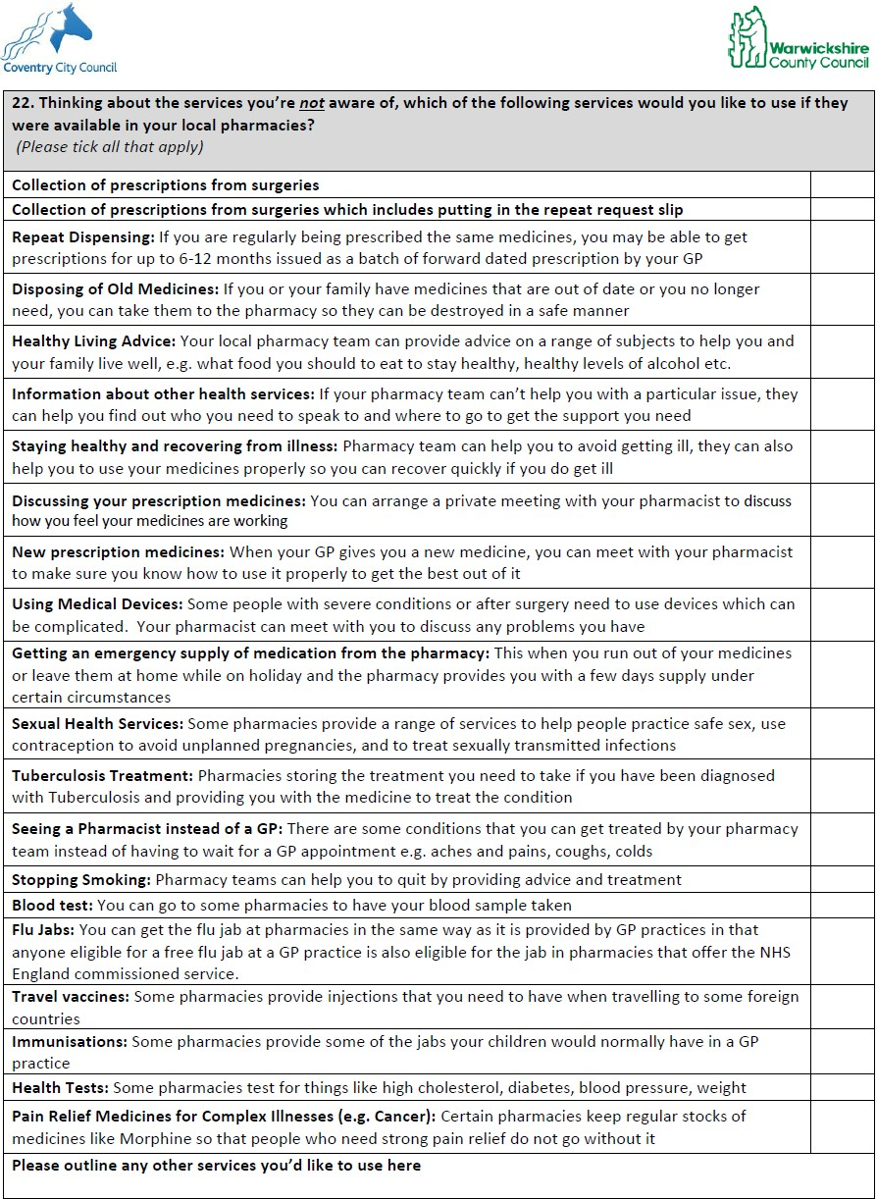

c

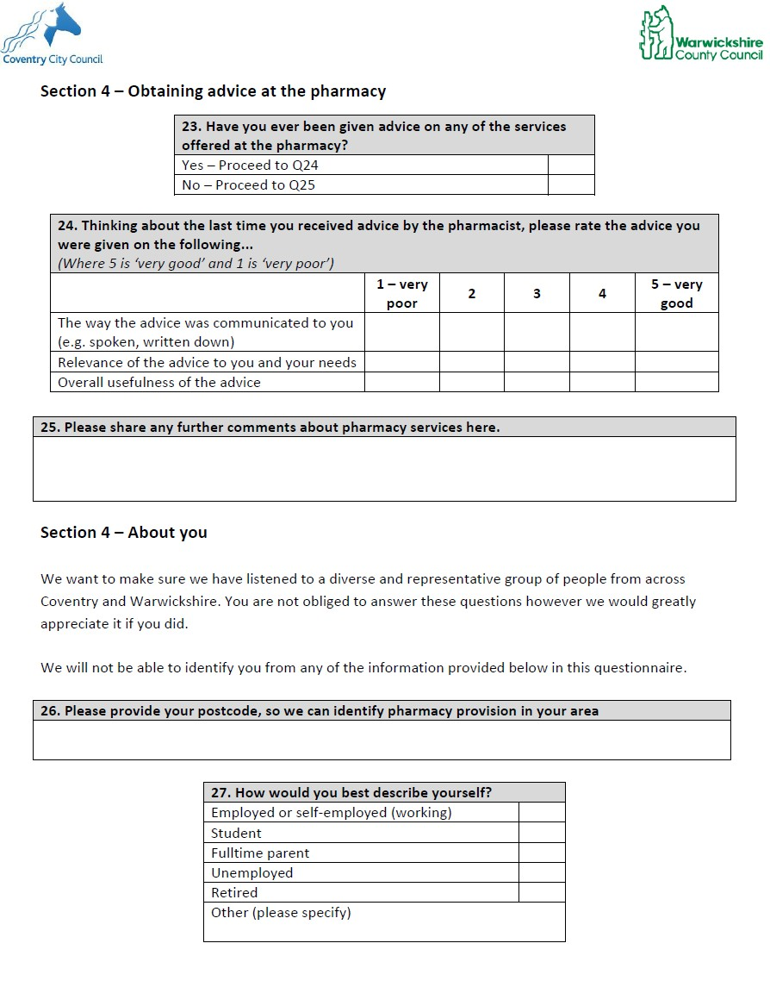

c

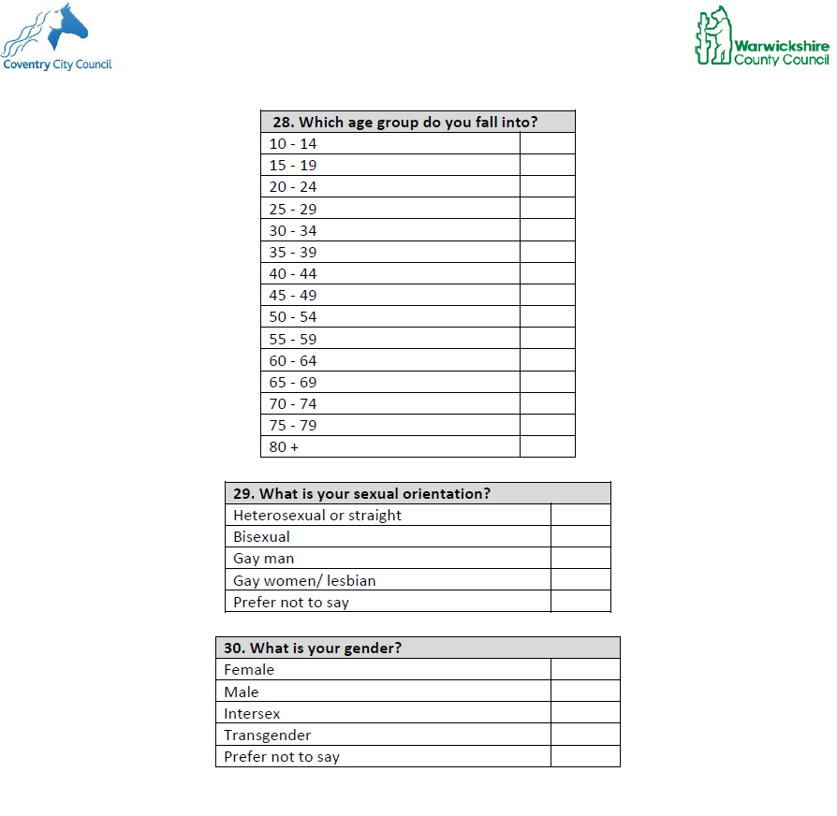

c

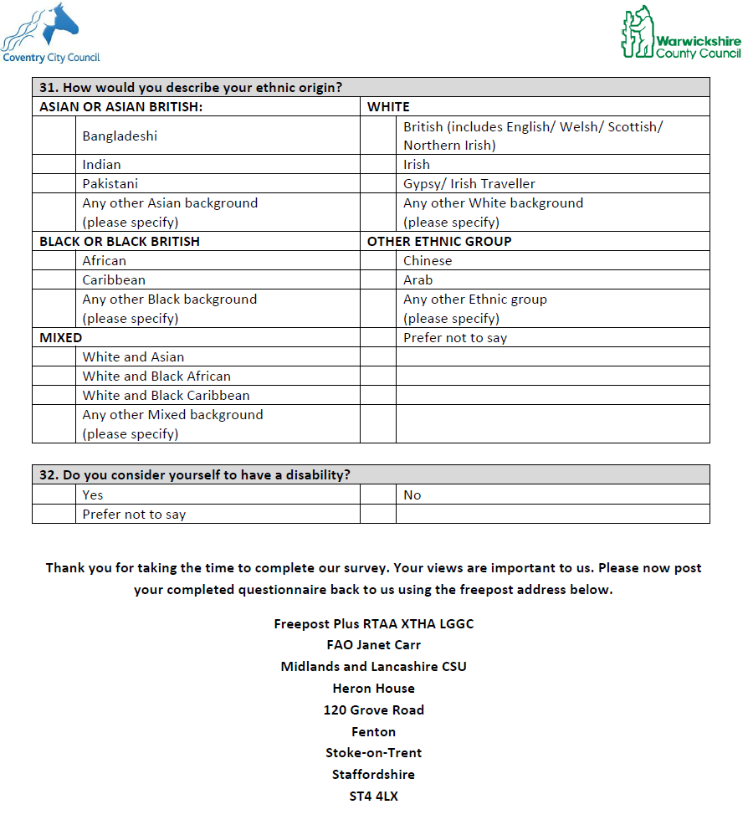

c

APPENDIX xxx: Patient Survey Report – Warwickshire

1.0 Introduction

Warwickshire County Council and the NHS Midlands and Lancashire Commissioning Support Unit ran a survey from 30th August to 4th October 2017, and it’s aim was to understand how people use pharmacy services in Coventry. In detail the objectives were

1. To explore when and how people access pharmacy services
2. To understand what factors are most important to pharmacy users
3. To explore the demographic profile of pharmacy users
4. To understand the quality of services that pharmacies offer
5. To understand there are where gaps in provision/ demand for other services
6. To understand what aspects could be improved
7. To understand factors that influence choice of a particular pharmacy

The survey was disseminated using the following methods:
• Via email to local organisations and key stakeholders
• Links to the online survey were also promoted through social media
• Printed copies were left in local pharmacies, with Freepost return envelopes

A total of 318 responses were received, the vast majority of responses were received via the online survey.

c

2.0 Survey Findings

2.1 The pharmacy you use and why

When asked about details of the last pharmacy used, over 50 different outlets were mentioned, of which the two high street pharmacies, Boots and Lloyds are most popular.

Q2. Please provide details of the last pharmacy you used?

Lloyd’s Pharmacy
Boots
Wellesbourne pharmacy 6% Birk & Nagra 5%
Lapworth Surgery Pharmacy 5% Stratwicks Ltd Pharmacy 4%
Rowlands Pharmacy 4% Tesco instore pharmacy 3%
Mellor and Co of Warwick 3% Dudley Taylor Pharmacies 3%
Paddox pharmacy 2% Vithlani Chemist 2% Well Pharmacy 2%
Leyes Lane pharmacy 2% Asda Pharmacy 2% Bilton Pharmacy 2%
Pharmacy to my door 1% Primary Care Pharmacy 1% Lister Chemist 1%
Morrisons 1% Rajja Ltd 1%
Stratford Pharmacy 1% Budbrooke Medical Centre 1% Claverdon Surgery pharmacy 1% Knights Pharnacy 1%
Phillips 1% Browns Pharmacy 1% Pharmacy Republic 1% Lillington Pharmacy 1%
Taylor Dudley Pharmacies Ltd 1% Southam Pharmacy 1% No 8 Pharmacy 1% Revel Pharmacy 1% Hopkins Pharmacy 1% Skeltons Pharmacy 1%
Alcester Health Centre 1%
14%
13%

Base: 309 (open responses)

c

Other less frequently mentioned pharmacies are shown in the table below;

Other less frequently mentioned pharmacies
Walmley Pharmacy | Sainsburys
Bidford pharmacy | DAY LEWIS
Saiful alam | Hastings house
M W PHILLIPS | Dhaliwal
Binley Woods | KASLI
Magson | Pharmacy Vithlani
Central surgery pharmacy | Arrow Surgery
Chase Avenue Pharmacy | Bishop's Itchington Surgery
Harbury Pharmacy | Viflani
Chemist | Pool Road
Superdrug | Burrs
Next to Whitehall Medical Practice | Edgwich Pharmacy
Village Pharmacy | Warwick Hospital Outpatient Pharmacy
Atherstone Pharmacy | Priory Surgery
Warwickshire to your door | Castle Medical Centre
No.1 Pharmacy | Fenny Compton Surgery
Alliance Pharmacy | Galley common
Copsewood | Grendon Pharmacy

The vast majority state the last pharmacy they visited is also the pharmacy they normally use. A small proportion (4%) state the last pharmacy they used is not their normal pharmacy.

Q3. Is this the pharmacy that you normally use?

96%

4%
Yes No

Base: 316 (single response)

A third walk to their pharmacy and just over a half drive their own car. Public transport is used by just under
3%.

c

Q5. Thinking about the pharmacy you normally use, how do you normally travel to it?

51.50%

33.89%

6.98% 4.65% 2.66%

0.33% 0.00%

Car (driver) Walk Car
(passenger)
Other (please specify)
Public transport
Bicycle Taxi

Base: 301 (single response)

For over four fifths, their pharmacy is less than 10 minutes away, perhaps justifying the large proportion of participants who choose to walk to their pharmacy. Only a tiny proportion have to travel more than 30 minutes to reach their pharmacy..

Q6.Typically, how long does it take you to get there in minutes?

45%

36%

10%

4% 4%
1%

5 minutes or less 6 to 10 minutes 11 to 15 minutes 16 to 20 minutes 25 to 30 minutes More than 30 minutes

Base: (297 open responses)

Delving into greater depth, the main reasons for choosing to visit the pharmacy individuals choose to do is because it is their home, the staff are friendly, polite and the service is quick, they have confidence in the pharmacy and they pharmacy stock the medicine that is required by the individual.

c

Q7. Again, thinking about your normal pharmacy, what are your main reasons for choosing to visit this pharmacy?

C
Friendly and polite |  |  | 60.34%
It is near my home |  | 44.41%
It is near/ at my local GP surgery |  | 40.00%
I have confidence in the pharmacy |  | 38.31%
Stocks the medicine / items I require |  | 36.95%
A quick service |  | 34.24%
The pharmacist takes time to talk to me |  | 26.78%
an provide you with the right advice when 24.07%
you’re unwell

A room for a private consultancy is available |  | 23.39%
I can park the car there easily |  | 22.37%
Convenient opening hours |  | 16.95%
It is easy to get to whilst shopping |  | 12.88%

I can visit the pharmacy in the evening and weekend

The pharmacy delivers my prescriptions

It is near my work

Provides advice and guidance about where to go for health advice and assistance
Other (please specify) Can advise you on living a more healthy
lifestyle

It has good public transport links (e.g. bus)

10.17%

9.15%

8.81%

8.47%

7.80%

3.73%

0.68%

Base: 295 (multi responses)

c

Focussing on the last visit, the vast majority visited the pharmacy for themselves. One tenth visit for family member aged 17 years and older and a small proportion for young children.

Q8.Thinking about your last visit to a pharmacy, who did you visit for?

For yourself

For a member of your family aged
17+

For a child between 6 years and 16 years

For a child between 13 months and
5 years

Other (please specify)

For a friend/neighbour etc. aged 17+ For a child under the age of 12
months

14.52%

2.58%

2.26%

1.94%

0.65%

0.32%
77.74%

Base: 310 (single response)

Most people visited the pharmacy to pick up a dispensed prescription. Just under 4% of survey participants visited the pharmacy for advice.

4.53% Q9. Why did you go to the pharmacy?
3.56%

9.06%
For a prescription (to have a prescription dispensed)

To buy an over the counter medicine (e.g. paracetamol or plasters)

82.85%

Base:309 (single response)

c

When evaluating the level of satisfaction, about four fifths of participants state they were very satisisfied following their last visit. Positively, only a small minotiy (5%) state they were dissatisfied after their visit.

Q10. Overall, how satisfied were you with your last visit to the pharmacy?

80.13%

12.62%

2.21% 2.52% 2.52%

Very satisfied Fairly satisfied Neither satisfied not dissatisfied
Fairly dissatisfied
Very dissatisfied

Base: 317 (single response)

When asked why to provide further detail behind their level of satisfaction, around half stated the staff were friendly and helful and four in ten, cite the high level of service. However some experienced poor service from staff and trouble obtaining all of the medication they required. The figure and verbatim responses below summarises the key themes mentioned by individuals in this survey and the colour coding used in the chart illustrates whether the theme is positive, negative or neutral/ factual.

c

Q11. Please explain why you were or were not satisfied with your last visit

Friendly and helpful Staff

Good, efficient service e.g. prescriptions all ready - telephone when prescription arrives

Provide good advice/knowledgeable

Very slow service / long wait for prescription

Medication always in stock

Run out of items on repeat prescription / items not in stock

Staff are unfriendly and unhelpful

Ordering system - cannot have items on repeat have to keep telephoning a hotline
Medical condition(s) and medicines known by pharmacist

Other facilities available - chiropodist

Other facilities available - blood pressure

Advice is no better than I can get off the internet

Would like a text message when prescription ready

Receive a text message when my prescription is ready

Accessibility issues (e.g. lack of parking) Pharmacy is easily accessible

Base: 173 single responses

10%

6%

5%

3%

2%

2%

1%

1%

1%

1%

1%

1%

1%

1%

40%

Positive theme Negative theme Neutral/ factual
47%

c

2.2 Using an internet phrmacy

The vast majority have not used an internat pharmacy in the last year. However, approximately 4% have.

Q12. Have you used an internet pharmacy in the last year?

4.13% 0.32%

95.56%

Base: 315 (single response)

Of the minority using an internet pharmacy the main reason for use is because it’s easier followed by privacy.

Q13. Why did you use the internet pharmacy?

Easier than visiting a high street pharmacy i.e. more convenient

It’s more private and I don’t have to
ask/pay for the items over the counter

The items were cheaper

I could not find them in my pharmacy or other shop

I can buy larger amounts of the item i.e. buying in bulk

Other (please specify)

15.38%

15.38%

7.69%

15.38%

38.46%

61.54%

Base: 13 (single response)

c

2.3 Pharmacy opening hours

Focusing on pharmacy opening hours, over eight in ten are happy with the opening hours of the pharmacy they use whilst a very small proportion are unhappy.

Q15. To what extent are you happy with the opening hours of the
pharmacy you normally use?

53.46% 32.08% 11.95% 1.89%

Very happy Happy Neither happy nor unhappy Unhappy Very unhappy

Base: 318 (single response)

The figure below shows at which times survey participants usually visit the pharmacy. Whilst six in ten choose to visit the pharmacy during the week, around three in ten state they usually visit on Saturday. Only a small proportion tend to visit the pharmacy on Sunday. Focussing on the time of day, 50% state they tend to visit between 12pm and 5pm, whilst around two fifths state they visit between 8am and 12pm. Interestingly the most popular out of hours time to visit the pharmacy is between 5pm to 8pm with one third stating they usually visit at this time.

Q18. When do you usually visit?

Sunday

Saturday

Monday to Friday

8pm to midnight

Between 5pm and 8pm

Between 12pm and 5pm

Between 8am and 12pm

Midnight to 8am

0.00% 10.00% 20.00% 30.00% 40.00% 50.00% 60.00% 70.00%

Base: 315 (multiple responses)

When asked if individuals were aware some pharmacies are opened outside the conventional working hours of 9am-5pm, Monday to Friday, the vast majority (95%) state they knew this information. However only two thirds (63%) of those who knew this information knew which pharmacies operated our of conventional hours.

c

2.4 Pharmacy services

When focusing on the level of access to pharmacy services, the vast majority feel as though they are able to access the pharmacy services they need when they require them. Positively only about one tenth of those surveyed feel the are unable to access the services they require.

Q19. To what extent do you agree/disagree with the following statement “I am always able to access the pharmacy services I require, when I need them.”

62.89% 24.53% 6.92%4.72%

Strongly agree Slightly agree Neither agree nor disagree Slightly disagree Strongly disagree

Base: 260 (single response)

c

When evaluating the level of awareness of the different services offered by local pharmacies, most services are known about by at least 50% of respondents. The least well known services are: travel vaccines, blood tests, immunisations and TB.

20. Thinking about the services provided by the pharmacies in your area, which of the following are you aware of?

Disposing of old medicines

Collection of prescriptions from surgeries

Collection of prescriptions from surgeries which includes putting in the repeat request slip
Seeing a Pharmacist instead of a GP Stopping smoking Healthy living advice Flu jabs
Information about other health services Discussingyour prescription medicines New prescription medicines
Staying healthy and recovering from illness

Repeat Dispensing

Health tests

Getting an emergency supply of medication from the pharmacy
Sexual health services Pain relief medicines for complex illnesses (e.g. Cancer) Using medical devices
Travel vaccines

Blood test

Immunisations
93.99%

92.63%

86.77%

85.48%

77.67%

77.52%

76.95%

76.13%

75.40%

74.36%

72.17%

70.87%

63.25%

61.81%

53.56%

51.67%

51.16%

39.73%

32.44%

28.52%
6.01

7.37

13.23%

14.52%

22.33%

22.48%

23.05%

23.87%

24.60%

25.64%

27.83%

29.13%

36.75%

38.19%

46.44%

48.33%

48.84%

60.27%

67.56%

71.48%

Tuberculosis treatment
15.41%
84.59%

Yes No

(Base: 318 multiple responses)

c

Overall the pharmacy services that are applicable to survey participants are rated very highly, with very few stating they were dissatisfied with any of the services they have used. Satisfaction is particularly high for repeat dispensing, discussing prescription medicines, collection of prescriptions from surgeries and disposing of old medicines. Interestingly the data suggests health tests, immunisations, Tuberculosis treatment, travel vaccines, sexual health and smoking cessation services are least used.

21. Focussing on the services you have used, how satisfied are you
with each of them?

Discussing your prescription medicines | 62.78% | 19.73% 6.73%0.31
Repeat dispensing | 62.56% | 15.76%5.42% 11.82%
Disposing of old medicines | 60.89% | 14.02%5.54% 18.45%
Collection of prescriptions from surgeries | 60.31% | 17.90%5.84%14.40%
New prescription medicines | 58.17% | 18.27% 9.13% 13.94%
Collection of prescriptions from surgeries which… | 56.89% | 15.11%6.22% 20.44%
Seeing a Pharmacist instead of a GP | 49.11% | 20.98% 9.82% 19.20%
Getting an emergency supply of medication from… | 47.17% | 18.24% 6.29% 27.04%
Flu jabs | 47.12% | 9.95%6.28% 36.13%
Information about other health services | 39.89% | 16.94% 12.57% 30.60%

Immunisations | 38.10% | 4.76%.35% | 49.21%
Staying healthy and recovering from illness | 38.01% | 15.79% 10.53% | 35.67%
Healthy living advice | 37.57% | 17.99% 10.05% | 34.39%
Using medical devices | 31.75% | 14.29%11.11% | 42.86%
Travel vaccines | 30.12% | 9.64%6.02% | 53.01%

Blood tests

Pain relief medicines for complex illnesses (e.g.…

Health tests
29.23%

26.96%

25.00%
3.081%2.31%

10.43%7.83%

12.50%7.81%
53.85%

53.91%

54.69%

Sexual health services
20.91%
8.18%13.64%
56.36%

Stopping smoking

Tuberculosis treatment
19.75% 4.329%.88%

17.24%03.0.405%%
66.05%

75.86%

Very satisfied Satisfied Neither satisfied nor dissatisfied Dissatisfied Very Dissatisfied N/A

Base: 317 (single response)

c

Respondents were asked of the services they are not aware of, which services they would like ot use if it were available in their local pharmacy.

Q22. Thinking about the services you’re not aware of, which of the following services would you like to use if they were available in your local pharmacies?

Blood test

Getting an emergency supply of medication from…
None of these Travel vaccines Health tests

27.47%

24.91%

21.25%

18.32%
37.36%

Repeat Dispensing |  | 17.22%
Immunisations |  | 14.65%
Information about other health services | 9.16%
New prescription medicines | 9.16%
Staying healthy and recovering from illness | 8.42%
Discussingyour prescription medicines | 8.06%
Using medical devices | 7.69%
FluJabs | 7.69%
Please outline any other services you’d like to use… | 4.76%
Disposing of old medicines | 4.40%
Seeing a Pharmacist instead of a GP | 4.40%
Pain relief medicines for complex illnesses (e.g.… | 4.40%
Collection of prescriptions from surgeries which… | 4.03%
Tuberculosis treatment | 3.66%
Sexual health services | 2.20%
Healthy living advice | 1.47%
Collection of prescriptions from surgeries | 1.10%
Stopping smoking | 0.37%

(Base: 273 multiple responses)

c

2.5 Obtaining advice at the pharmacy

When asked whether participants had ever been given advice on any of the services offered by the pharmacy the response was split, with 48% stating thaey had been given adive and 53% stating they hadn’t.

Q23. Have you ever been given advice on any of the services offered at the pharmacy?

47.94%

52.06%

(Base: 315 single response)

Of those who have received advice about services at the pharmacy, the vast majority feel the advice they
were given was very good with around three quarters stating the advice was communicated well, was relevant and useful

Q24. Thinking about the last time you received advice by the pharmacist, please rate the advice you were given

Overall usefulness of the advice %
 | 77.36% |  |  |  | 13.84%5. |  | 033.%7 |  | 7
 | 77.36% |  |  |  | 13.84%5 |  | .636.%1 |  | 4
 | 79.25% |  |  |  |  | 13.21%4. |  | 430.1 | %4

Relevance of the advice to you and your
needs %

The way the advice was communicated to you
(e.g. spoken, written down) %

0% 20% 40% 60% 80% 100%

1 - very good 2 3 4 5 - very poor

(Base: 159 single response)

c

During the survey, participants were given the opportunity to shareany further comments regarding the pharmacy services in the area. Interestingly, almost half commented on the excellent service they receive and the helpfulness of staff. Other comments surrounded the themes of the location and easy access, knowledge of the pharmacy team and the need fo the service – all of which suggests the majority of local residents are happy with the current services they are receiving from their local pharmacy.

c

Q25. Please share any further comments about pharmacy services here.

Pharmacy offers an excellent/ efficient service

Pharmacy staff are helpful and friendly

The pharmacy is conveniently located/ easy to access 7% Pharmacy staff are knowledgeable and provide clear,
detailed advice 7%

Don’t close it/ keep it open 7%

Poor, slow service received at the pharmacy 7% The pharmacy is the hub for residents (particularly
older residents) 6%
Dissatisfaction regarding the prescription ordering
services 6%
Requirement for additional facilities/ services (e.g.
blood test, at home services, vaccinations 5%
Greater out of hours access to medication 5% Pharmacies allow individuals to speak to healthcare
professional/ get advice without the need for an… 3%
Pharmacies should offer more information/advice/
review medication 3%
Residents would like the pharmacy to offer extended/
flexible opening hours 2%
The level of service received is variable and
dependent on varying elements (e.g. staff/ size of… 2%
Improve awareness of which services are avialble at
the pharmacy 2%

Residents would like greater assistance disposing of unwanted items/ medication (e.g. used syringes) 1%

GP - Pharmacy relationship is key in the services
offered by the pharmacy 1%

Advice given by the pharmacist isnt always appropriate/ correct 1%

Residents are uncomfortable sharing private, medical information with members of the pharmacy team 1%

The pharmacy doesn’t have enough medicines in
stock 1%
Pharmacies are under increasing pressure to provide
more services to take the burden off GP surgeries 1%

13%
36%

Base: 87 (open responses)
c

2.6 About you

The vast majority of participants live in the postcode areas of CV2, CV3, CV5 and CV6. The table below also shows the areas covered within these postcodes.

13%

10%
9% 9%
Q26. Postcode area breakdown

5% 5% 5% 5% 5% 5% 4% 4%

3% 3% 3%

2% 2% 1% 1% 1%
1% 1% 1%
0.3%0.3%0.3%0.3%0.3%0.3%

(Base: 298 single response)

Postcode | Coverage Area | Local Authority Area
CV35 | Rural area between Warwick and Stratford-upon-Avon and straddling the M40.
CV22 | Area to the south of Rugby including Rugby
CV21 | Area to the north of Rugby including Rugby
CV34 | Warwick

Over half of those participating in the survey are employed or self-employed whilst around one third are retired. A small proportion of the sample include those who are unemployed, students and full
time parents.

c

Q27. How would you describe yourself?

Employed or self-employed (working) Retired
Other (please specify) Unemployed Fulltime parent
Student

5.38%

3.80%

0.63%

0.00%

36.71%
53.48%

Base:316 (single response)

c

All age groups above 25 are well represented in this survey. The age groups of 50-59 and 60-74 were the most strongly represented in the survey.

Q28. What age group do you fall into?

16.61%

0.64%

2.56%

4.15%

5.43%

8.31%

9.27%
13.10%

8.31%

12.14%

9.90%

6.07%

3.51%

20-24 25-29 30-34 35-39 40-44 45-49 50-54 55-59 60-64 65-69 70-74 75-79 80+

Base: 313 (single response)

The majority of participants are heterosexual (86%). However, also state they are bisexual, gay women/ lesbian and gay man. Around a tenth of participants chose not to disclose their orientation.

Q29. What is your sexual orientation?

90.82%

0.33% 0.66% 0.33%
7.21%

0.66%

Hetrosexual (people of the opposite sex)
Bisexual Gay man Gay women /
lesbian
Prefer not to say Other (Please specify)

Base: 310 (single response)

Around seven in ten participants are female and three in ten male. c

Q30. What is your gender?

60.65%

36.45%

2.90%

Female Male Prefer not to say

Base: 310 (single response)

The sample under represented ethnic minorities.

Q31. How would you describe your ethnic origin?

British (includes English/ Welsh/… |  | 89.00%
Indian | 2.91%
Irish | 1.94%
Chinese | 0.97%
African | 0.65%
Bangladeshi | 0.32%
Pakistani | 0.32%
Caribbean | 0.32%
Other black background (please… | 0.32%
White and Asian | 0.32%
Other mixed background (please… | 0.32%
Any other ethnic group (please… | 0.32%
Prefer not to say | 2.27%

Base: 309 (single responses)

20% of those participating in the survey consider themselves to have a disability, w hilst three quarters do not.

c

