Appendix 8: Warwickshire PNA
Consultation Report

1.0 Introduction

Warwickshire’s Pharmaceutical Needs Assessment (PNA) has been prepared by Midlands & Lancashire Commissioning Support Unit. The PNA has been prepared to support how decisions are made about pharmacy services in Warwickshire, we hope that it will generate discussion and debate as to how we can make the most of the pharmacy services and identify areas for improvement going forward.

The PNA is also a tool used to inform commissioners of the current provision of pharmaceutical services and identify any gaps in relation to local health needs. These gaps can therefore be addressed by improving services or even access to those services in local areas.

PNA’s as a statutory requirement must be updated at least every 3 years. As part of the PNA process there is a statutory provision that requires consultation of at least 60 days to take place to establish if the pharmaceutical providers and services supporting the population are accurately reflected in the final PNA document, which is to be published by 1st April 2018. This report outlines the considerations and responses to the consultation.

In order to complete the Pharmaceutical Needs Assessment process Midlands and Lancashire Commissioning Support Unit consulted with those identified under Regulation 8 of the NHS Pharmaceutical and Local Pharmaceutical Services Regulations 2013, on behalf of Warwickshire County Council, to establish if the draft PNA document addresses issues they consider relevant to the provision of pharmaceutical services.

Example of statutory consulted parties include;
• Local pharmacies
• Dispensing practices
• Healthwatch, Warwickshire
• Warwickshire LMC

In addition, other local stakeholders were invited to consult on the draft. These included local GP
practices and members of the public.

The consultation ran from 1st December 2017 until 5th February 2018 and it was disseminated using the following methods:
• Via email to local organisations and key stakeholders
• The online survey was also promoted and made available on Warwickshire County Council’s
website
• Via PharmaOutcomes to all local pharmacies

A series of email reminders were sent and key stakeholders contacted by telephone to promote the consultation and encourage response.

Overall 34 responses were received to this consultation.

Please note figures are shown to 0 decimal places, therefore, if values do not add to 100%, this is due to rounding. Also data labels are not included on charts for values 3% or below.

c

2.0 Survey Findings

2.1 Key themes emerging from the consultation

Participants provided 73 responses to the free text questions in the consultation survey. Around one fifth (14) of the responses express general agreement with the conclusions and recommendations outlined in the draft PNA document, some example verbatims illustrating this have been included below;

“It directly highlights what the needs of the general public are where I live.”

“Very clear report drawing on evidence to support recommendations and conclusions .” “It highlights what services are available currently.”
“Based on comprehensive information in the document.”

The remaining responses refer to the information presented in the draft PNA document and the consultation process as a whole. Upon review of these responses, 5 key themes have been identified;

Comments around the scope for community pharmacies to offer more services

Comments around the accuracy of pharmacy provider data
The requirement to raise awareness of the services offered by pharmacies

Addressing the impact of future housing developments and growing population

Feedback on the quality of service provided

Each comment was reviewed and where applicable the PNA document was updated accordingly, the following sections provide an overview of the comments that were received and the resulting response.

Comments around the scope for community pharmacies to offer more services

‘You said’ Examples of what participants said are;

“Need for more services”

“Feel there still needs to be more services open to more pharmacies. Regularly get patients asking for stop smoking services, Minor ailments, substance misuse services and needle exchange service. Unfortunately, when I have queried whether I can offer these services have been told that only certain pharmacies are allowed to provide No Smoking Services and the Full Minor Ailment Scheme and that they were waiting on a change of service operator for the needle exchange and substance misuse.”

“There are enough pharmacies, but more out-of-hours access would be advantageous.”

c

“The only pharmacy services near me are my prescribing GP which is fine if I have been to the Dr
and been given a prescription.”

‘We did’ In response to the comments provided, the following clarifications and actions have been outlined;

Each locally commissioned service provided by Warwickshire pharmacies has been reviewed under section 6 of the PNA Current Pharmacy Provision. Opportunities or recommendations for each service made as a result of identified gaps in provision are outlined in Table 1 Summary of findings from the 2018 PNA. For example, a minor ailments scheme for under-16s has been implemented in North Warwickshire and Rugby. The recommendation in the PNA has been amended to state that the scheme should be extended across the county and for all ages.

Out of hours access to pharmacy services has been highlighted as an area that could be developed further. There are currently 9 ‘100 hour’ pharmacies in Warwickshire as described in section 6.4. Access to pharmacies in Warwickshire. The opening hours of individual pharmacies are provided in Appendix 7.

To improve access to pharmaceutical services for patients in rural areas, NHS legislation provides that in certain rural areas classified as controlled localities, GPs may apply to dispense NHS prescriptions. Appendix 7 lists the dispensing GPs in Warwickshire and their opening hours. NH SE are due to update the controlled localities in Warwickshire as per the Rurality and related determinations policy.

Comments around the accuracy of pharmacy provider data

‘You said’ Examples of what participants said are;

“It looks at Warwickshire as a whole whereas the needs in North Warwickshire are very different from those in Warwick/Leamington.”

“There is now a new pharmacy within the vicinity of the Bidford health centre which is not included
in the draft PNA document.”

“Covers all pharmaceutical services, however did not reference any pharmaceutical services
provided by hospitals.”

“I have concerns that future planning will not fully consider the benefits of dispensing practices and may only consider increased pharmacy provision”

‘We did’ In response to the comments provided, the following clarifications and actions have been outlined;

Maps showing differences in levels of deprivation and age profile across the county have been used to assess pharmacy service provision. Differences between the boroughs/districts of Warwickshire have been accounted for in this way. As part of the Rurality and Related Determinations Policy Standard Operating Policies and Procedures for Primary C are, NHSE are due to update the locality maps in Warwickshire. The LPC have requested NHSE to do this and the PNA steering group supports this.

The PNA focusses primarily on Pharmacy service provision and the role of dispensing doctors in providing the essential service of dispensing NHS prescriptions. The role of non-pharmacy providers (such as GP practices) has also been considered when assessing the locally
c

commissioned services, e.g. sexual health services and smoking cessation services.

The PNA does not consider within its scope, pharmacy provision in secondary care settings as outlined in section 1.4 Exclusions from the PNA.

In relation to the number of pharmacies in the area, information within section 6.4 Access to pharmacies in Warwickshire has been updated to reflect any new additions.

The requirement to raise awareness of the services offered by pharmacies

‘You said’ Examples of what participants said are;

“The document should provide list and name of the pharmacies providing additional services as pharmacies are not very good at advertising these services and it would help GP practices. You have told us who has 100 hour contracts but I would like some appendices with the names of those doing sexual health services, smoking cessation, MUR, NMS - I do not see a lot of these activities happening in Nuneaton.”

“Not sure how up to date the information is without more detail of which pharmacies are offering which services.”

“Offering current services to other age groups like EHC is limited to below 25, there are many patients above 25 who need to access this service and would free up doctors time.”

“More on levels of antibiotic use and disposal of unused/out-of-date medication.”

‘We did’ In response to the comments provided, the following clarifications and actions have been outlined;

Throughout this PNA document there is a repeated recommendation that pharmacies and organisational bodies need to do more to raise awareness of services available from pharmacies. Whilst this PNA acknowledges the existence of NHS Choices and the Directory of Services (DoS), the issue of raising awareness of pharmacy services needs to be addressed. The Steering group established for this PNA going forward will work with commissioners to consider the opportunities and recommendations from this assessment.

Appendix 8 has been included in the document detailing opening hours, name, address of pharmacy and a directory of locally commissioned services offered. Additionally, potential future pharmacy service provision has been discussed in the recommendations and opportunities section of the PNA.

As outlined in section 6.11, the EHC pharmacy service in Warwickshire is available to patients of all ages, rather than limited to those under 25.

The disposal of unwanted medication is covered in the ‘Essential Services’ section (6.6). As part of their essential services, pharmacies are required to participate in public health campaigns at the request of NHS England. An example of such a campaign pharmacies have been involved in is
‘Keep Antibiotics Working’ which was launched in October 2017. However, the monitoring of
antibiotic use is not within the remit of the PNA.

Addressing the impact of future housing developments and growing population

‘You said’ Examples of what participants said are;

c

“Currently the services provided are enough to cover the needs of this population; however there are lots of new housing developments in the Warwick and Kenilworth area and therefore regular reviews will need to be conducted to make sure this remains the ca se.”

“I think it is important that we consider the pharmaceutical provision in the developing areas of the county and also where it is difficult for people to access services. This needs to a significant part of the wider access to health provision. Especially where out of hours is being offered.”

“Need to address growing population.”

‘We did’ In response to the comments provided, the following clarifications and actions have been outlined;

The WHWB PNA steering group will monitor the development of major housing sites and produce supplementary statements to the PNA if deemed necessary, to ensure that appropr iate information is available.

Feedback on the quality of service provided

‘You said’ Examples of what participants said are;

“Proper assessment by pharmacists before making recommendations.”

‘We did’ In response to the comments provided, the following clarifications and actions have been outlined;

Assessment of quality of service provision is not within the remit of the PNA. Concerns about pharmacists and pharmacy technicians can be raised with the General Pharmaceutical Council (GPhC).

2.2 Survey participants

In total there were 34 responses to the consultation survey, with around three quarters (74%) responding on behalf of an organisation. The remaining responses were from members of the public.

c

Please tell us whether you are responding as a member of the
public or on behalf of an organisation?

As a member of the public
26%

On behalf of an organisation
74%

Base: 34 (closed responses)

Focusing on those responding on behalf of an organisation, nearly half (44%) of responses were received from pharmacies, whilst 16% of responses were received from other health or social care professions, and 12% from dispensing practices.

Which of the following best describes your organisation?

Pharmacy Another health or social care profession Dispensing practice
Health and Wellbeing Board HWB Local Medical Committee
Other

12%

4%

4%

16%

20%
44%

Base: 25 (closed responses)

2.3 Feedback on the draft PNA document

The vast majority (88%) agree the draft document clearly explains the purpos e of the PNA, with over half (53%) strongly agreeing with this statement.

c

To what extent do you agree/ disagree that the draft document
clearly explains the purpose of the PNA?

53%

35%

9%
3%
0% 0%

Strongly agree Slightly agree Neither agree nor disagree
Slightly disagree Strongly disagree
Unsure

Base: 34 (closed responses)

Around three quarters (72%) agree with the statement “the information in the draft PNA document is
an accurate reflection of the needs of the Warwickshire population”.

To what extent do you agree/disagree with the following statement; "The information in the draft PNA document is an accurate reflection of the needs of the Warwickshire population"

45%

27%

15%
9%
3%
0%

Strongly agree Slightly agree Neither agree nor disagree
Slightly disagree
Strongly disagree
Unsure

Base: 33 (closed responses)

2.4 Feedback on local pharmaceutical service provision

From the 34 responses received 79% agree the information in the draft PNA document is an accurate reflection of current pharmaceutical service provision within Warwickshire.

c

To what extent do you agree/ disagree with the following statement; "The information in the draft PNA document is an accurate reflection of the current pharmaceutical service provision within Warwickshire"

41% 38%

12% 9%

0% 0%

Strongly agree Slightly agree Neither agree nor disagree
Slightly disagree
Strongly disagree
Unsure

Base: 34 (closed responses)

Over half of participants (53%) strongly agree the current level of services and provision is adequate in Warwickshire.

Thinking about local pharmaceutical service provision in your area, to what extent do you agree/ disagree that current services and provision is adequate?

53%

29%

9% 6%
0% 3%

Strongly agree Slightly agree Neither agree nor disagree
Slightly disagree Strongly disagree
Unsure

Base: 34 (closed responses)

When asked whether there are any services available that are not covered in the draft PNA
document, only a small minority said yes (12%).

c

Are there any pharmaceutical services currently provided that
are not currently highlighted within the draft PNA document?

12%

Unsure
35%

No
53%

Base: 34 (closed responses)

When asked if any additional information should be included in the draft PNA document , just over half stated ‘No’ (56%), whilst a small minority (12%) feel additional information should be included in the PNA document.

Is there any additional information that you believe should be included in the draft PNA document?

12%

Unsure
32%

No
56%

Base: 34 (closed responses)

2.5 Assessments and Recommendations in the draft PNA

Approximately three quarters of respondents strongly/slightly disagree with the assessments and recommendations made in the draft PNA document.

c

Thinking overall, to what extent do you agree/ disagree with the assessments and recommendations made in the draft PNA document?

44%

32%

12%

6%
3% 3%

Strongly agree Slightly agree Neither agree nor disagree
Slightly disagree Strongly disagree
Unsure

Base: 34 (closed responses)

Focusing on the assessments and recommendations made in the document around current provision of services, over eight in ten agree they are appropriate, relevant and accurate. Positively, only a small minority disagree.

To what extent do you agree/ disagree that the assessments and
recommendations around current service provision are….

Appropriate
42%
42%
10% 6%

Relevant
41%
44%
13% 3%

Accurate
42%
39%
12%
3%3%

Strongly agree Slightly agree Neither agree nor disagree Slightly disagree Strongly disagree

Base: 34 (closed responses)

Thinking about the assessments and recommendations made in the document around future opportunities, over seven in ten agree they are appropriate, relevant and accurate. Positively, only a small minority disagree.

c

To what extent do you agree/ disagree that the assessments and
recommendations around future opportunities are….

Appropriate
29%
42%
13%
10%
3%3%

Relevant
28%
41%
16%
13% 3%

Accurate
27%
42%
15%
6% 6% 3%

Strongly agree | Slightly agree | Neither agree nor disagree
Slightly disagree | Strongly disagree | Unsure
Base: 34 (closed responses)

c

2.6 Draft PNA document – Services

Thinking about current services, when asked to what extent participants feel the draft document provides the information to make decisions about future provision, the majority state; ‘Somewhat’ in response.

Thinking about current services, to what extent do you feel the draft PNA document gives you the information you need to make a decision about future provision?

52%

24%

16%

4% 4%

To a great extent Somewhat Very little Not at all Unsure

Base: 25 (closed responses)

Equally, significant proportions of those responding to the consultation feel the draft document provides enough information to inform future commissioning or provision of services.

Focussing on the future, to what extent do you feel the draft PNA document provides enough information to inform future commissioning or provision of services?

36%
40%

20%

4%
0%

To a great extent Somewhat Very little Not at all Unsure

Base: 25 (closed responses)

c

3.0 Demographic profiling

To ensure the consultation considered the views of a diverse and representative group of individuals across Warwickshire a series of demographic profiling questions were asked to members of the public, the results of which are summarised below.

To gain an idea of which area participant’s resided, the consultation survey asked members of the public to provide the first half of their postcode. Overall, 9 members of the public provided their postcode, and the table below shows a breakdown by postcode region.

Postcode | Number of participants
CV3 | 2
CV | 1
CV2 | 1
CV7 | 1
CV8 | 1
CV10 | 1
CV12 | 1
CV35 | 1

Over half of members of the public participating in the survey and answering this demographic profiling question are retired (56%), whilst around one third are employed or self-employed.

What is your employment status?

Retired
56%

Employed or self-employed
33%

Prefer not to say
11%

Base: 9 (closed responses)

c

The vast majority of the public are aged between 35 and 74, with 44% aged over 65.

What is your age?

44%

22%

11% 11% 11%

0% 0% 0% 0%

Under 18 18 - 24 25 - 34 35 - 44 45 - 54 55 - 64 65 - 74 75+ Prefer not to say

Base: 9 (closed responses)

The vast majority are of English/ Welsh/ Scottish/ Northern Irish/ British ethnicity.

What is your ethnicity?

English / Welsh / Scottish / Northern Irish / British
78%

Indian
22%

Base: 9 (closed responses)

c

Just over half of those stating their gender are male.

What is your gender?

Female
44%
Male
56%

Base: 9 (closed responses)

All of the respondents state they are heterosexual.

What is your sexual orientation?

100%

Heterosexual (people of the opposite sex)

Base: 8 (closed responses)

c

Nearly two thirds state they are Christian. 13% of the respondents state they are either Atheist/no religion, Sikh or Hindu.

What is your religion or belief?

Christianity
63%

Atheist/ no religion
13%
13%

Sikhism

Hinduism
13%

Base: 8 (closed responses)

Around nine in ten of the members of the public do not consider themselves to have a disability. However, some state they have a long term illness (11%).

Do you consider yourself to have a disability? (The Equality Act
2010 states a person has a disability if they have a physical or mental impairment which has a long term (12 month period or longer) or substantial adverse effects on their ability to carry

89%

11%

I do not consider myself to have a disability Long term illness

Base: 9 (closed responses)

c

Warwickshire Draft PNA Consultation Survey

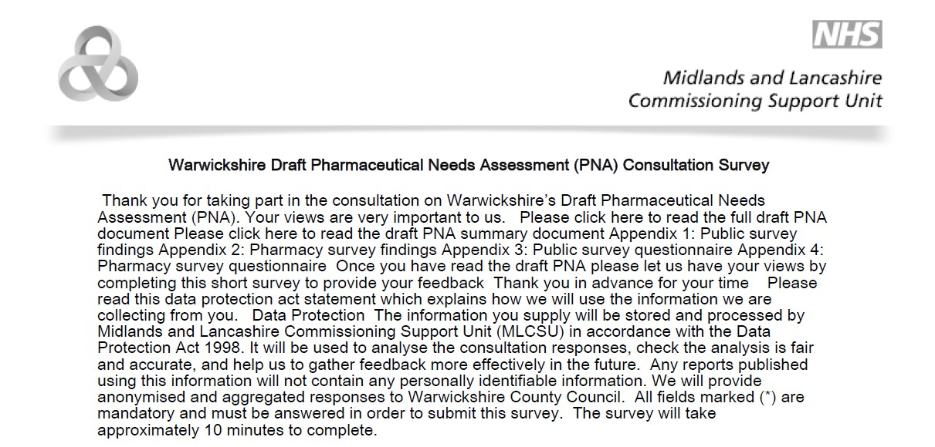

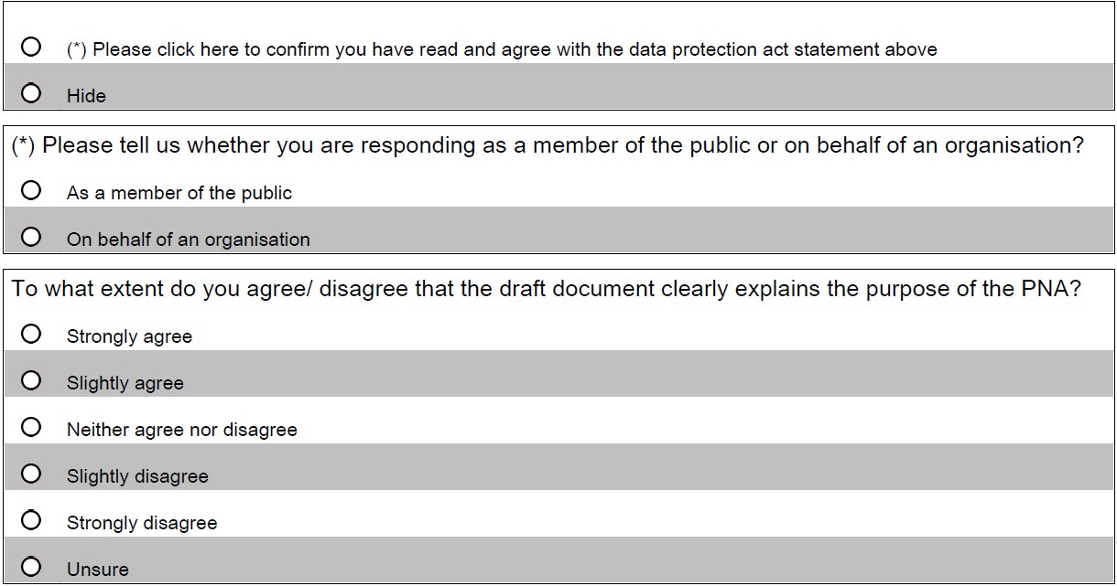

c

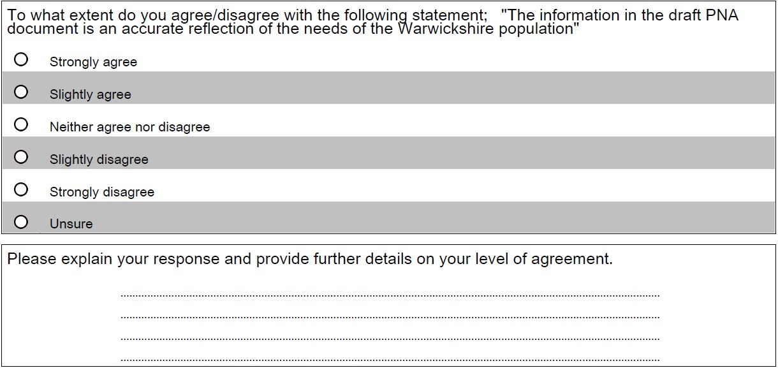

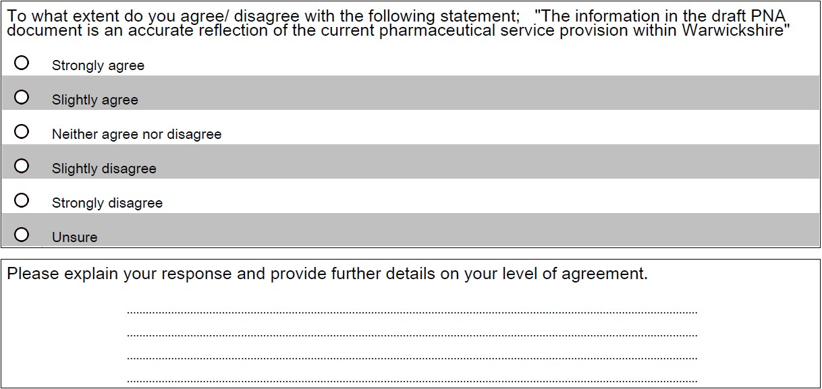

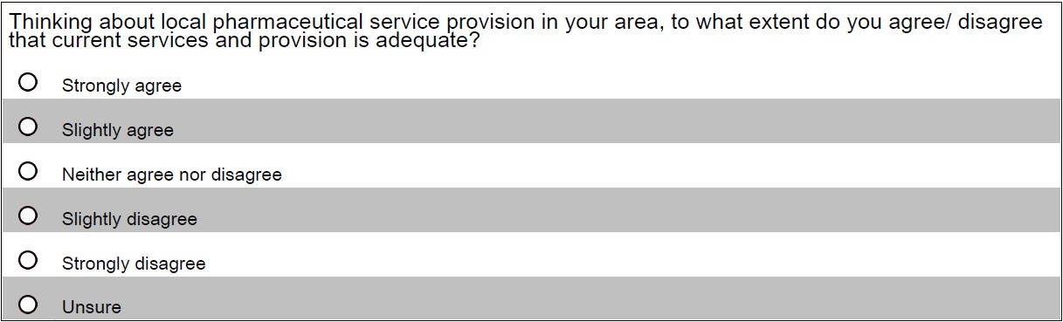

c

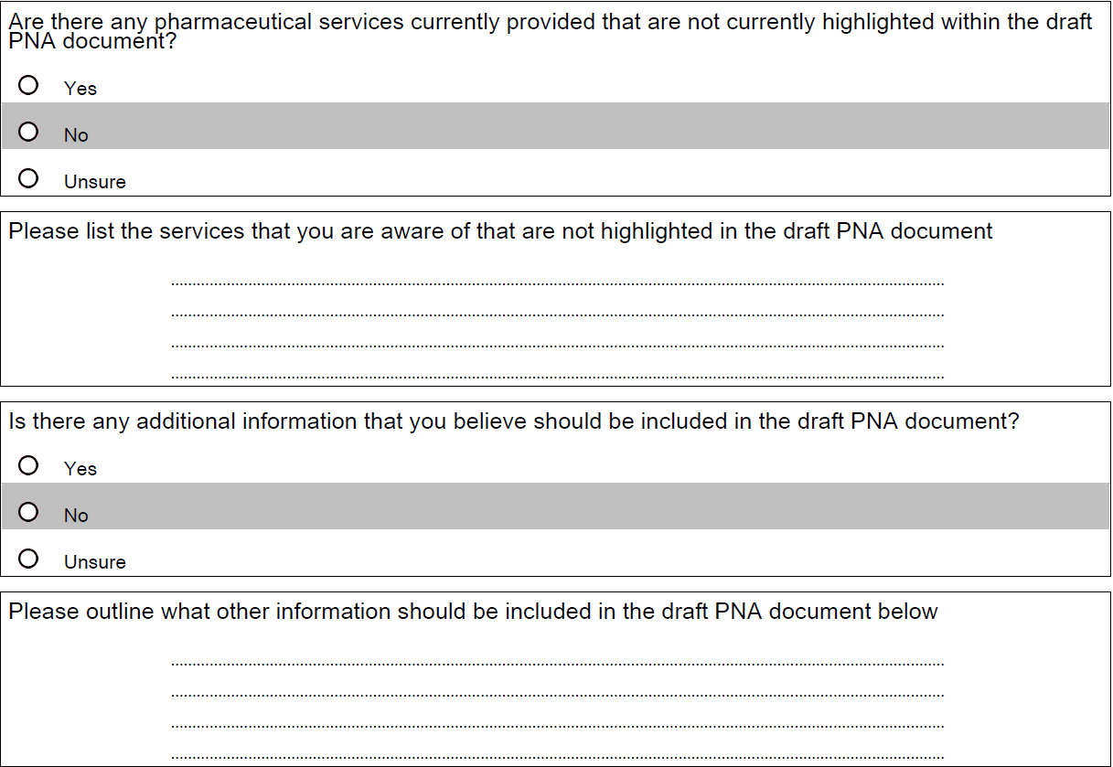

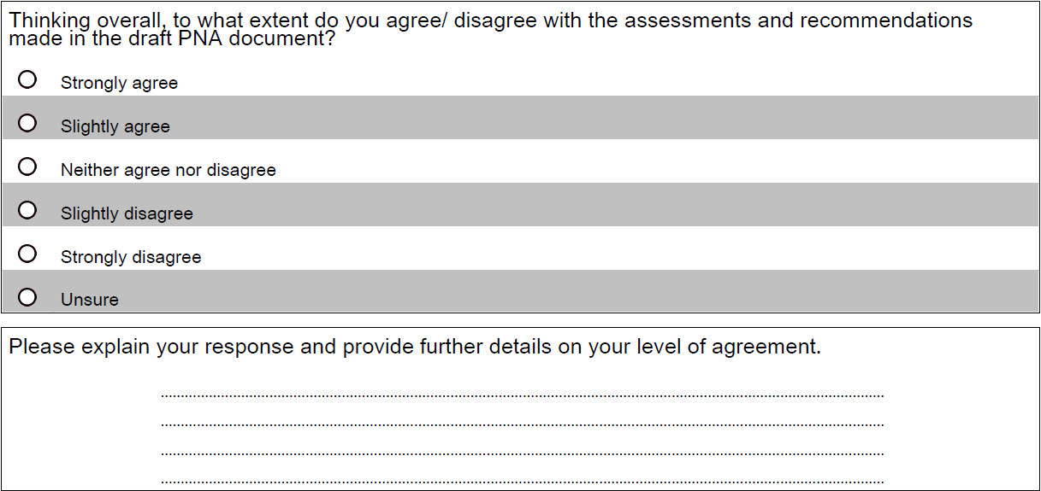

c

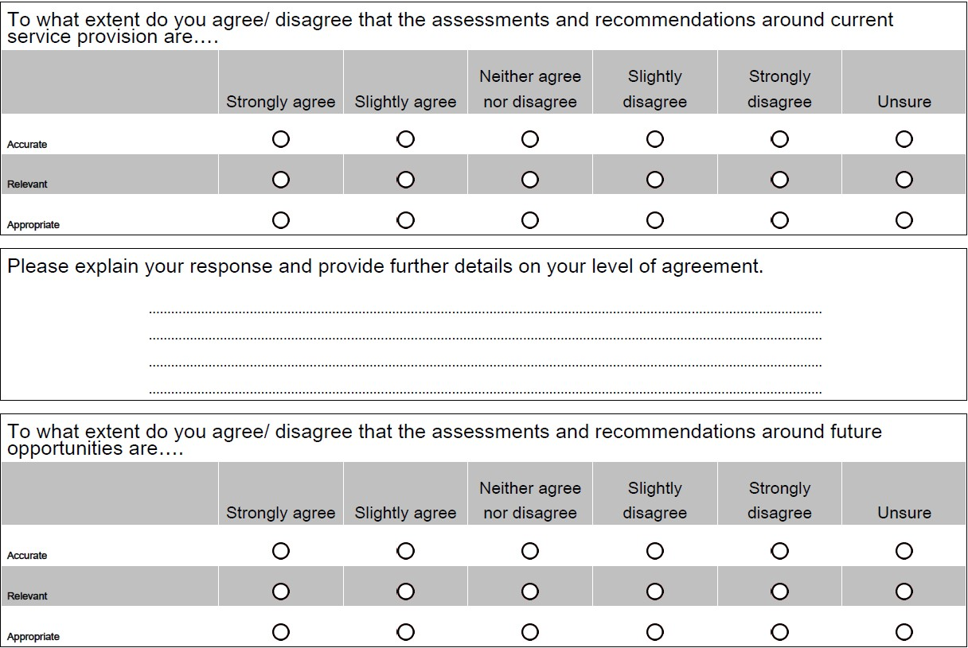

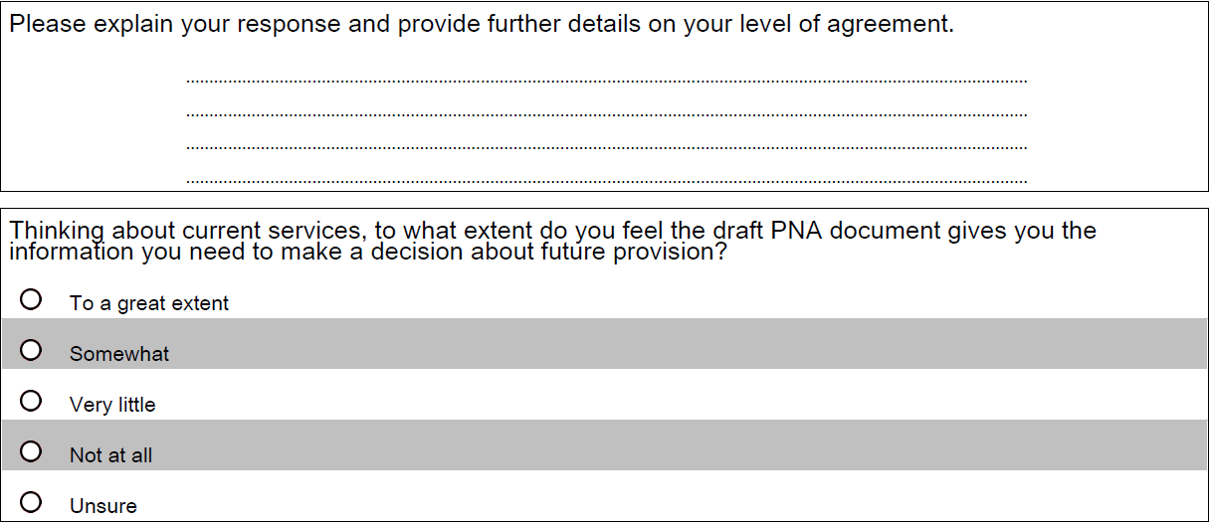

c

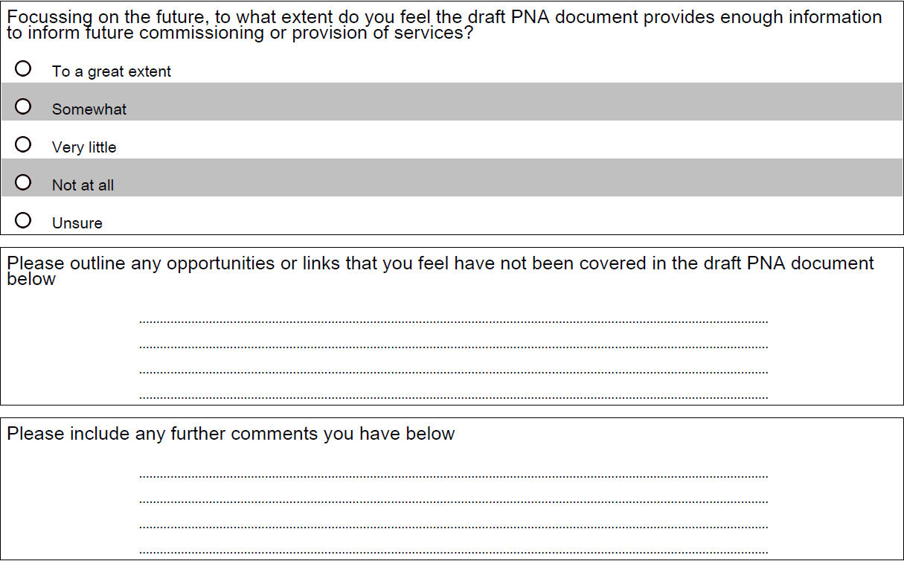

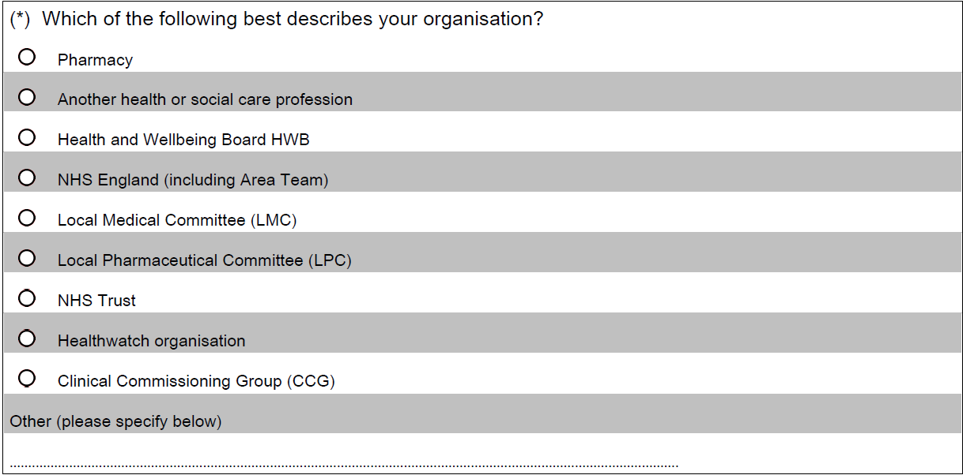

c

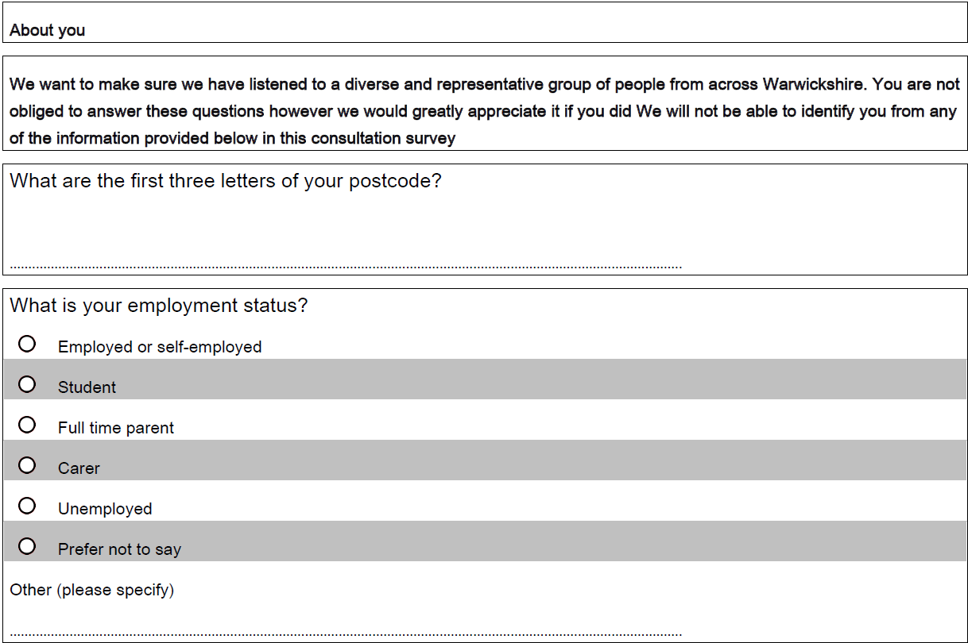

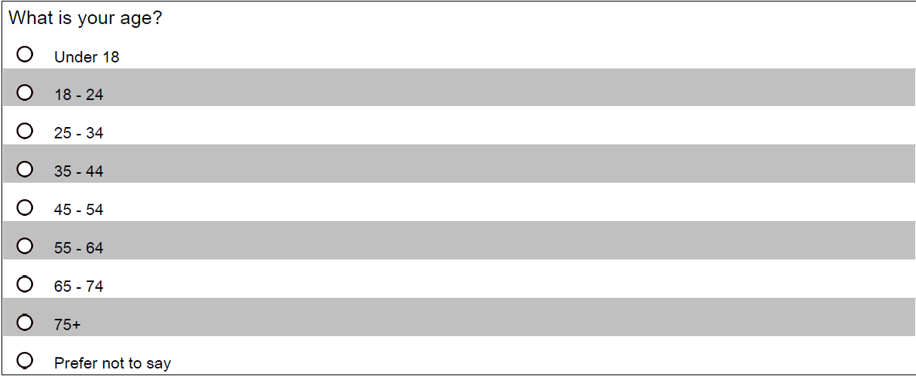

c

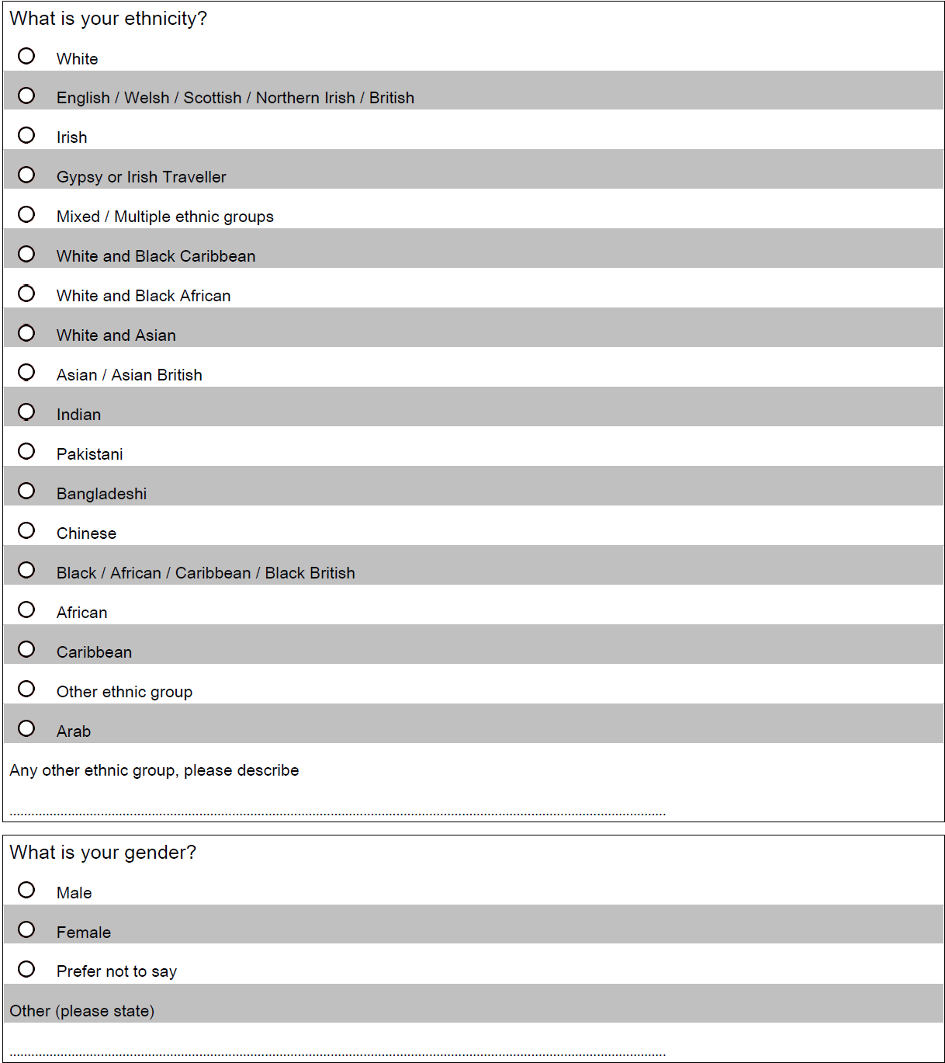

c

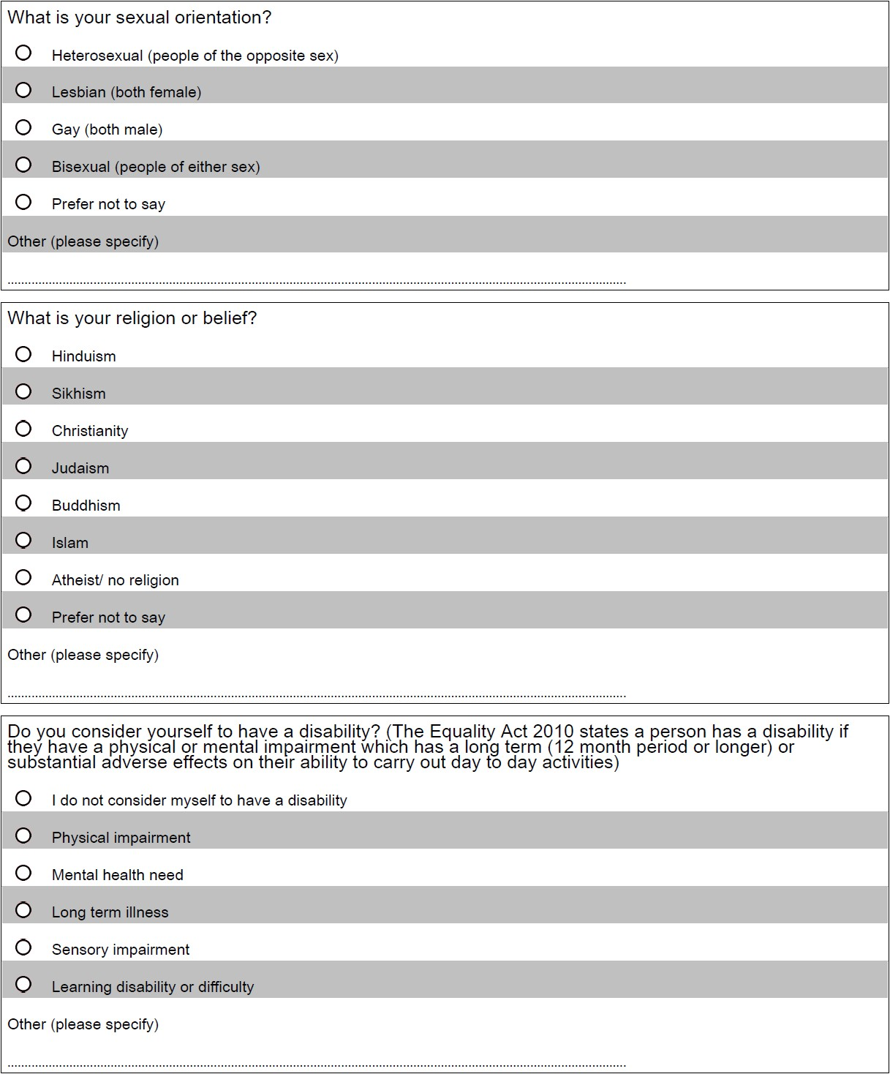

c

