Warwickshire Fire and Rescue Service
Prevention, Protection and Response Strategy
Frequently Asked Questions

Why do you have a Community Risk Management Plan (CRMP)?
It is our legal duty to produce a plan and it fulfils the requirements of the Fire and Rescue National Framework for England, which sets out the government's expectations for all fire and rescue services. The framework recognises that fire and rescue services are best placed to identify, plan, prepare for and address the risks within the communities they serve.
Why do you produce a prevention, protection and response strategy?
The strategy is one of the four components of our community risk management plan (CRMP). The other three components are:
- The risk analysis – which assesses fire and rescue related risk in the community.
- Performance measures - which measure the impact of the strategy on reducing risk in the community.
- The Annual Statement of Assurance –which provides financial, governance and operational assurance to the community and government.
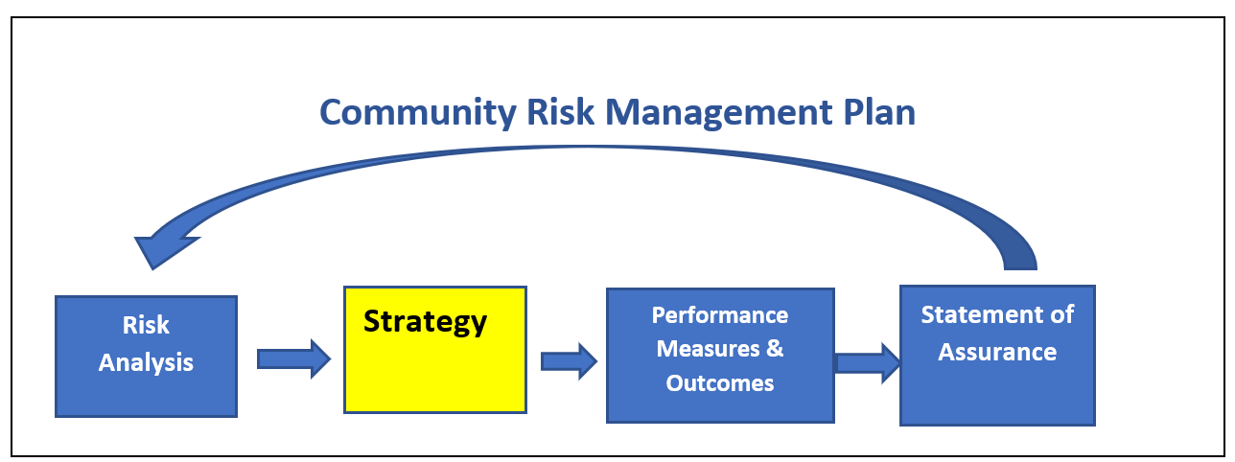

What is the purpose of the WFRS prevention, protection and response strategy?
Warwickshire Fire and Rescue Service’s (WFRS) Prevention, Protection and Response Strategy 2022 – 2027 sets out the Fire Authority’s mission for the next five years. It defines the priorities and the approach we take to ensure communities and individuals who choose to live, work, do business, study, or visit Warwickshire are safe.

What are your main priorities over the next few years?

Our priorities
Our prevention, protection and response priorities are set out below. They are driven by risk and support our mission statement of keeping people safe at home, at work, travelling in and through Warwickshire and in their environment.

Prevention priorities
- We are identifying the most vulnerable people in our communities and improving their safety, health, and wellbeing through targeted prevention activities directly linked to vulnerability and risk.
- We are ensuring that our people and relevant partners have the necessary skills and capabilities to deliver a wide range of prevention activities to improve community safety.
- We are adopting a collaborative approach, sharing information, and learning with relevant stakeholders and partners to improve organisational performance and community safety outcomes.
- We are pro-actively engaging with and supporting relevant partners in reducing identified community risk, for example road traffic collisions.
- We are ensuring that our people can act on safeguarding concerns and have the necessary skills and knowledge to do so.
- We are evaluating our integrated approach to ensure its effectiveness in reducing risk.
Protection priorities
- We are identifying those premises that pose the greatest risk and effectively targeting our resources to protect the built environment.
- We are ensuring accurate risk information is available to those that need it when they need it.
- We are strengthening our specialist Fire Protection capacity to ensure that we have a sustainable staffing model.
- We are developing our people to utilise more of our workforce to reduce community risk.
- We are supporting businesses to help themselves and encourage a strong fire safety culture.
- We are evaluating our integrated approach to ensure its effectiveness in reducing risk.
Response priorities
- We are resourcing to risk, to provide a risk based, effective and efficient response because our communities expect us to be there when they need us.
- We are ensuring our people have the necessary skills and competencies to deliver prevention, protection and response activities because we are committed to keeping our community and people safe.
- We are strengthening our specialist response capability and developing our people in response to the broadening nature and increasing variation of the types of incidents we attend.
- We are ensuring accurate risk information is available to those that need it when they need it.
How will you deliver the strategy?
It is important that we deliver our priorities in the right way and to the standard expected by those who need us, work for or with us. Our approach is based on 4 themes, Risk, Ethics, People and Sustainability. These themes will provide assurance that we are delivering our priorities in the right way.
We are a reputable and trusted service, and it is important that we behave in a manner that demonstrates that we are doing the right things in the right way.
The strategy mentions a service offer – what does this mean?
Understanding risk is crucial to the delivery of our service. Community risk management planning ensures that we understand the risks faced by our communities and that we are taking appropriate action to reduce and manage those risks. Our strategy is about setting out an integrated approach through our prevention, protection, and response arrangements, balancing the necessary strategic emergency cover whilst targeting those most vulnerable to risk.
By identifying those people and areas most at risk we can make sure our resources are in the right place at the right time to deliver the most appropriate service based on need.
Our offer sets out the service you can expect when you need us. This means we will offer a universal service to all, targeted activities to support those who need us most and specialist support to resolve high risk complex situations.
Can you give an example of your service offer?
Example 1. If you call 999 our control staff will receive your call and will arrange a response from an appropriate emergency response vehicle that can deal with both the nature and severity of the emergency. (Universal)
Example 2. High risk fire safety activities, such as safe and well checks, road safety or school visits will be targeted at people and places that need us most. (Targeted)
Example 3. Complex high-risk buildings will be inspected by specialist fire safety inspectors who are able to enforce a range of fire safety regulations. (Specialist)

